**Course Description**

The data.table package provides a high-performance version of base R's data.frame with syntax and feature enhancements for ease of use, convenience and programming speed. This course shows you how to create, subset, and manipulate data.tables.

You'll also learn about the database-inspired features of data.tables, including built-in groupwise operations. The course concludes with fast methods of importing and exporting tabular text data such as CSV files.

Upon completion of the course, you will be able to use data.table in R for a more efficient manipulation and analysis process. Throughout the course you'll explore the San Francisco Bay Area bike share trip dataset from 2014.

**Introduction to data.table**This chapter introduces data.tables as a drop-in replacement for data.frames and shows how to use data.table's *i* argument to filter rows.

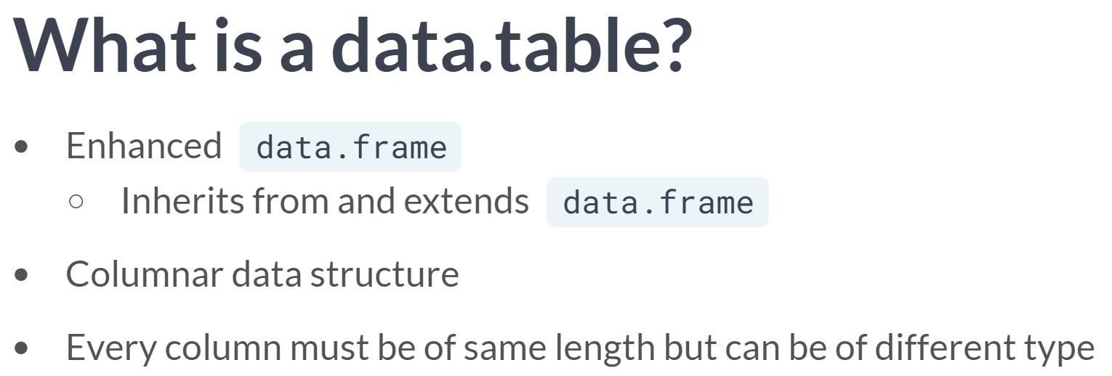

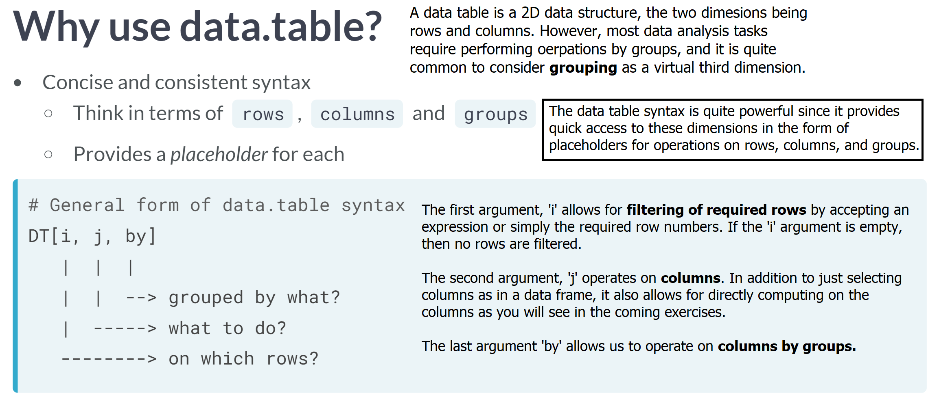

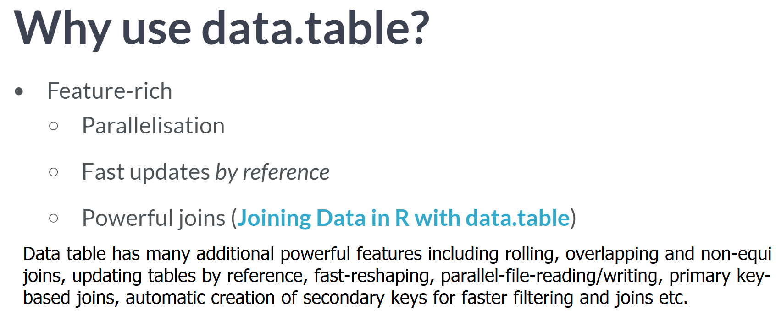

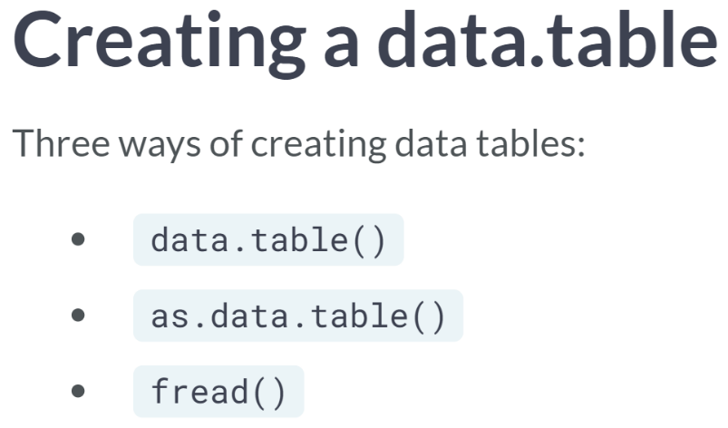

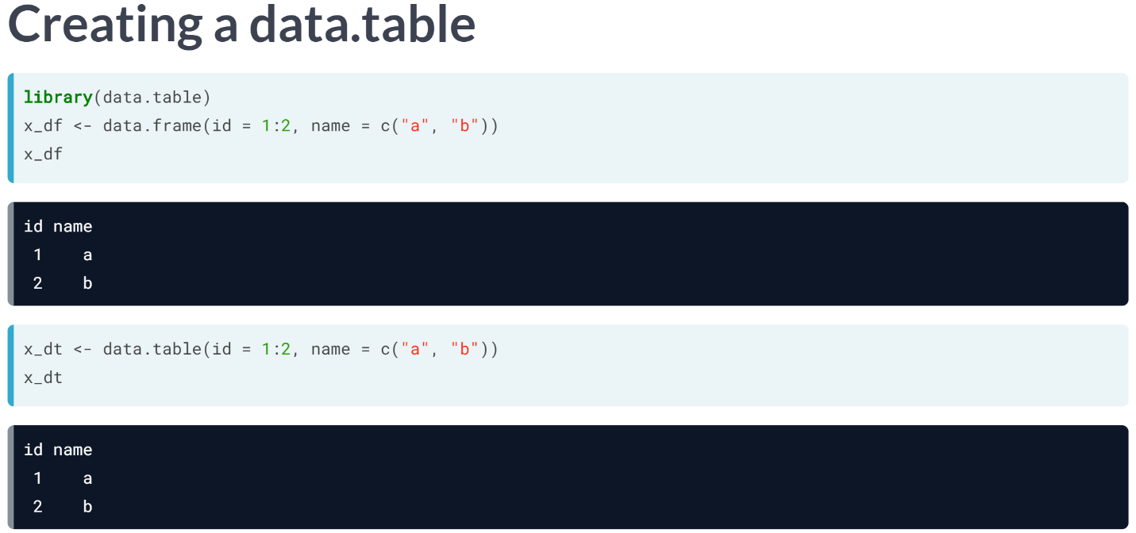  
You can use the data table function to create a data table from scratch the same way you would use the data frame function. All you need to do is pass vectors of the same length to the data table function.

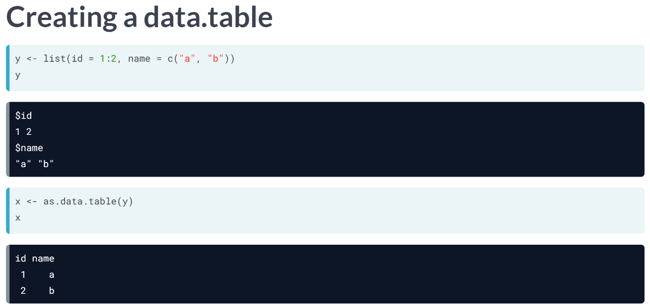  
To convert an existing R object to a data table, you can use the ***as.data.table()*** function. As you can see here, we converted the list y to a data table.

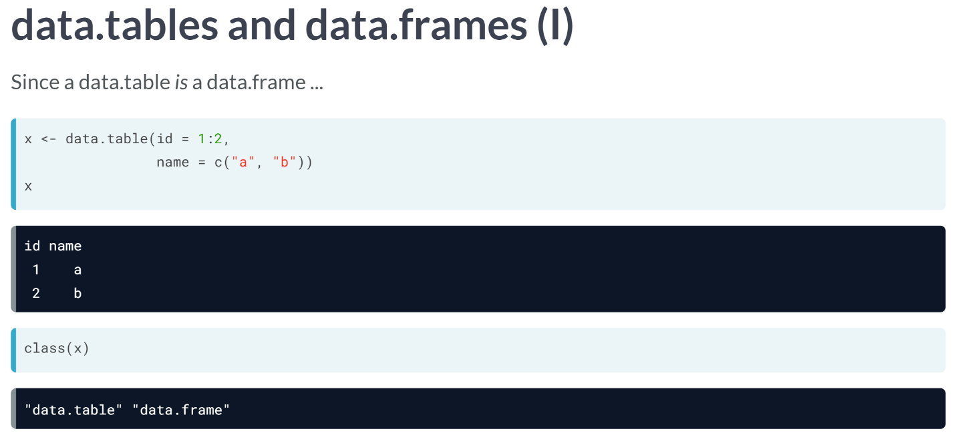  
As mentioned earlier, a data table is also a data frame and you can confirm that here from the output of ***class()***.

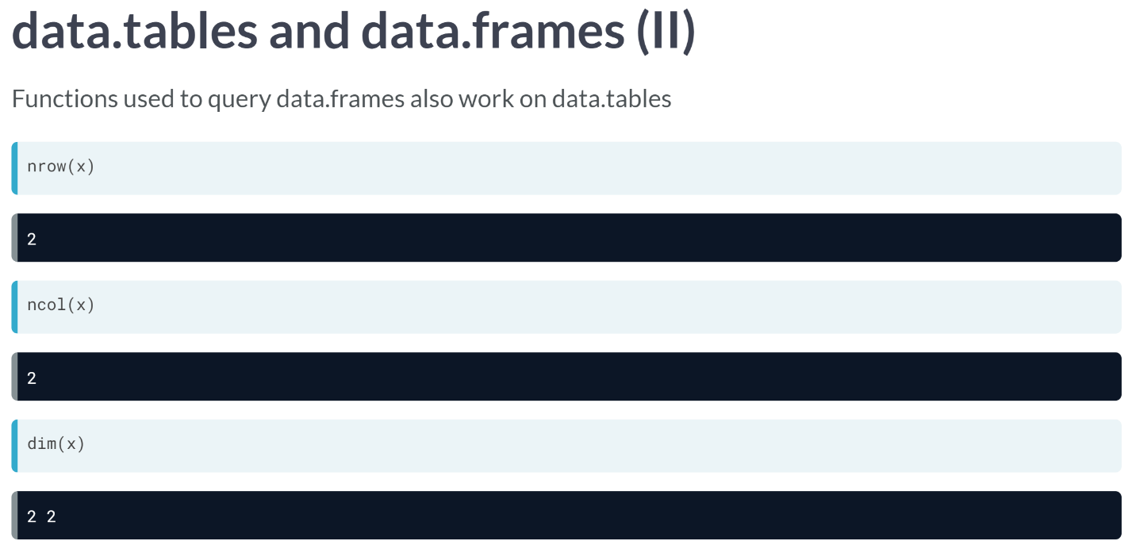

And thus you can use all the functions you would use on a data frame on a data table. ***nrow()***, ***ncol()***, and ***dim()***, for example, return the number of rows, columns, and dimensions of a data table, as it would on a data frame.

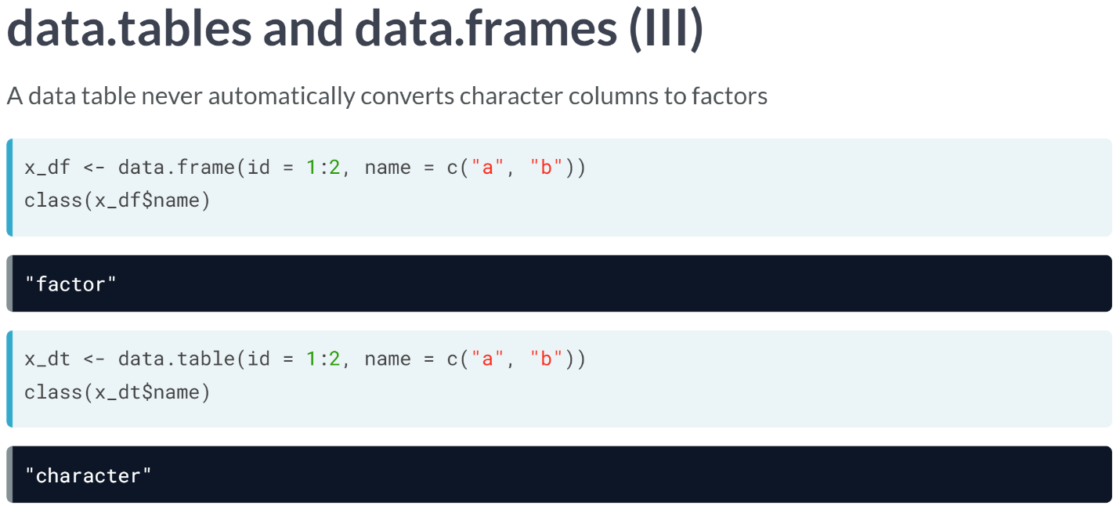  
However, there are a few enhancements. Unlike a data frame, a data table doesn't automatically convert characters to factors, thus preventing bugs by avoiding unexpected behavior.

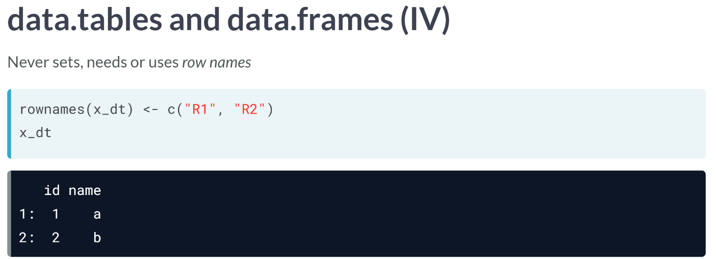  
Also, a data table never sets or uses the row names. Finally, a minor but useful feature is that when you print a data table, a colon(:) is added after the row number to visually separate it from the first column.

# data.table pop quiz

Which of the following statements are true about data.tables?

1. A data.table is a data.frame. It inherits and builds on top of it.
2. data.tables can have columns of different lengths.
3. Columns of data.tables cannot be of data type list.
4. data.tables never use or need row names.

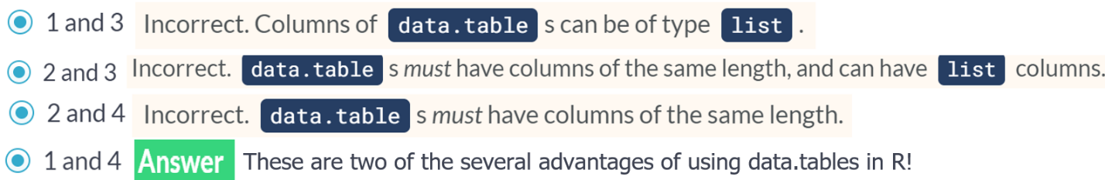

# Creating a data.table

Just like how the data.frame() function can be used to create a data frame, you can create a data.table using the data.table() function. In this exercise, you will create the following data.table:

X

id value

1: a 0.5

2: b 1.0

3: c 1.5

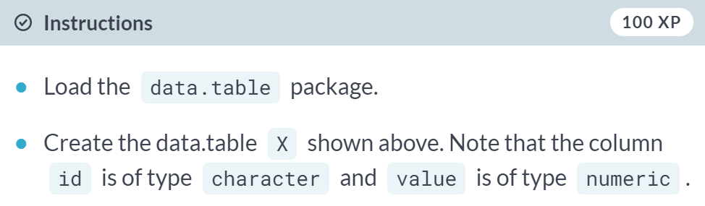

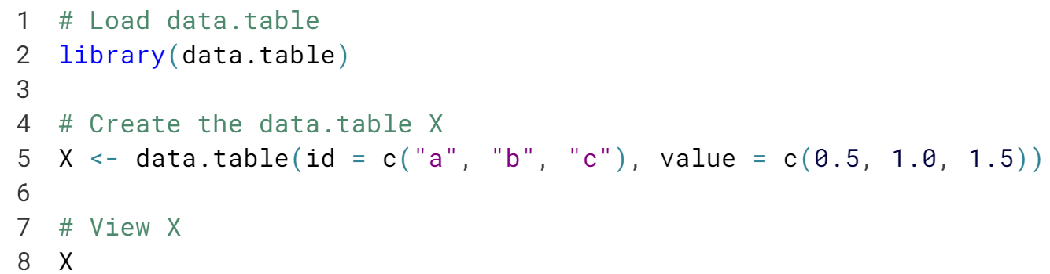

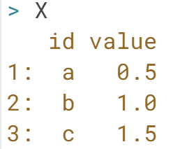  
Well done! Check out the other arguments of ***data.table()*** to gain a better understanding of how *data.tables* work.

# Introducing bikes data

Throughout the rest of the course, you will use the batrips dataset from the [**bikeshare14**](https://www.rdocumentation.org/packages/bikeshare14) package, which contains anonymous bike share data on bicycle trips around San Francisco in 2014. Type batrips in the console and hit enter. Note how data.table automatically limits printing to just the top 5 and bottom 5 rows of the dataset along with column names and row numbers.

Recall that since a data.table is a data.frame, you can use base R functions like ncol(), nrow(), head(), tail() and str() for exploring data.tables.

Unless otherwise mentioned, assume that both data.table and batrips are loaded in your exercises.

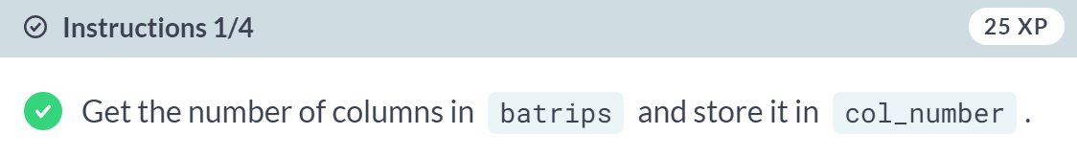  
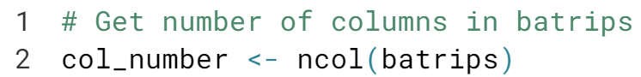  
  
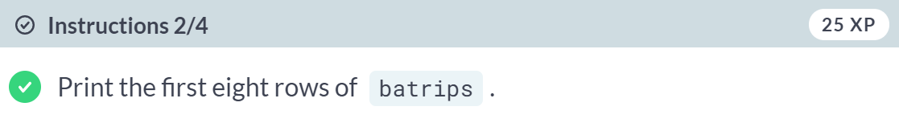  
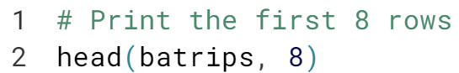  
  
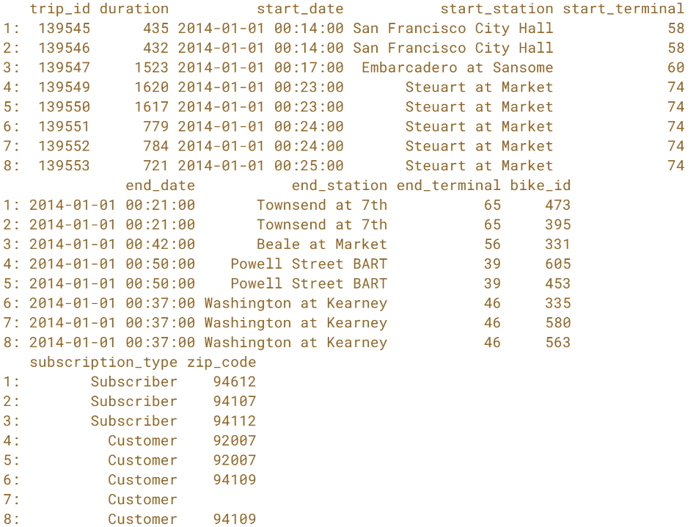

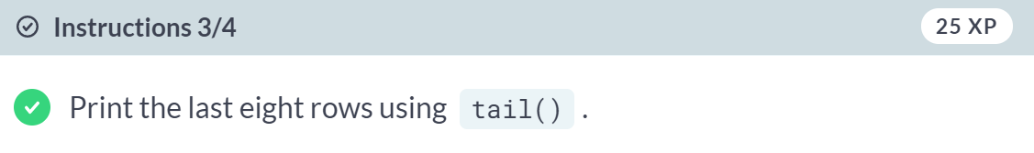  
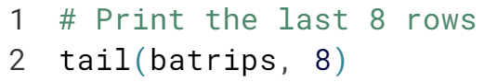  
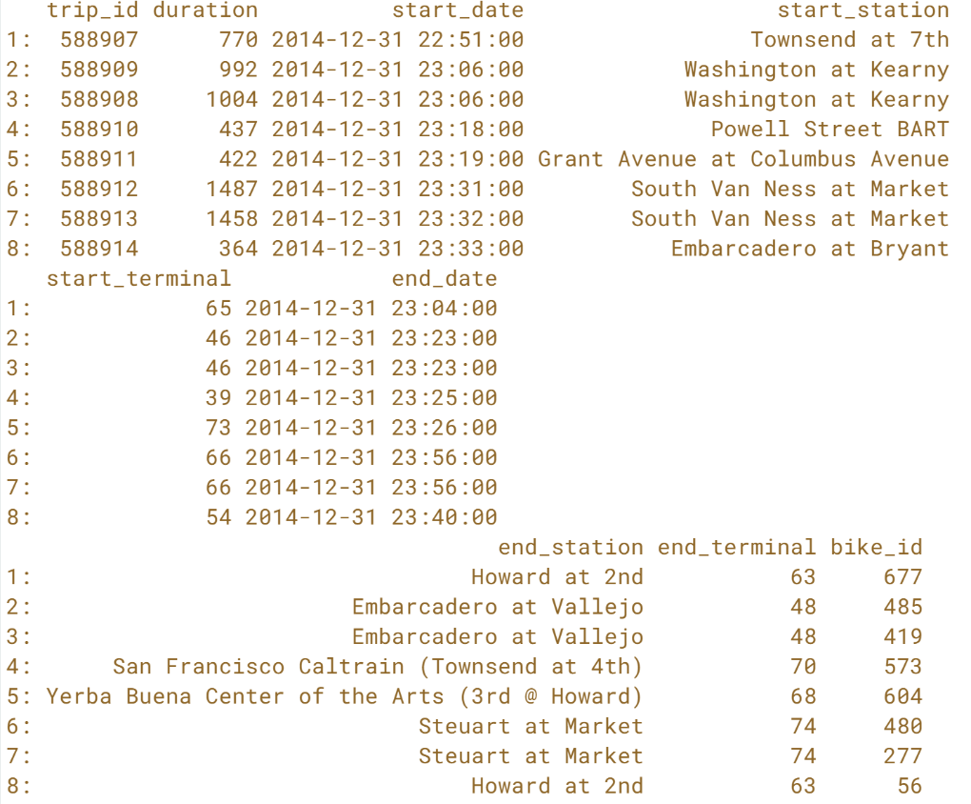  
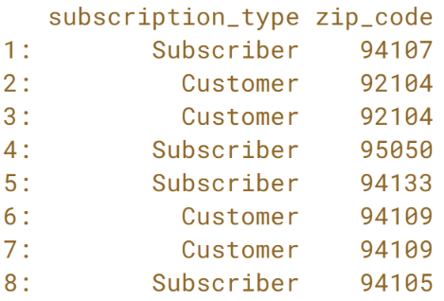  
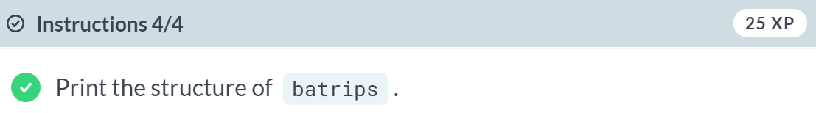  
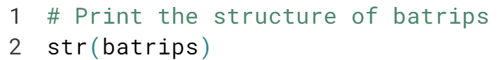  
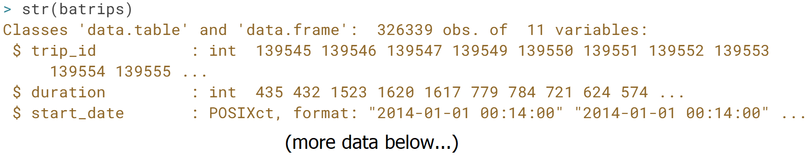



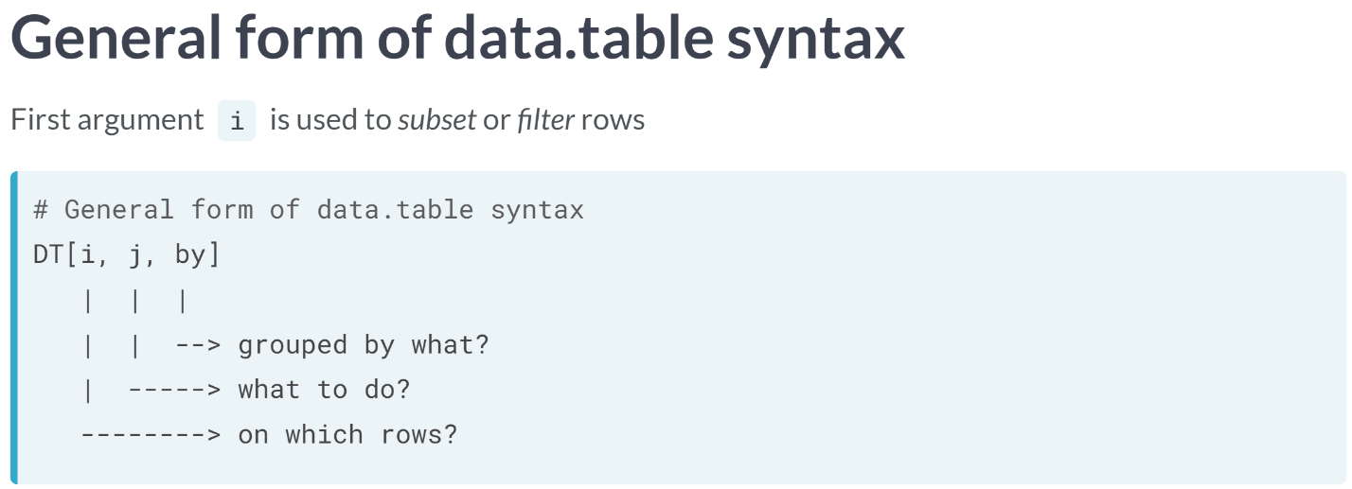  
It is read out load as, "Take DT, filter rows in "i", then compute "j" grouped by "by".  
The functionality is similar to data frames but more convenient and enhanced.  
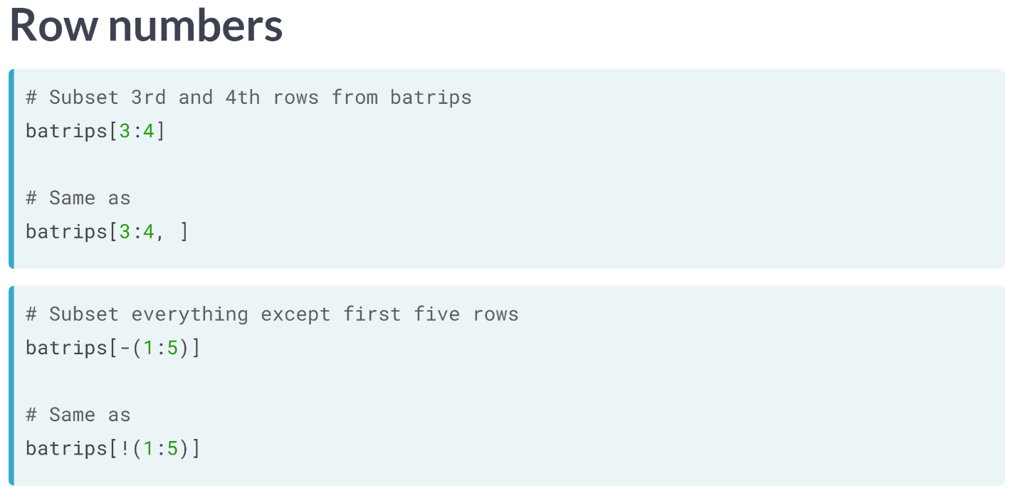  
Rows can be filtered using row numbers as you would do in a data frame, except the first argument is always interpreted as a row operation irrespective of whether or not you specify a comma.

For example, to subset the third and fourth rows, you can use the code as shown here. If you want to exclude a set of rows, you can use the negative sign, or the exclamation mark as shown here.

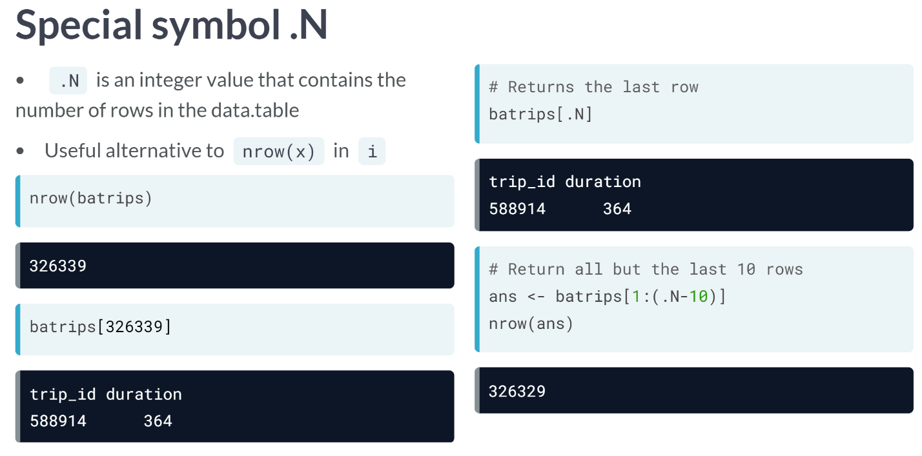  
Data table contains a few handy special symbols (or variables) that make many operations efficient. One such symbol is **.N**, which is an integer vector of length one. When used in the "i" argument, it returns the total numbers of rows in the data table.  
  
To get the last row for example, you can simply do **batrips[.N]**. Similarly, to get all but the last 10 rows, you can specify the "i" argument as **batrips[1:(.N-10)]**.

Since .N is the total number of rows, you are essentially creating a continuous sequence of integers from 1 to the required row number.

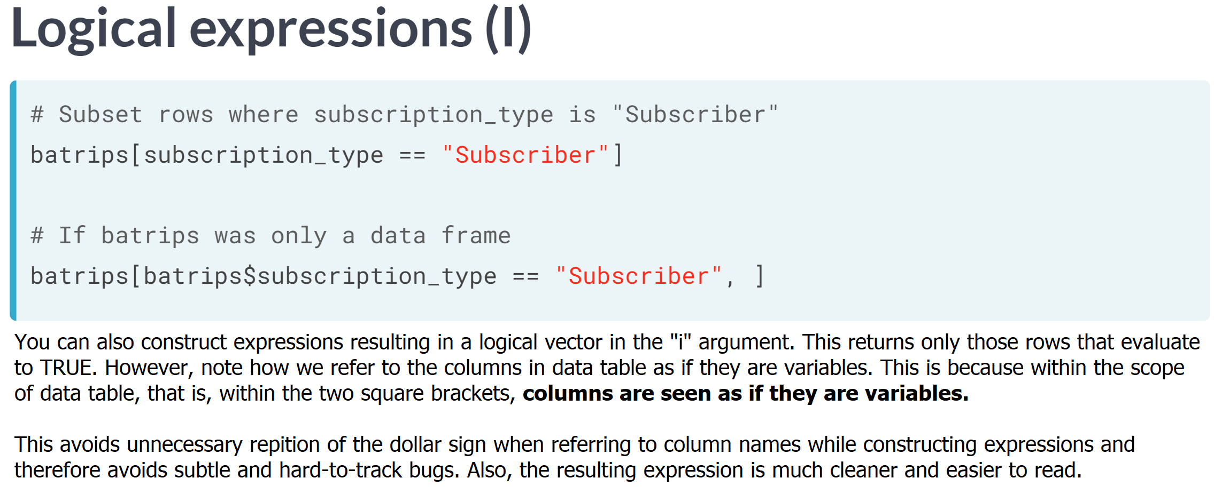

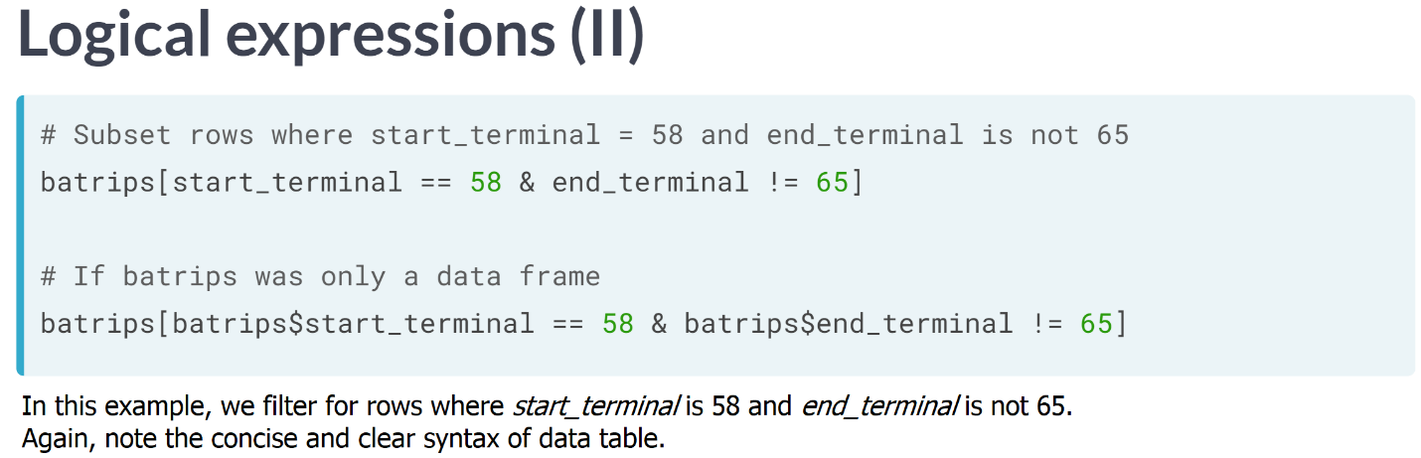  
  
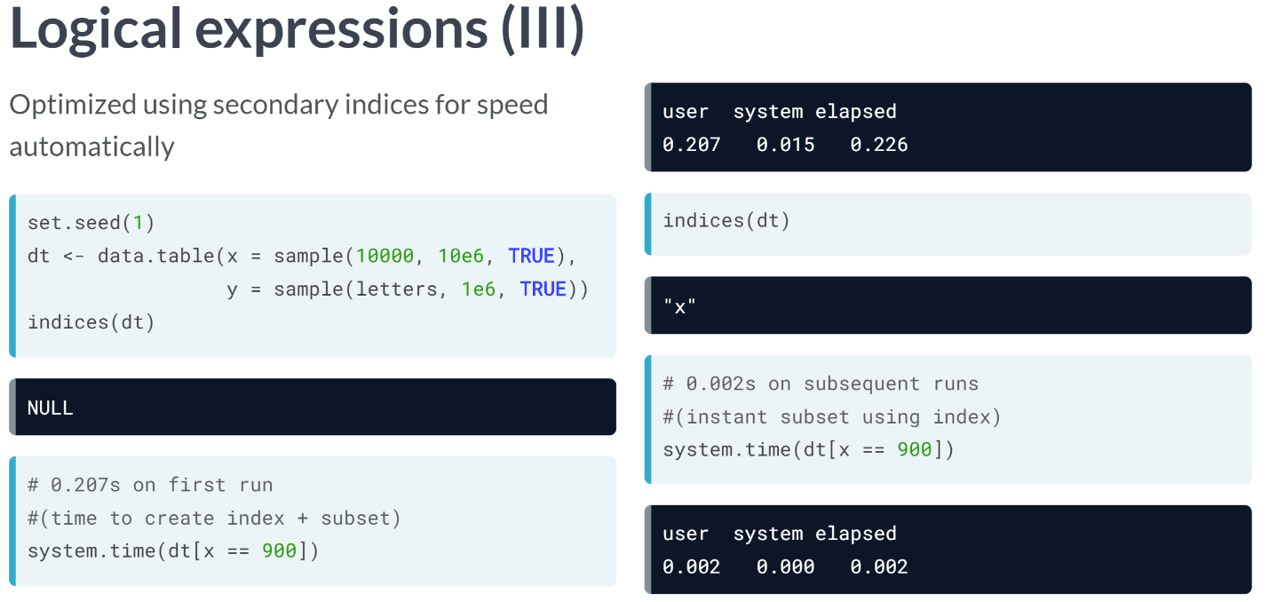  
As mentioned in the first video, data table is fast! It automatically creates an index (or key) of the columns used to subset the data so that any subsequent operations on that column are incredibly faster.

You can have a look at all such indices using the ***indices()*** function. First, we create a data table dt with 10 million rows. When we call ***indices()*** on dt, we can see that the result in **NULL**. Thus, at this point, the data table has no indices.

When we perform a subset operation for the first time, we can see that it takes about 0.2 seconds. Now when we run indices of dt again, notice that x is an index. So, when we perform the same operation again, it takes only about 0.002 seconds.

# Filtering rows using positive integers

You can filter the required rows from a data.table by providing the row indices to its first argument (i), just like when working with a data.frame. However, unlike a data.frame, you don't need to add a comma (,) when filtering rows.

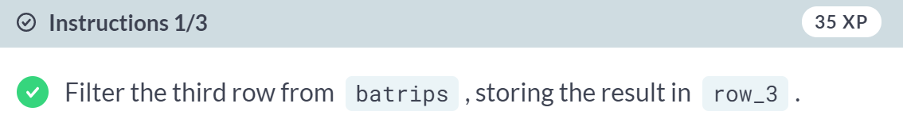  
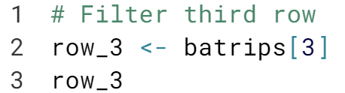  
  
  
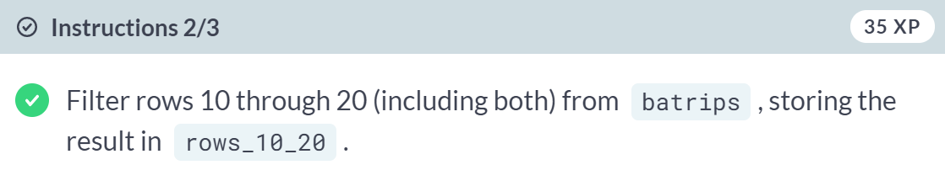  
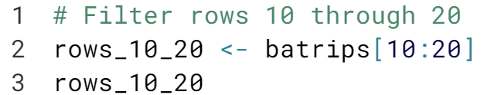  
  
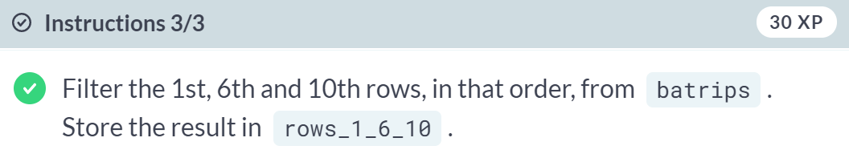  
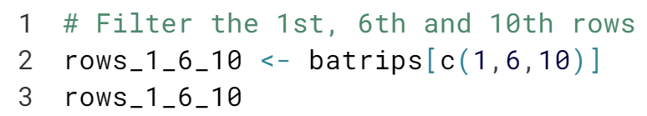

# Filtering rows using negative integers

Sometimes, instead of selecting all of the rows you want individually, it makes sense to deselect the rows you do not want to include. Recall that this can be done using either the ! or the - operators.

For example, dt[-(1:5)] returns all rows except the first five.

Note: dt[-(1:5)] is equivalent to dt[!(1:5)].

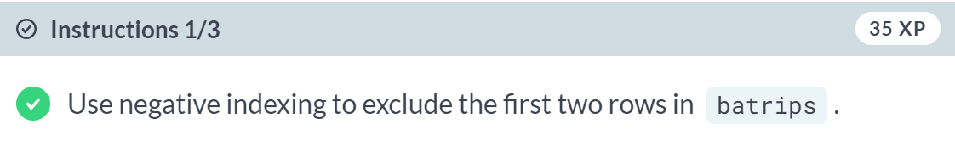  
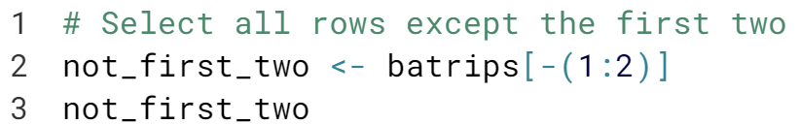  
  
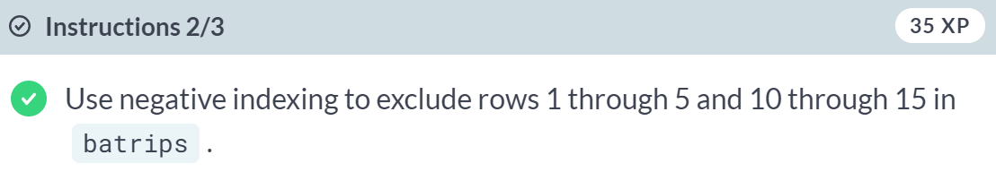  
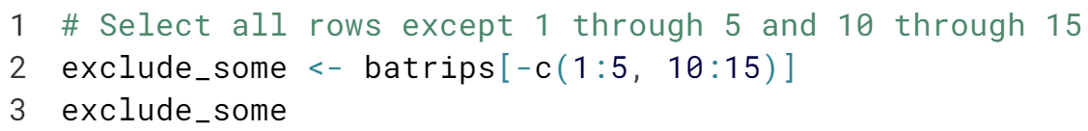  
  
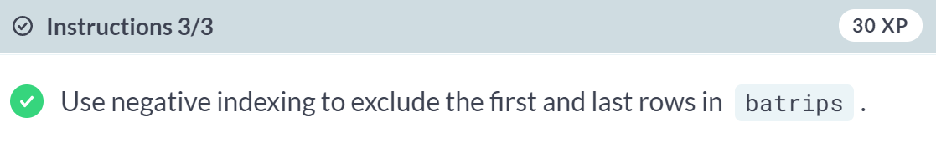  
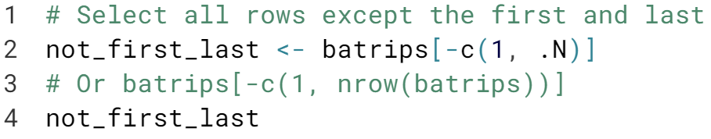

# Filtering rows using logical vectors

In this exercise, you'll use expressions that evaluate to a logical vector to filter rows in a data.table. All rows that evaluate to TRUE will be returned.

Note that you can refer to column names directly, without the need for the $ operator.

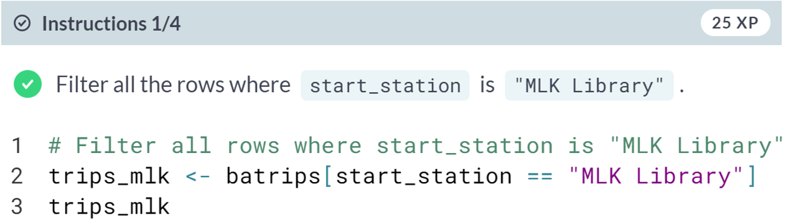  
  
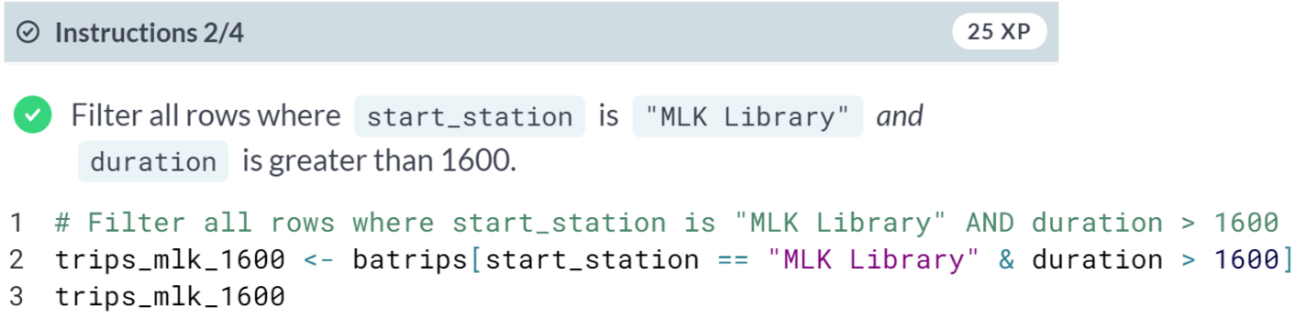  
  
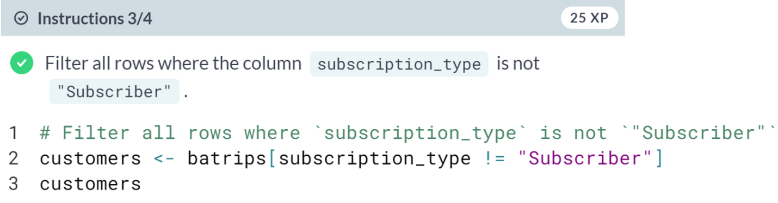  
  
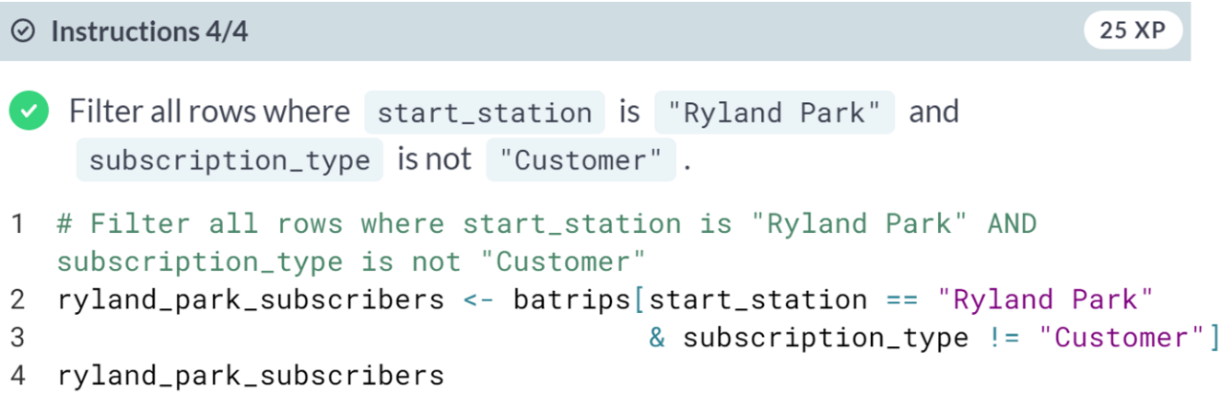



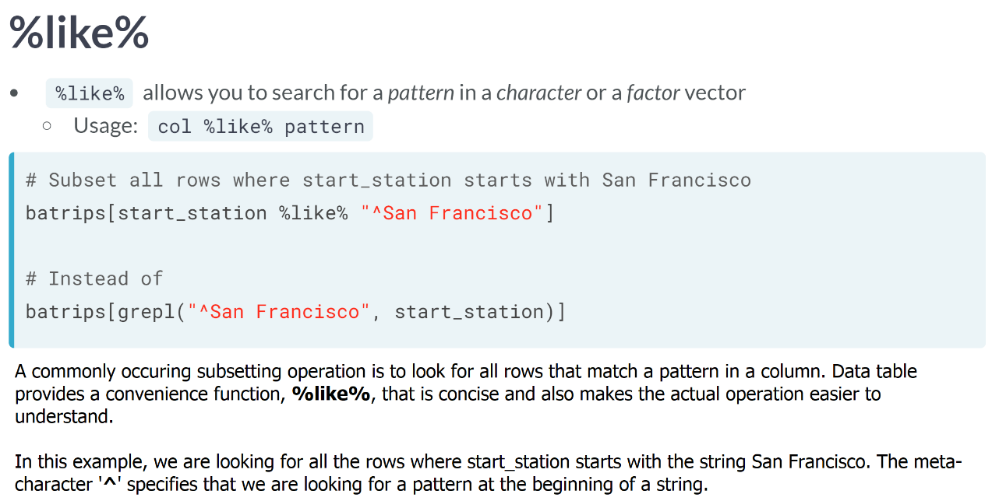  
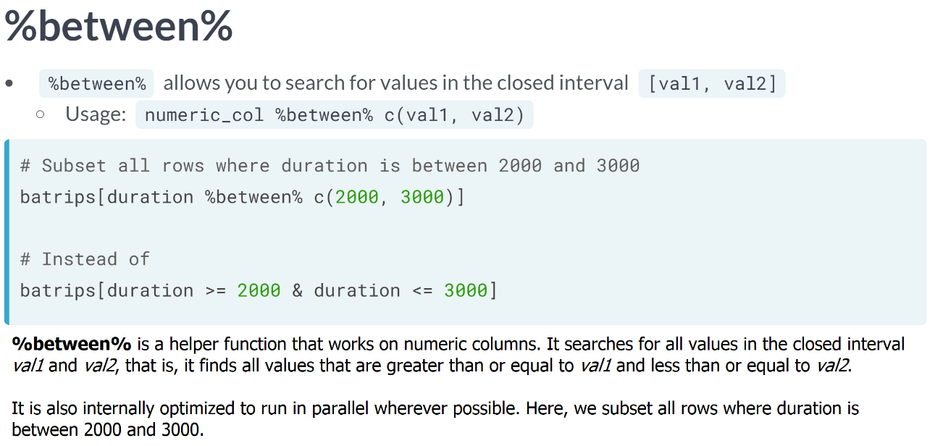  
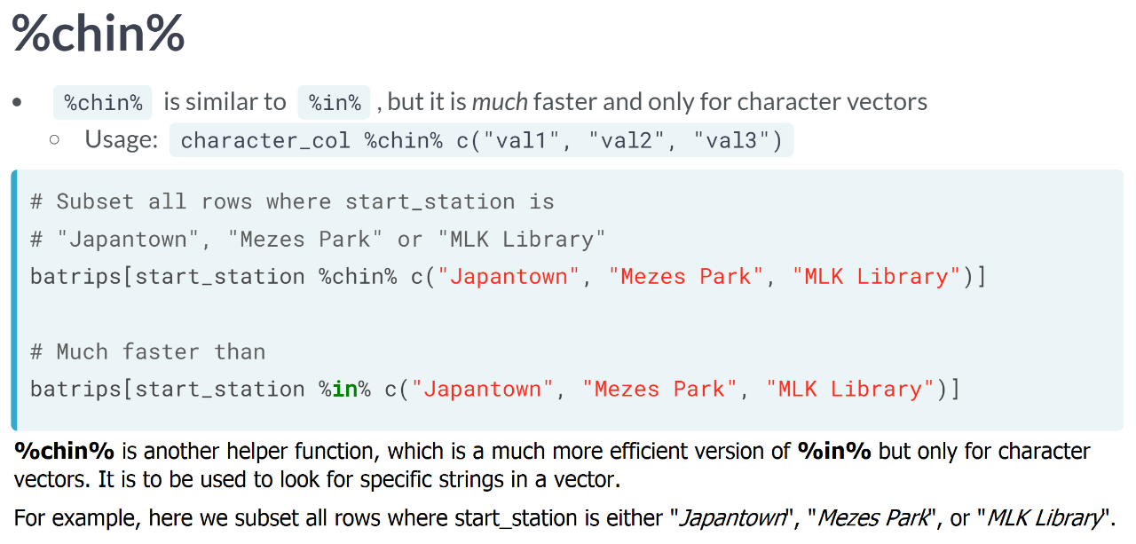

# I %like% data.tables

%like% is a very useful function to filter rows from data.tables that match a pattern, as opposed to exact matches as seen in the previous exercise. It can be used independently on a vector as well, for example:

x <- c("aaba", "aaba", "baca")

# Search for "aa" anywhere in the string

x %like% "aa"

[1] TRUE TRUE FALSE

# Search for "ba" at the end of a string

x %like% "ba$"

[1] TRUE TRUE FALSE

The metacharacter $ indicates that you are searching for the string that ends with a specific pattern.

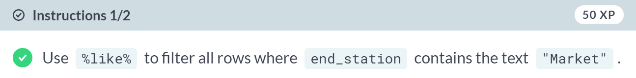  
  
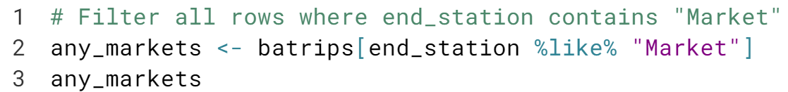  
  
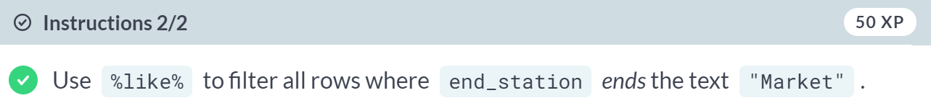

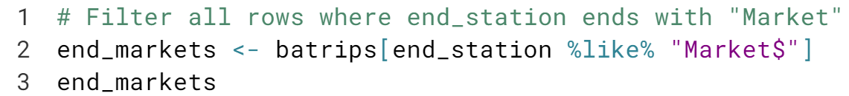  
  
Excellent! By the way, there are many more things to **%like%** about data tables.

# Filtering with %in%

%in% allows selecting rows that exactly matches one or more values, for example:

c("a", "b", "c", "d") %in% c("d", "a")

[1] TRUE FALSE FALSE TRUE

# You are tremendous! Although you can **%in%** it to filter character columns as well, **data.table** provides a much faster version of **%in%** for characters which you will see in the next exercise. Filtering with %between% and %chin%

Two other functions that can come in handy when filtering rows are %between% and %chin%.

* %between% works only on numeric columns and can be used to filter values in the closed interval [val1, val2].
* %chin% works only on character columns and is an efficient version of %in%. You can use it to look for specific strings in a vector.

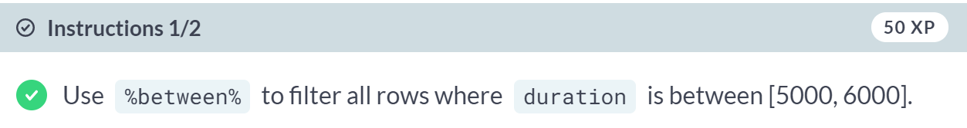  
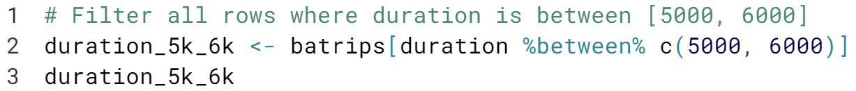  
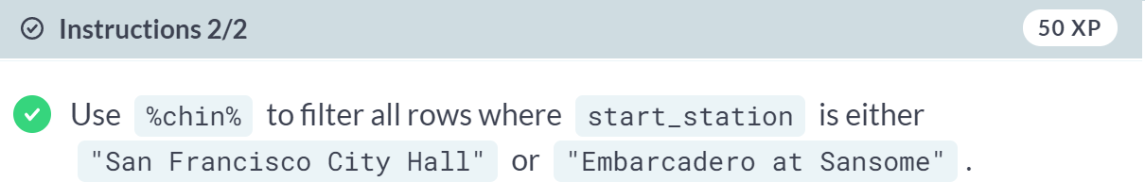  
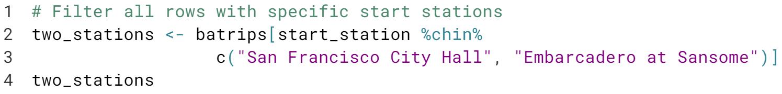

**Selecting and Computing on Columns**Just as the *i* argument lets you filter rows, the *j* argument of data.table lets you select columns and also perform computations. The syntax is far more convenient and flexible when compared to data.frames.

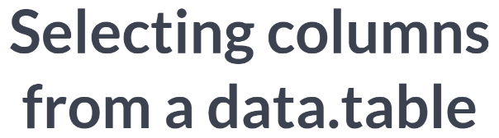

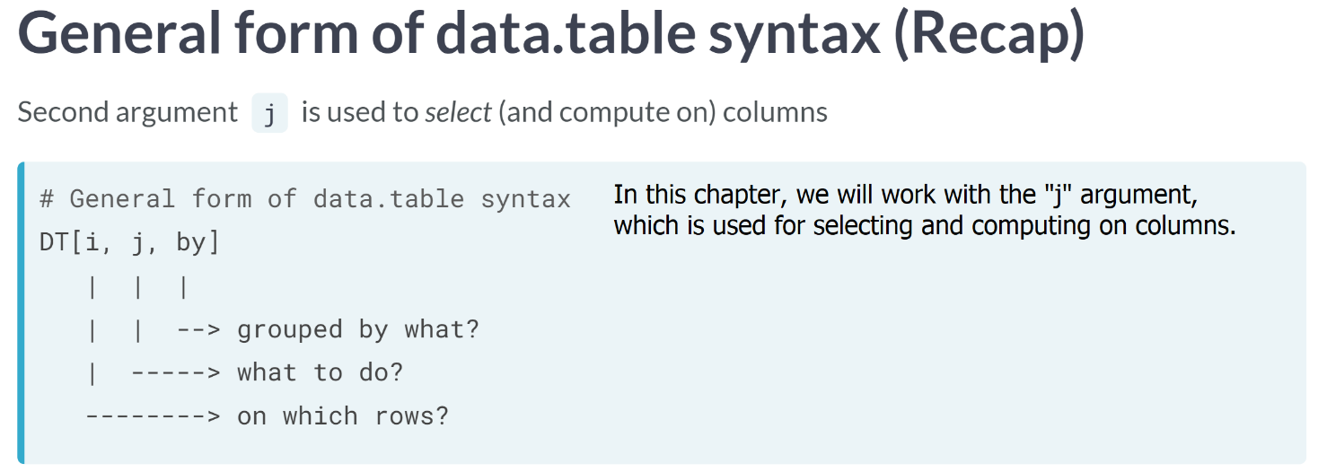  
  
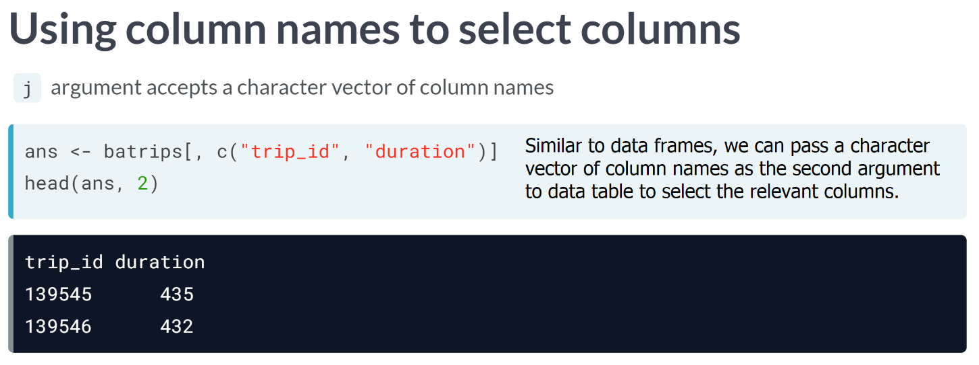

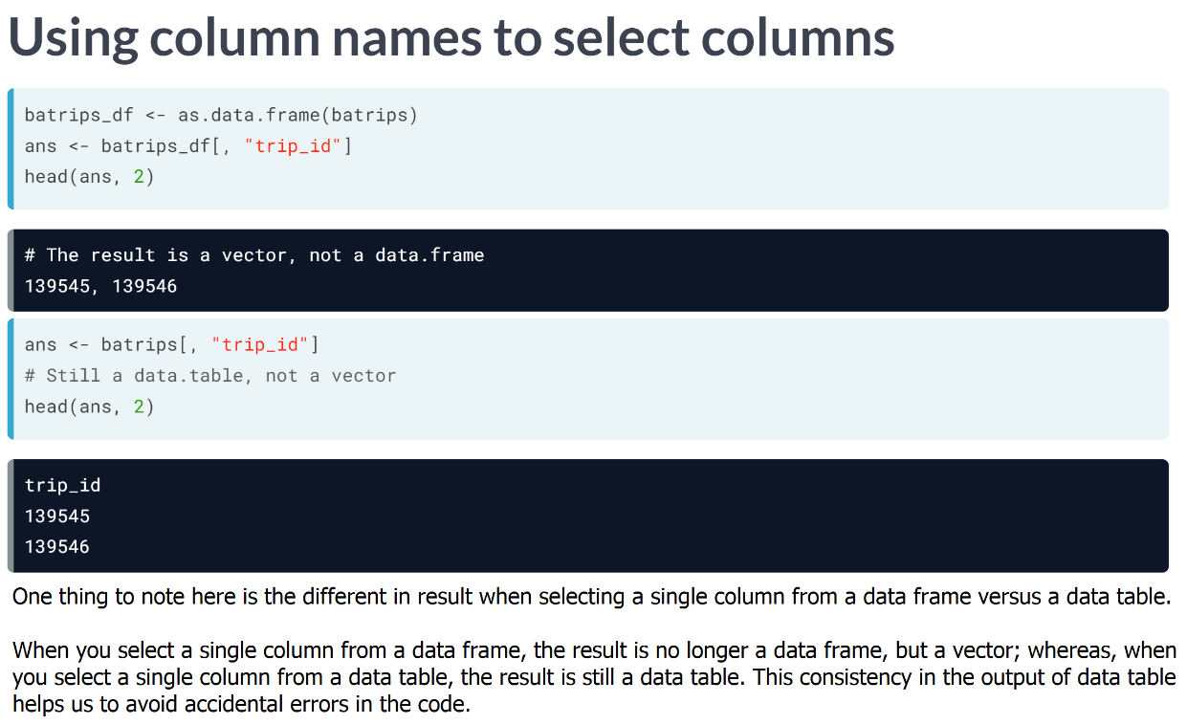

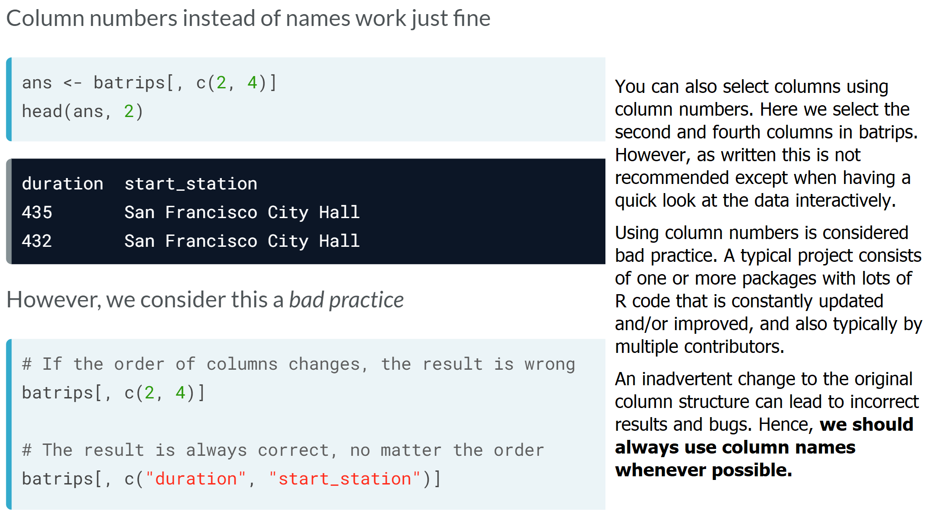

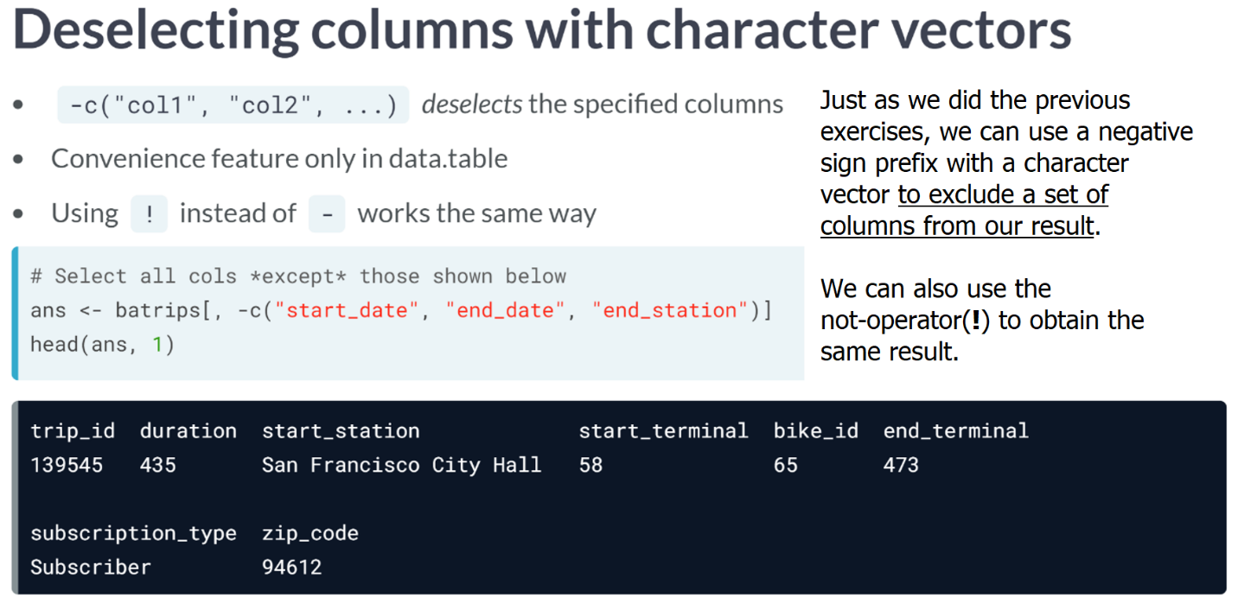

So far we have selected columns using the data frame way, but one limitation of this approach is that it only allows us to select columns; however, we will have to tweak the "j" argument using the data table approach if we want to compute on columns and to perform advanced data manipulation.

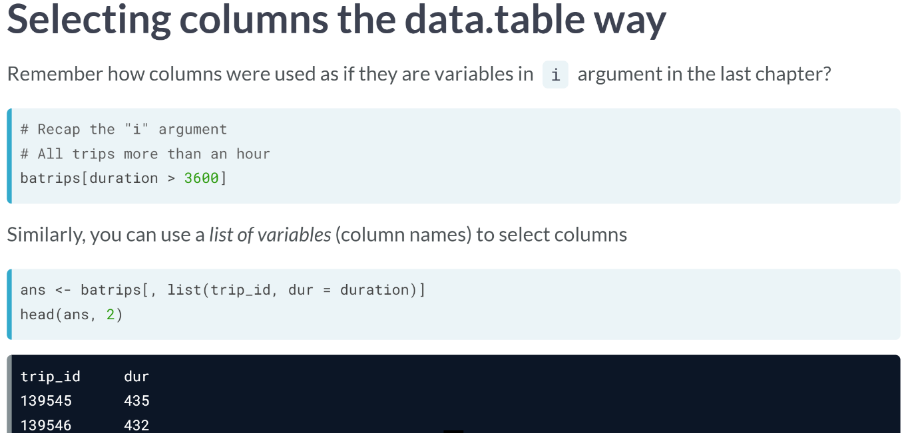

Recall how you could filter rows in "i" by referring to columns directly as if they're variables? We can do the same in "j" since we usually need to select one column, "j" accepts a list of columns. For example, we can select "*trip_id*" and "*duration*" columns as shown here.

Notice that there are no quotes around column names. Also note that since "j" accepts a list, we can also rename columns while selecting. For example, "duration" column is renamed to "dur".

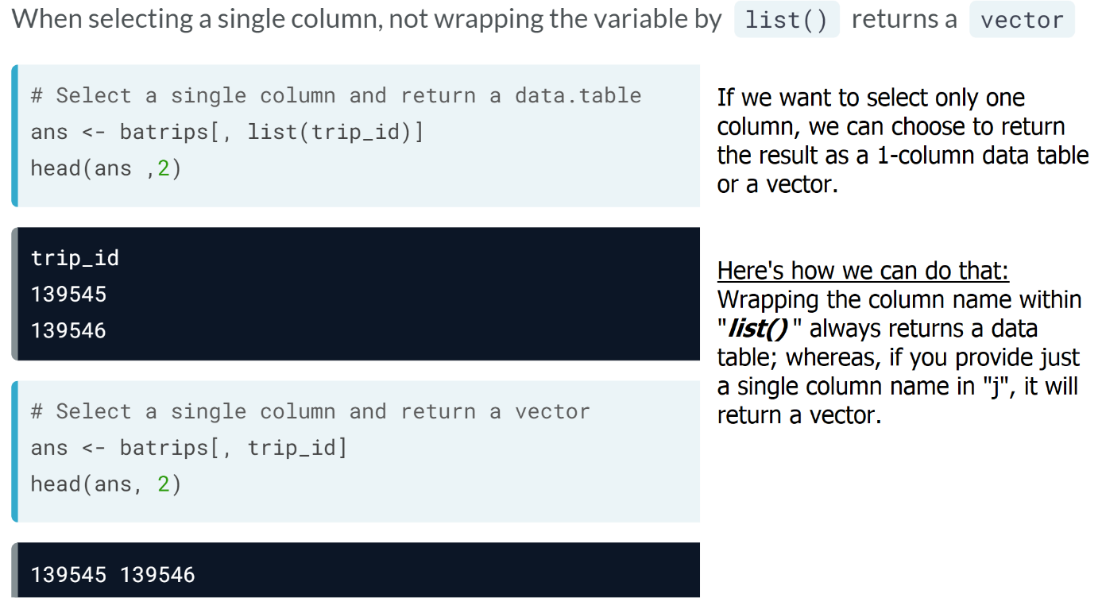

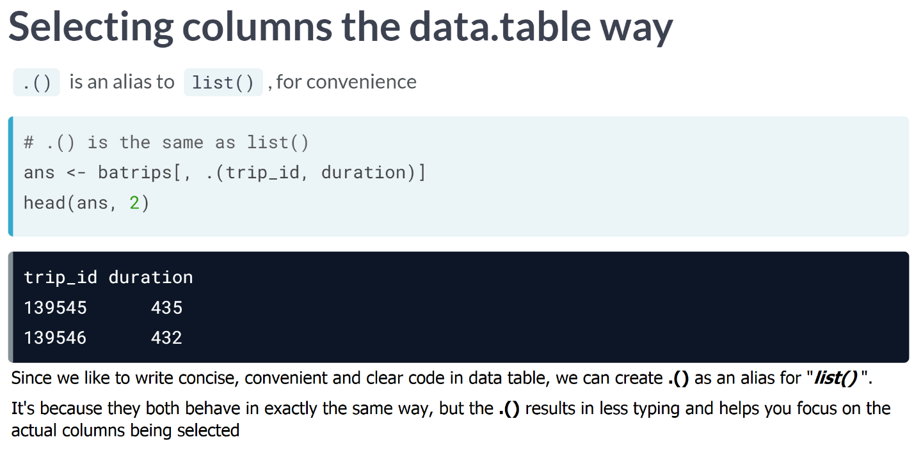

# Selecting a single column

Which of the following options does not return a data.table?

Note: *batrips* is a *data.table*.

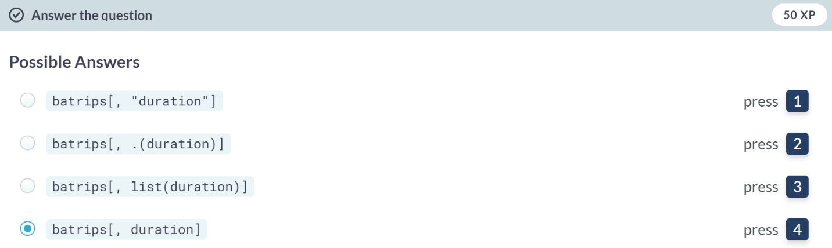  
Well done! If you don't wrap the column name either in **quotes** or **inside list()**, the result is a vector.

# Selecting columns by name

DT[, c("col1", "col2")] returns a data.table with two columns, just like a data.frame.

Alternatively, you can also select columns by passing a list with each element referring to the column name as if it were a variable, i.e., DT[, .(col1, col2)]. Note the absence of quotes, i.e., "" around column names here.

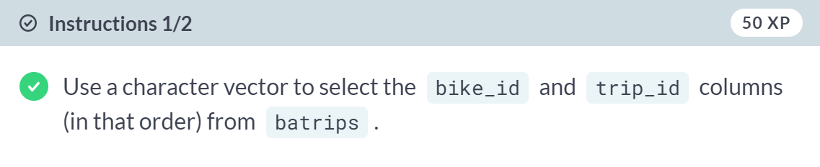  
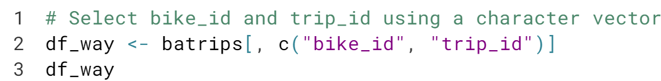  
  
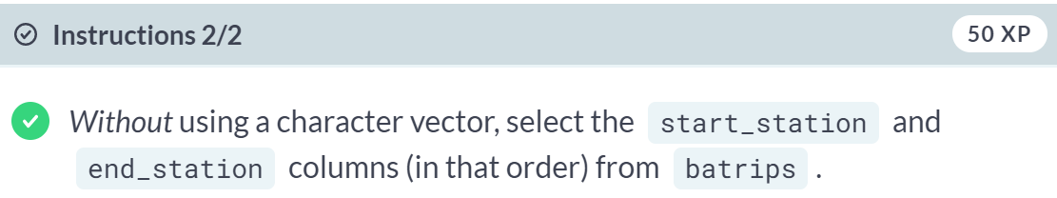  


Nice. As you saw, selecting columns from a data.table is easy!

# Deselecting specific columns

You can also drop or deselect columns by prepending the character vector of column names with the - or ! operators. For e.g., dt[, -c("col1", "col2")] or dt[, !c("col1", "col2")] would both return all columns except col1 and col2.

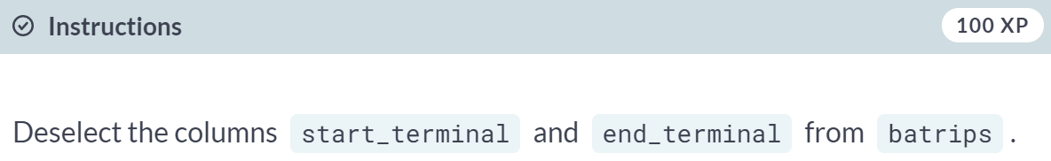

  
You are an expert in selecting and dropping columns! Now it's time to perform computations in j.



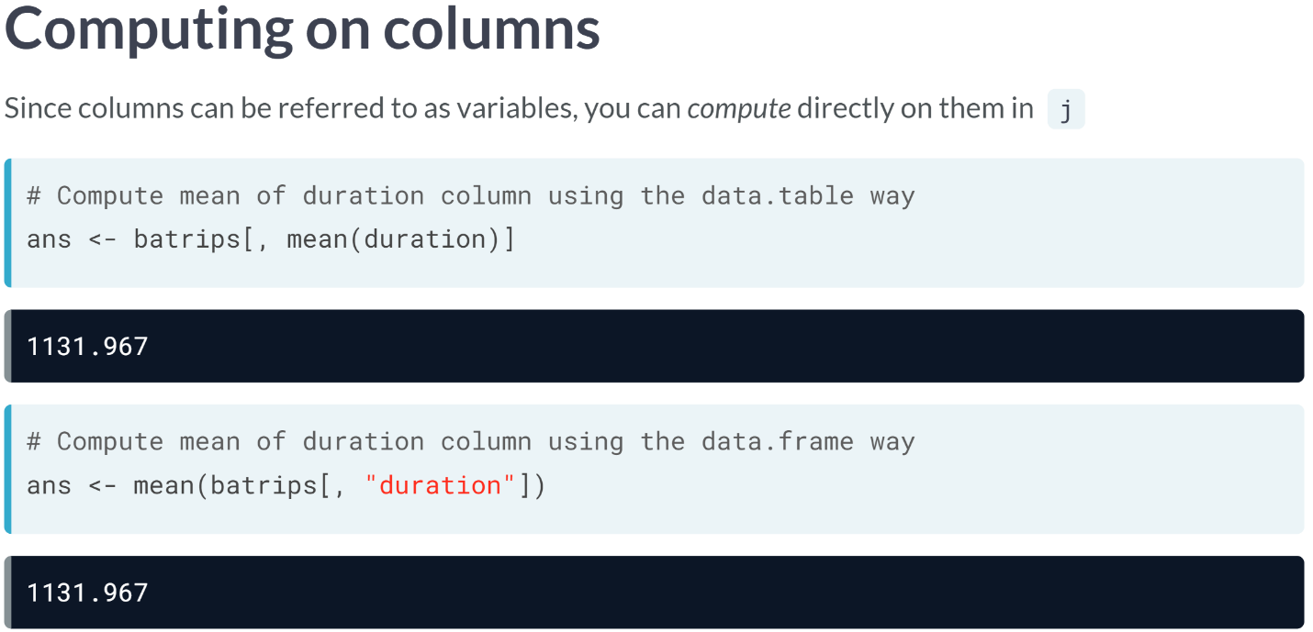  
If you want to compute the mean of "*duration*" column, all you need to do is write "*mean(duration)*" in "*j* ".

Also note that since "j" is not wrapped inside "***list()*** ", the result is a vector.

Now compare this to how you would do this in a data frame way. You will first select the column and then pass the result to the ***mean()*** function as an argument.

The data table way of computing directly on columns allows for clear, convenient, and concise code and can be easily extended to calculate statistics on multiple columns.  
  
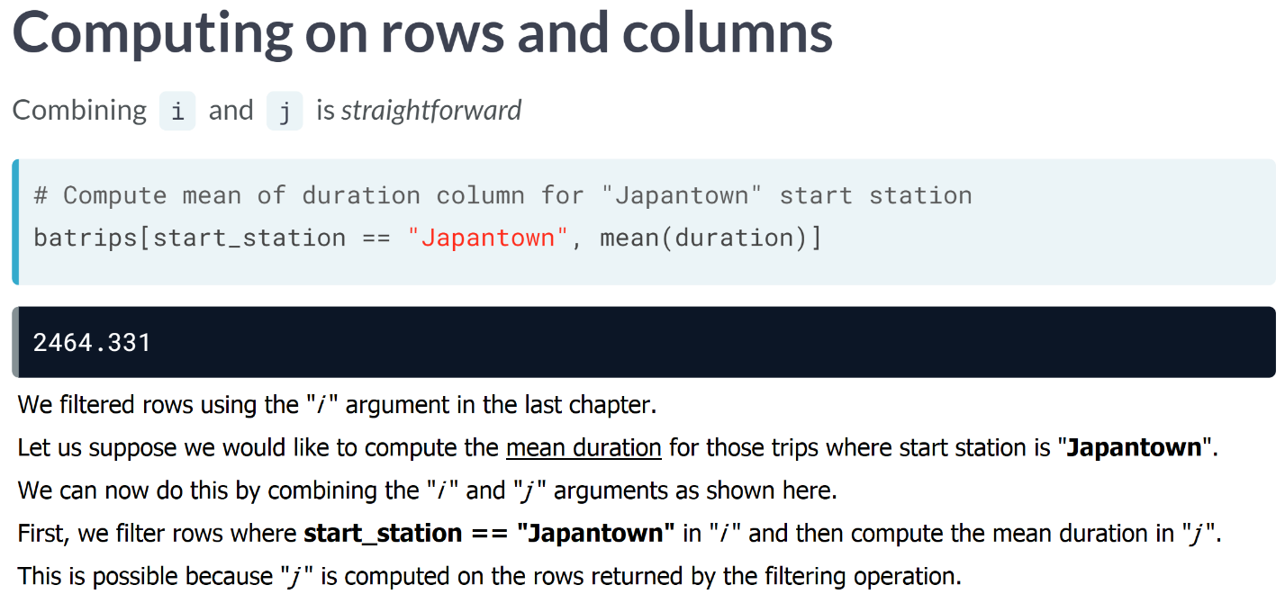

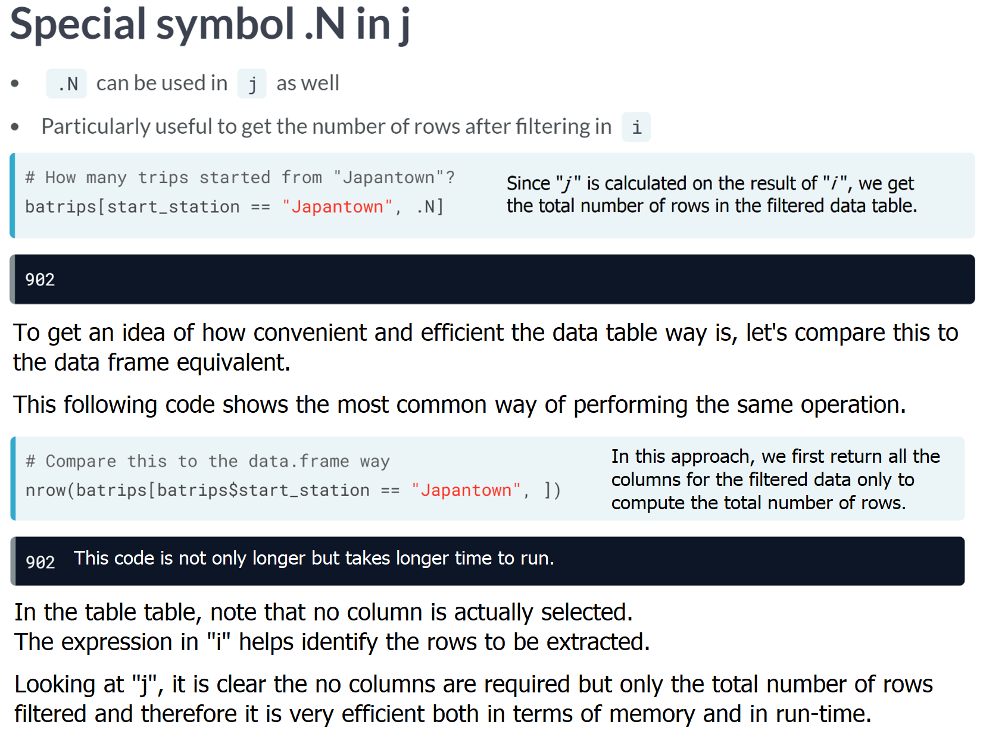

# Computing in j (I)

Since columns can be treated as variables inside data.table's square brackets ([ ]), you can compute on the columns directly in j.

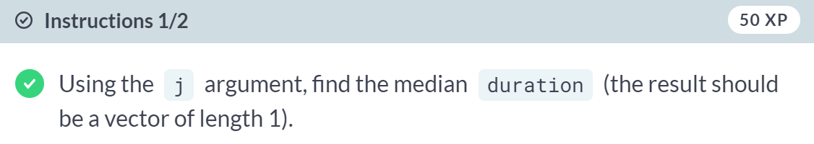  
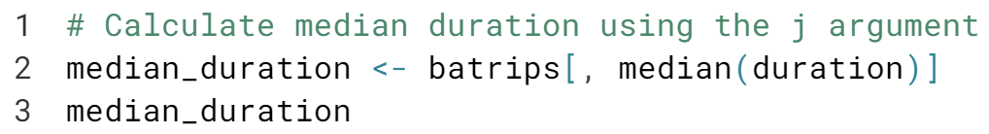  
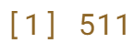

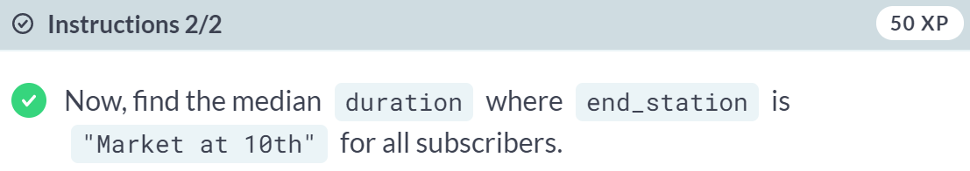  
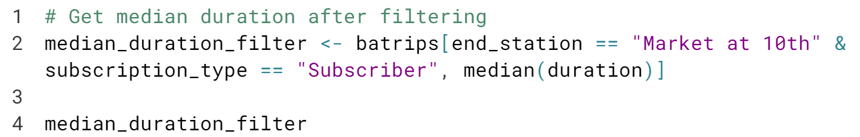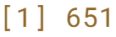  
  
You are fabulous! Remember that **data.table** first filters the rows in *i* and then computes in *j* .

# Computing in j (II)

In the last exercise, you performed computations in j which returned only a single value, a vector of length one. However, you often perform computations which return more than one value. The good news is that the syntax for these calculations is still the same!

You will use the [**difftime()**](https://www.rdocumentation.org/packages/base/topics/difftime) function in this exercise to calculate the difference in minutes between the trips. difftime() needs two required arguments, time1 and time2 to calculate the difference (time1 - time2). To calculate the difference in minutes, set the units argument to "min":

date1 <- "2018-12-20 11:30:00 EST"

date2 <- "2018-12-20 11:20:00 EST"

difftime(date1, date2, units = "min")

Time difference of 10 mins

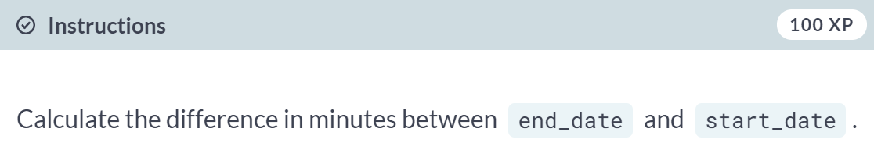

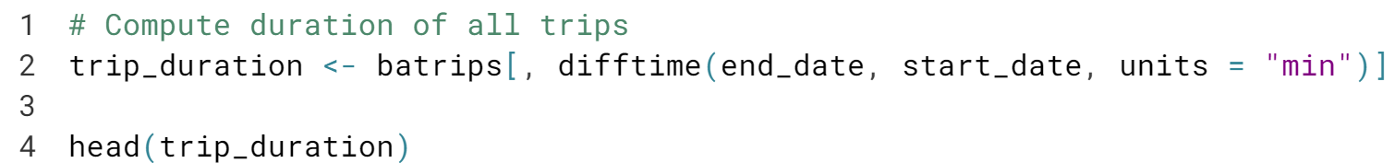

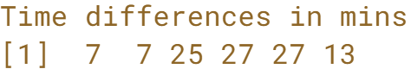

Isn't this amazing? You can perform any computations you want inside *data.table* 's square brackets.



Let's now explore how we can perform multiple computations in "j".

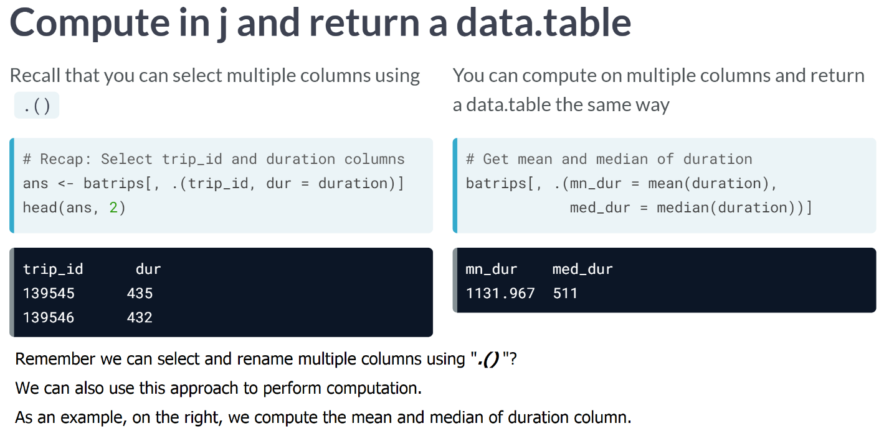

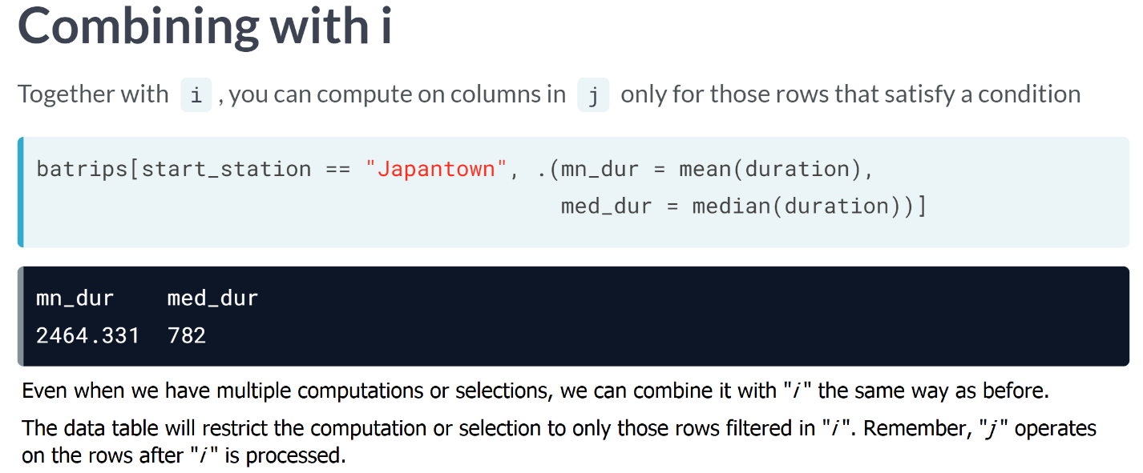

# Computing in j (III)

In the previous exercise, you were able to pass expressions in j that returned a vector. Recall that if you want to return a data.table instead, wrap the expression with list() (or it's alias, .()). This lets you:

* Rename the column result
* Compute more than one expression on a column
* Compute on more than one column

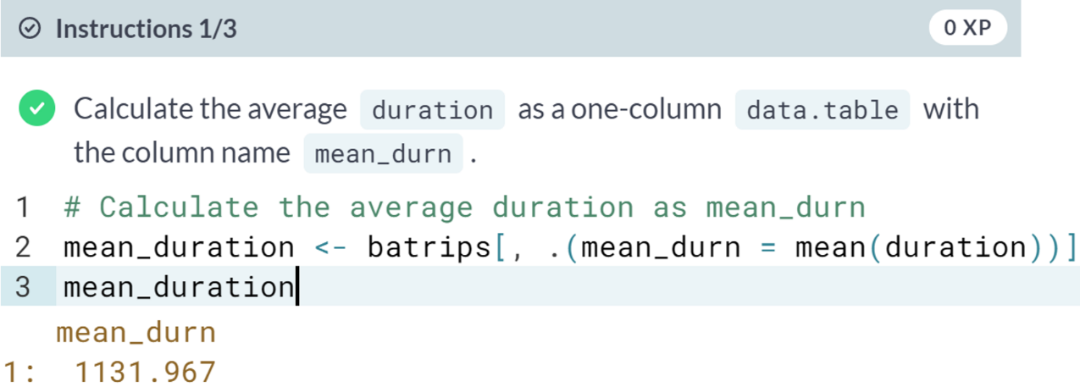  
  
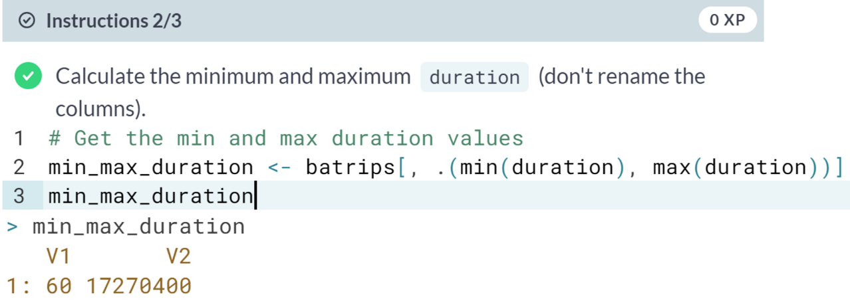  
  
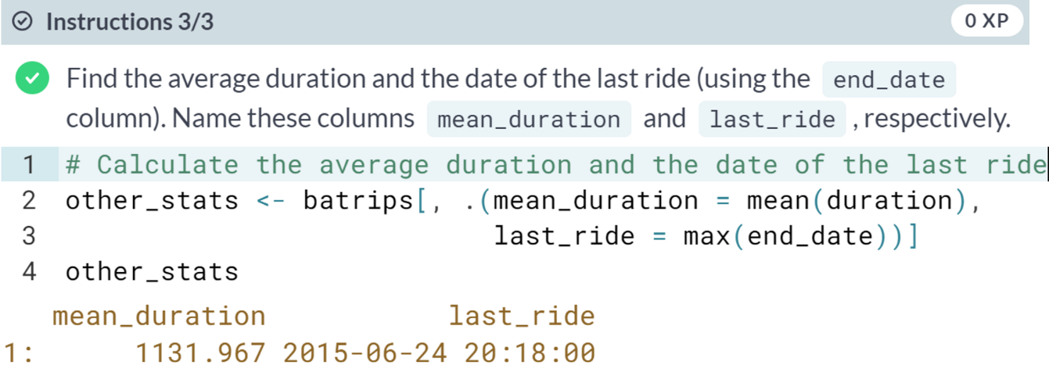

# Combining i and j

As you saw in an earlier exercise when you combine i and j, data.table first filters the rows in i and then applies the computation in j. This applies when calculating multiple stats as well.

Additionally, you can also specify plot(), hist() or any other plotting functions in the j argument.

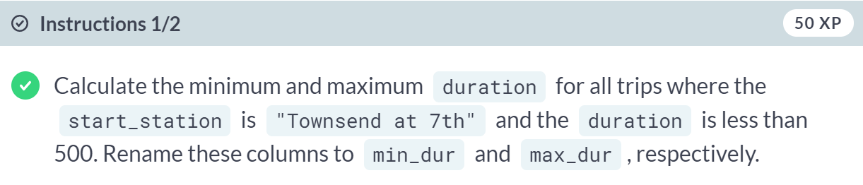  
  
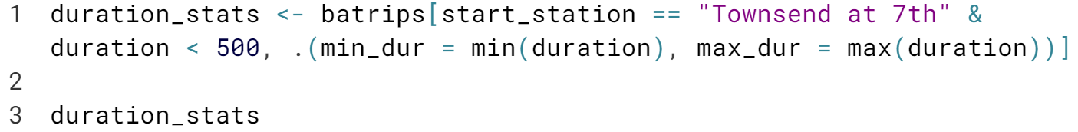  
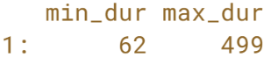

  
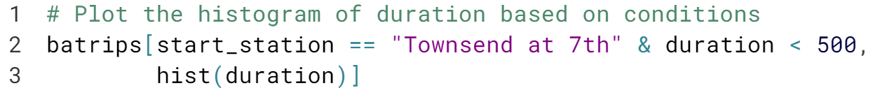  
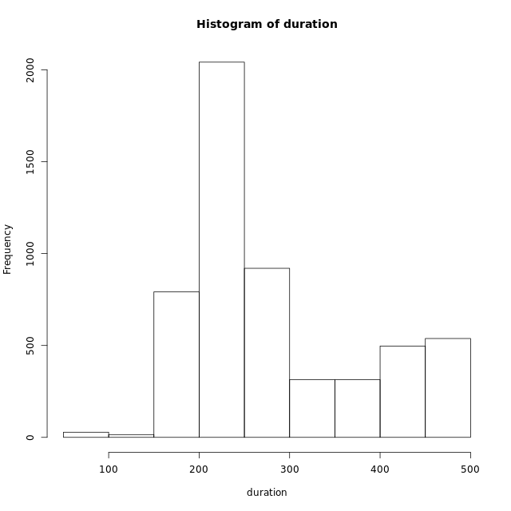  
You are doing great! You can filter rows, select columns, and perform computations with columns. What's next? Computations by groups!

**Groupwise Operations**This chapter introduces data.table's *by* argument that lets you perform computations *by groups*. By the end of this chapter, you will master the concise **DT[i, j, by]** syntax of data.table.



In this lesson, we will put together all the things we have seen so far to perform computations by group. You will now fully realize the potential of data table's [i, j, by] syntax.  
  
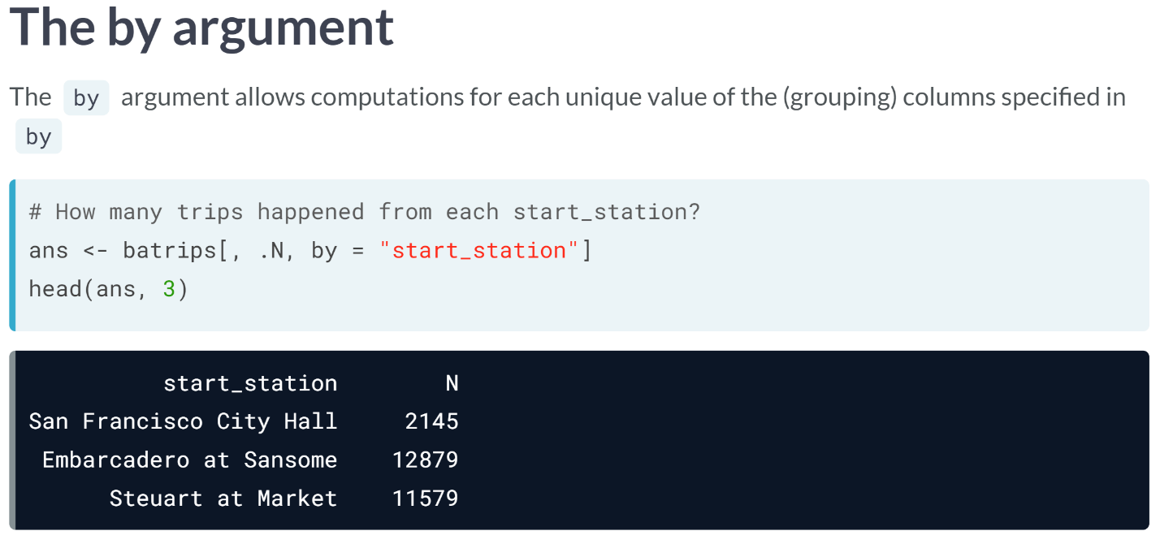  
Most data wrangling tasks require doing the same computation on several groups of data. For example, how would you calculate the total number of trips for each *start_station*?

This can be done using the "by" argument data table provides. Specifying by equals *start_station* groups the data by that column.

The expression in "j", here, **.N** is computed for each group; **.N** is the special symbol that contains the total number of rows, if we recall. When performing a grouping operation, it contains the number of rows for each group. Note the columns in the resulting data table.

Firstly, the column corresponding to the total rows computed using the special symbol **.N** is automatically named capital "N", for convenience.

Additionally, the column used in "by" is retained in the result. Also note that the column by which you group the data is always returned as the first column.

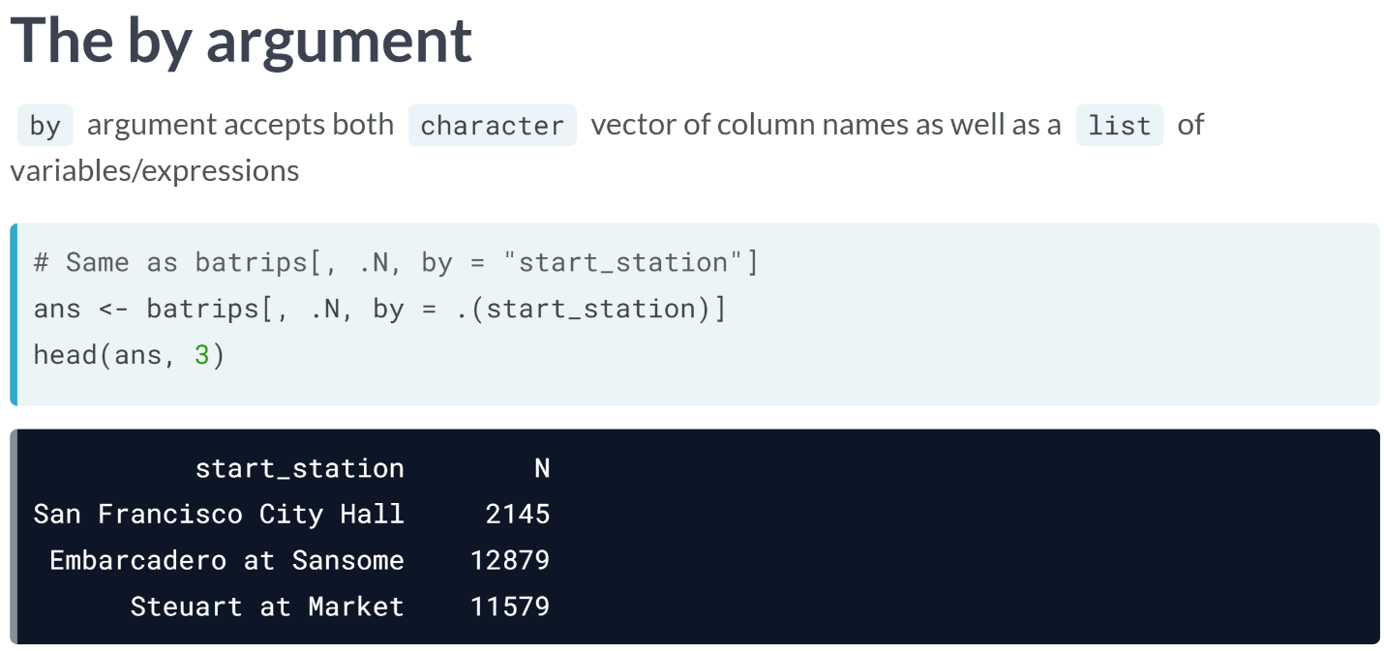  
**.()** and **list()** are both identical. ***by = "start_station"*** and ***by = .(start_station)*** are just two different ways to obtain the same result.  
  
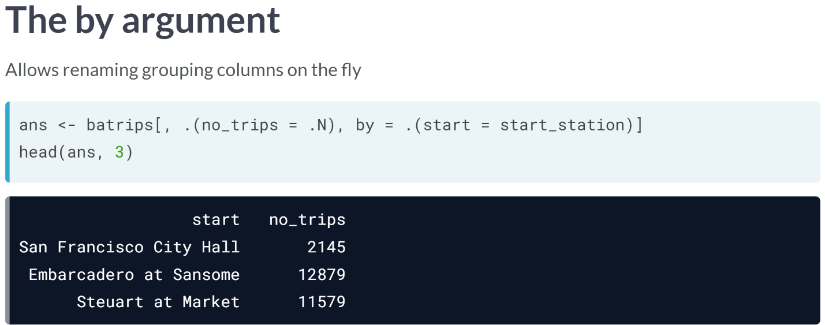  
***.()*** has some advantages, though, as we saw in the previous exercises.

It allows for naming the columns in the resulting data tables on the fly.

As shown here, ***by = .(start = start_station)*** results in the grouping column being named to "*start*". Similarly, **.N** is named as "*no_trips*".

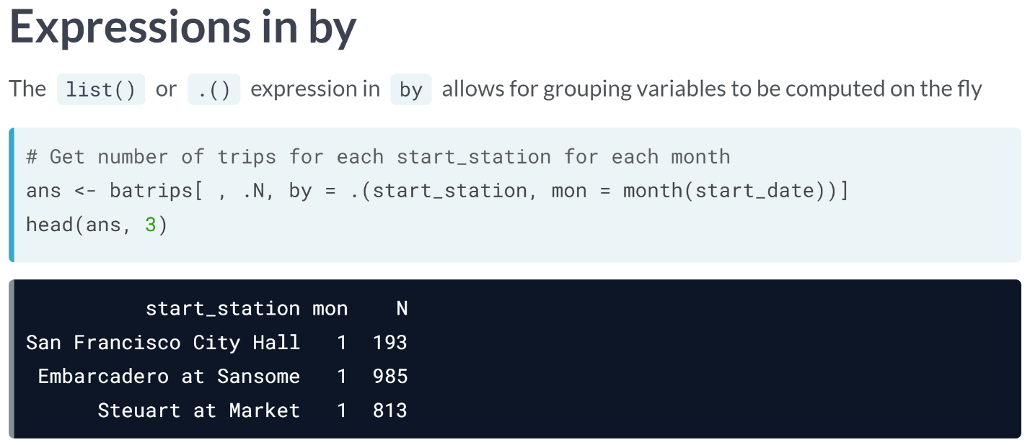  
Since ***.()*** allows for expressions to be provided directly within, **.(start_station, mon = month(start_date))** groups by required columns.

In addition, we also renamed the column in the result to "*mon".* With a single line of code, we've computed the total trips for each start station for each month.

# Computing stats by groups (I)

So far you have worked with the two dimensions, rows and columns of a data.table. It's now time to consider the virtual third dimension by dividing rows into groups to calculate statistics.

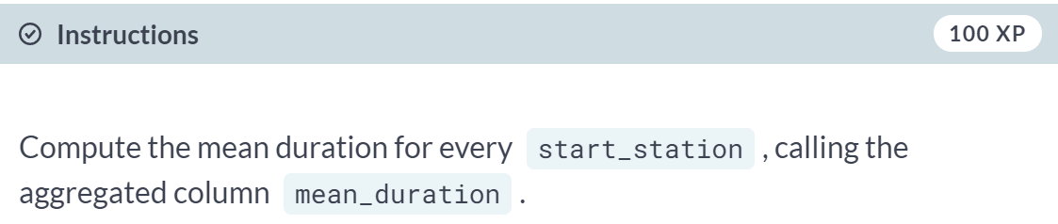  
  
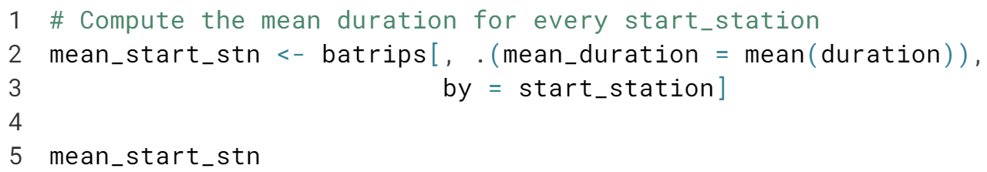  
  
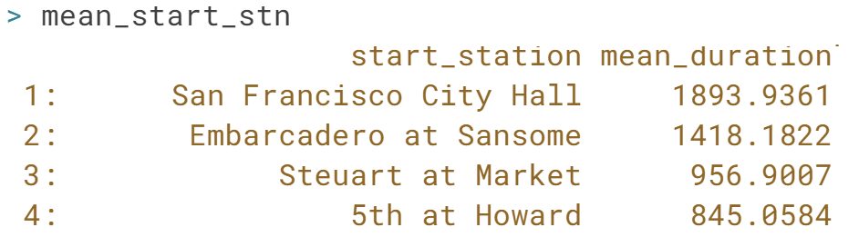

# Computing stats by groups (II)

When grouping a data.table by multiple columns, you need to specify the by argument as either a character vector or a list. In this exercise, you will calculate the mean of duration for:

* Each unique combination of start_station and end_station
* Each start_station for each month

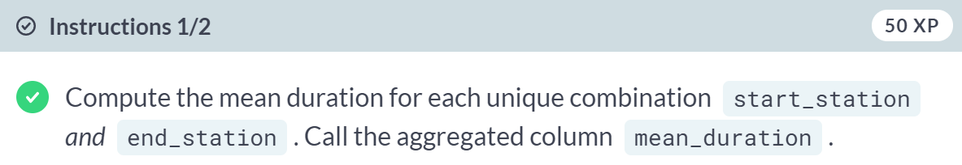  
  
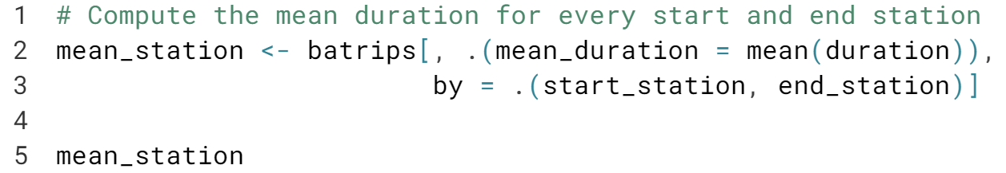  
  
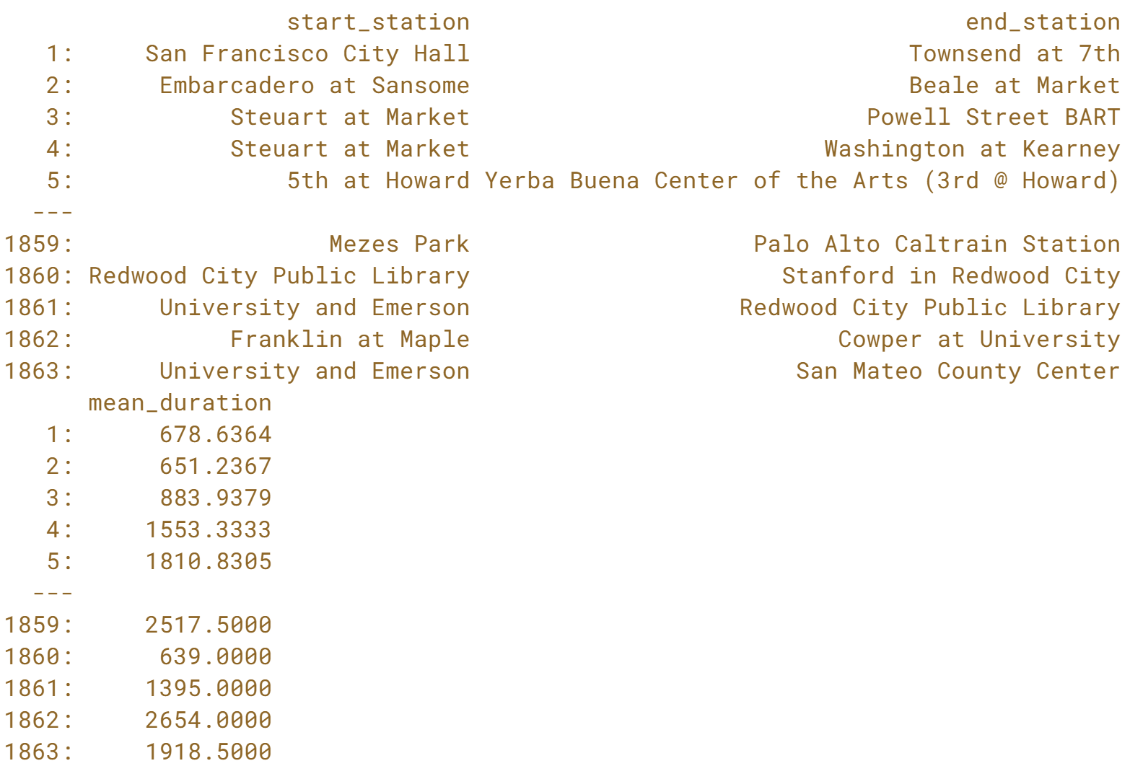

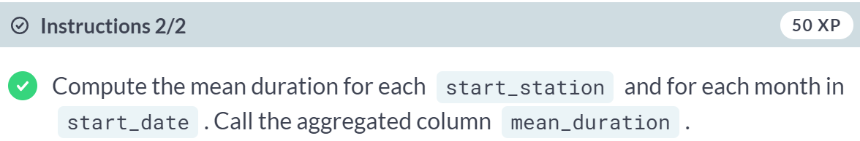

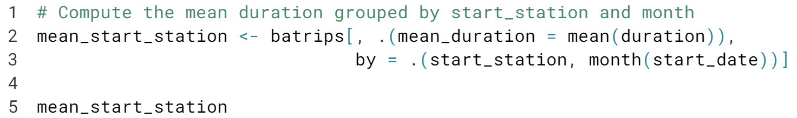

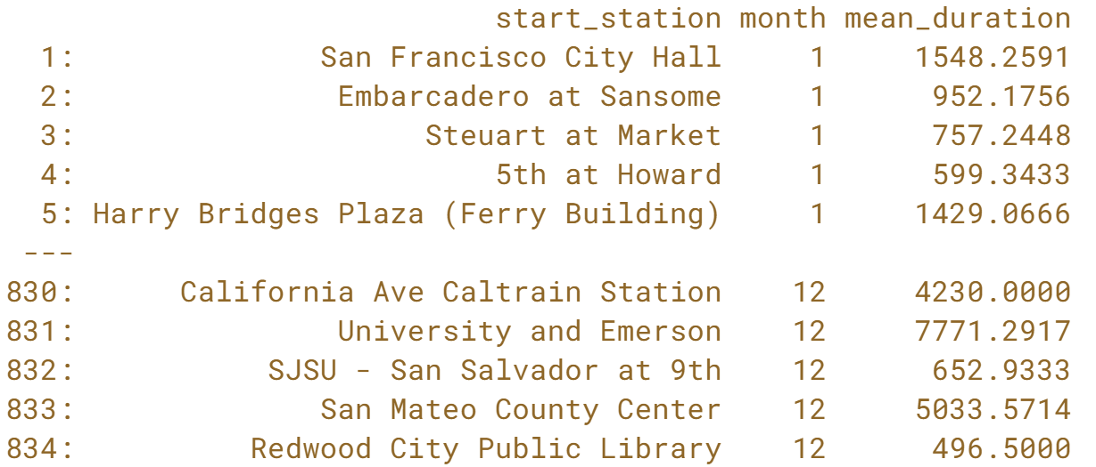

# Computing multiple stats

Let's now combine everything from the past two exercises to find multiple summary statistic with multiple groups in batrips.

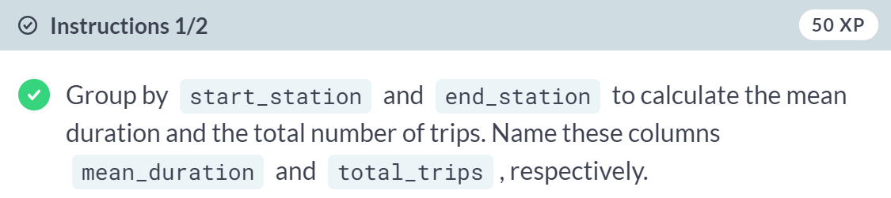

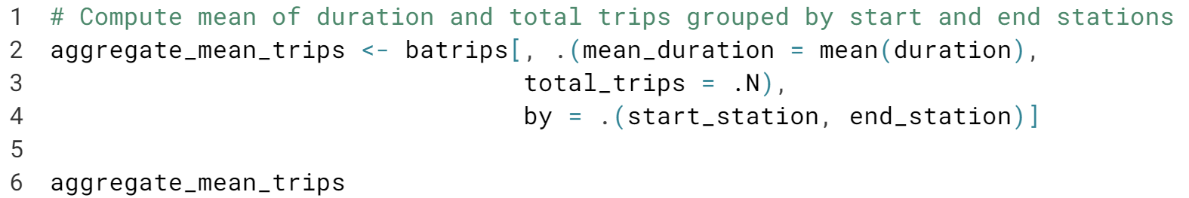

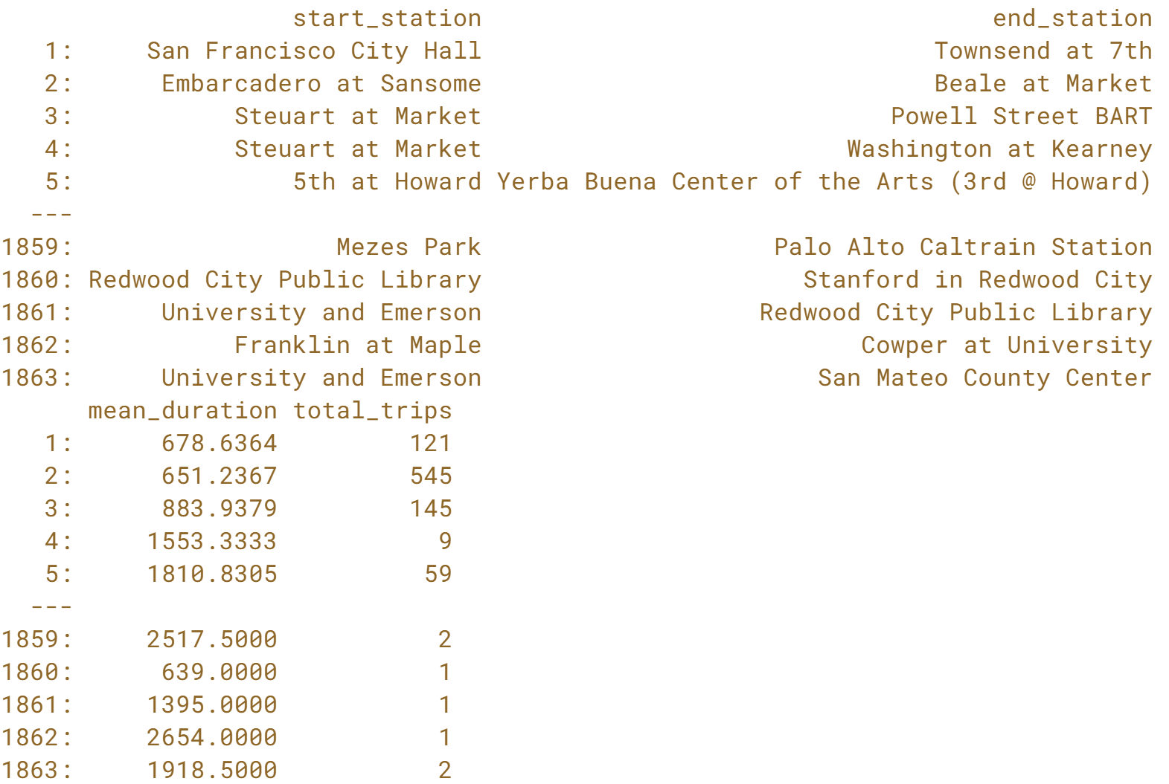

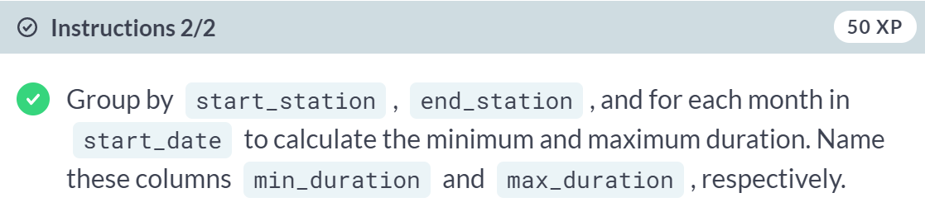

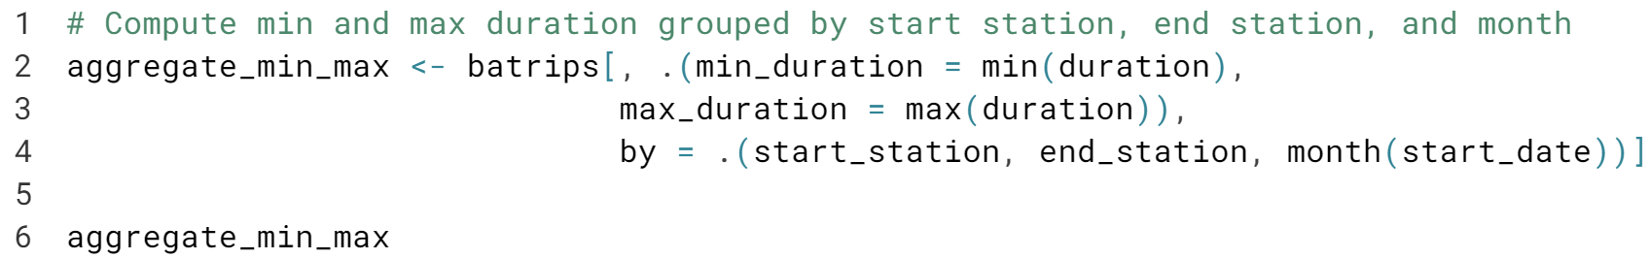

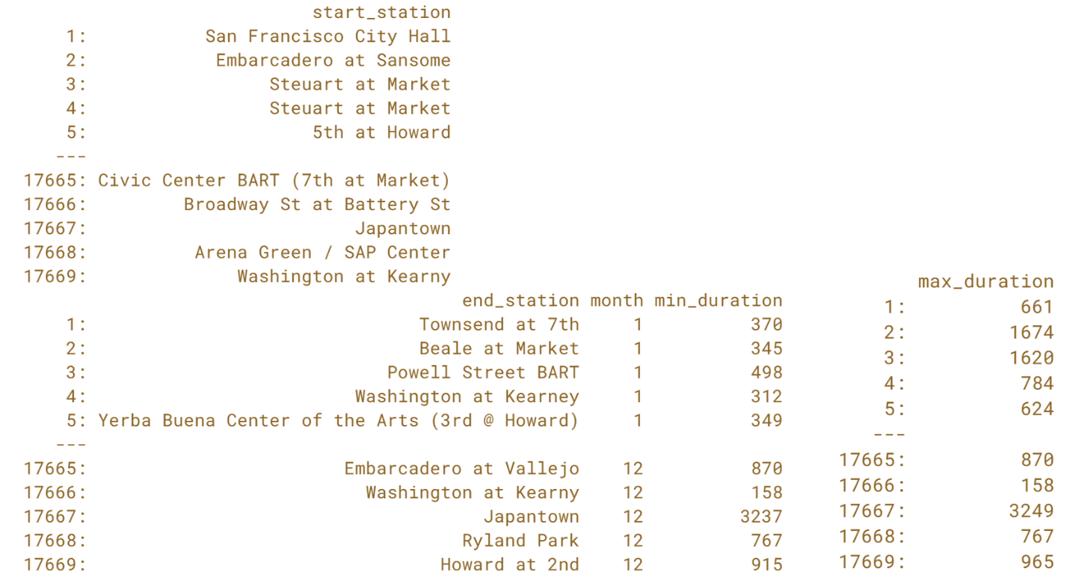  
You are tremendous! In the next lesson, you will learn how to chain **data.table** expressions to avoid intermediate objects.



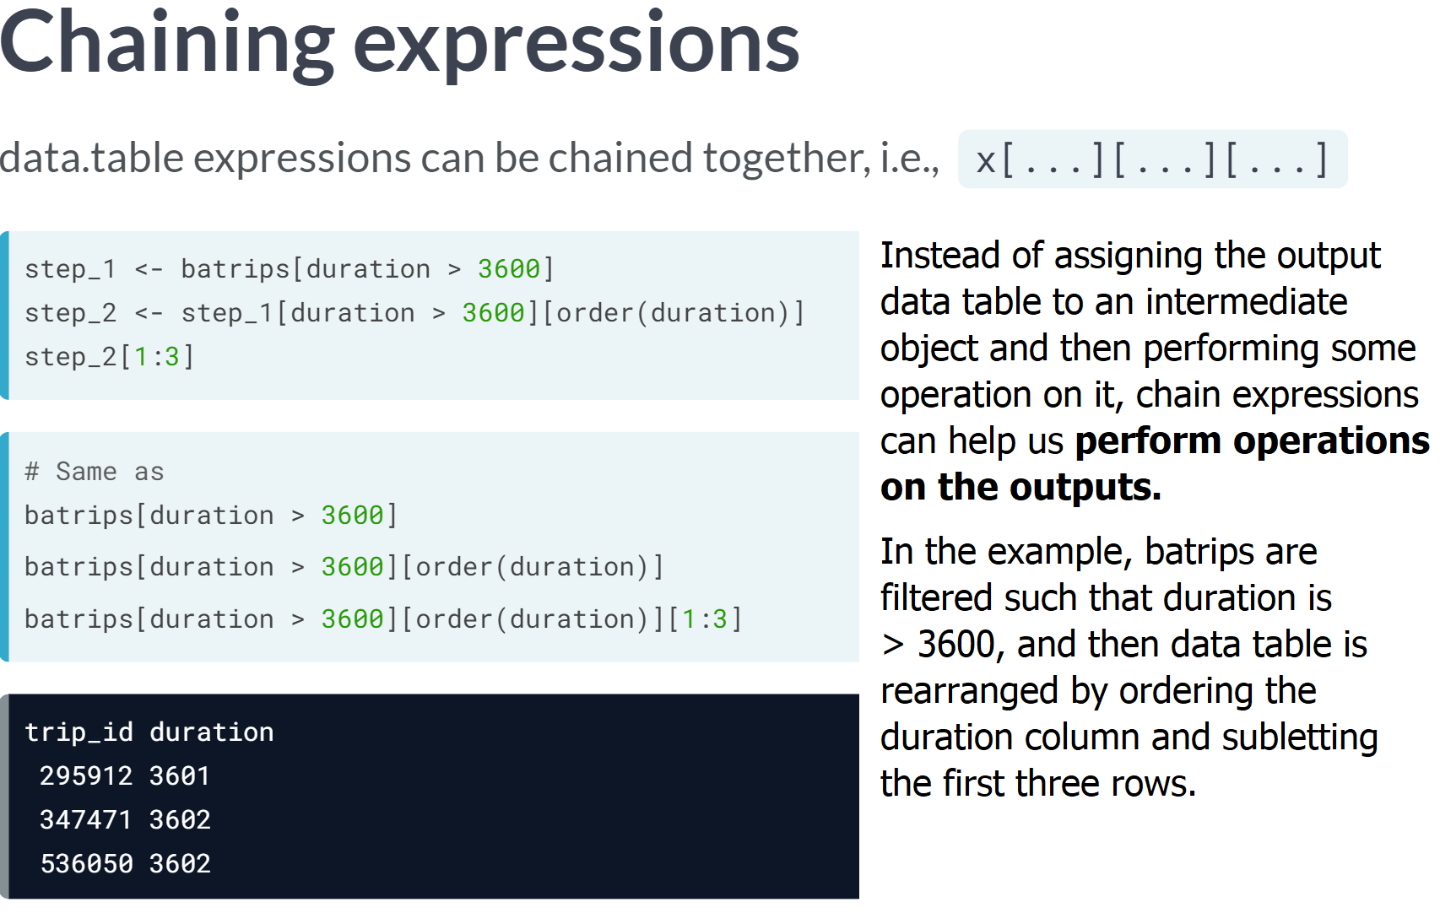  
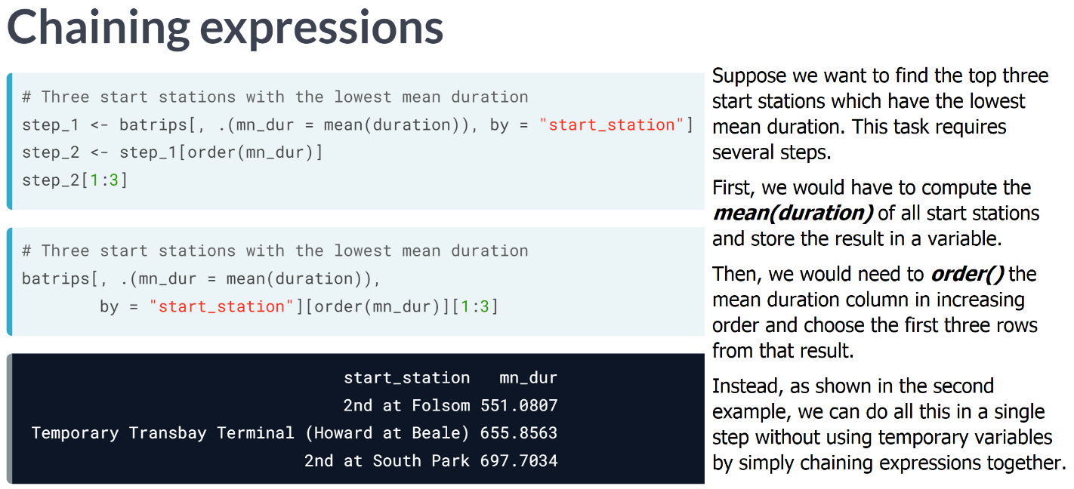

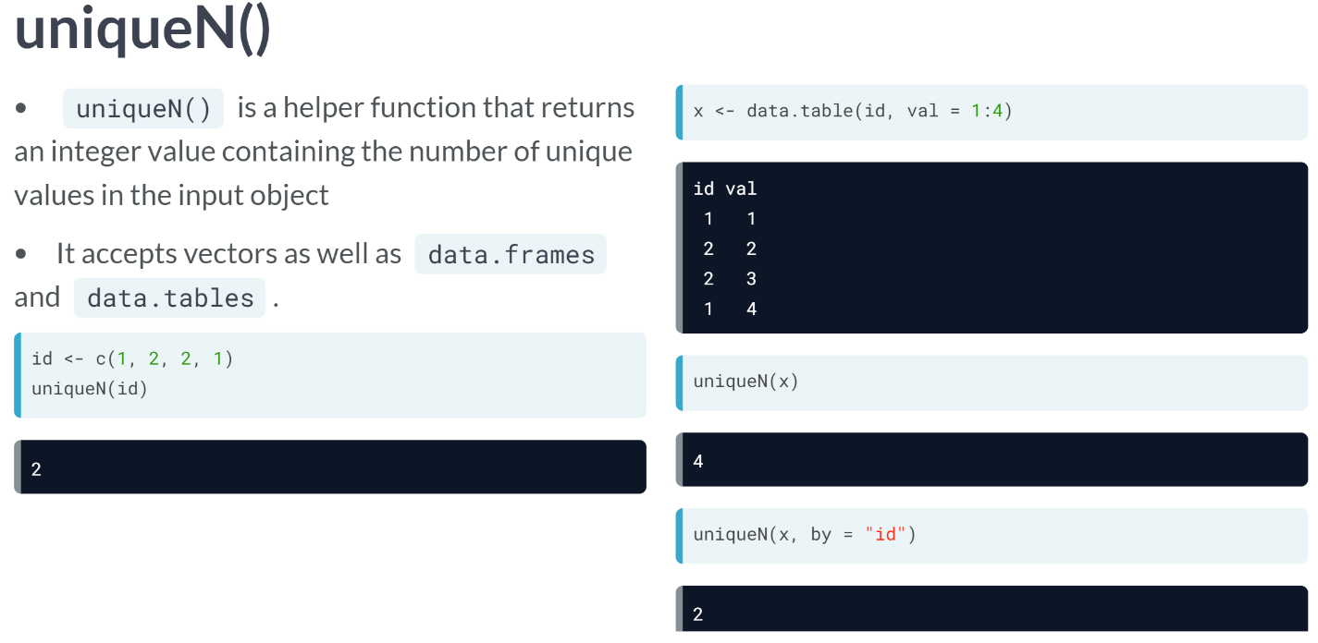  
***uniqueN()*** from data table simply returns the count of unique elements of the input object. It works on vectors, data frames, and data tables all alike. When you pass a data table to ***uniqueN()***, it looks at all the columns by default. Since there are no duplicate rows, the result is 4, which is the same as the total number of rows in X. You can also use the by argument in the ***uniqueN()*** to find the number of unique values in a specific column of a data table.

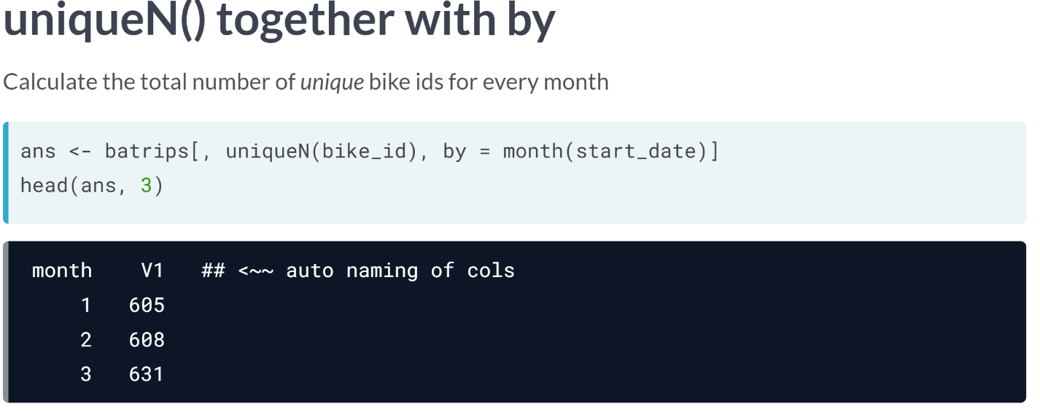  
Let's say we'd like to compute the number of unique bike ids for each month. We do this by first groping batrips by month. Remember that we can use **month()** function on the start_date column in the "by" argument to do this. Then you can use the **uniqueN()** function on *bike_id* in the "*j* " argument, thus calculating the number of unique bike ids for each month.

# Ordering rows

Ordering aggregated data is quite a common operation. This can be elegantly accomplished by simply chaining data.table expressions together.

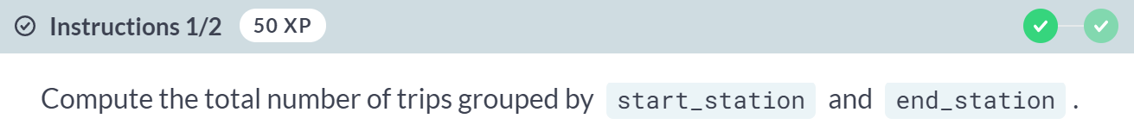

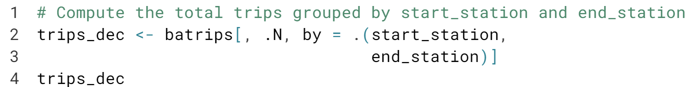

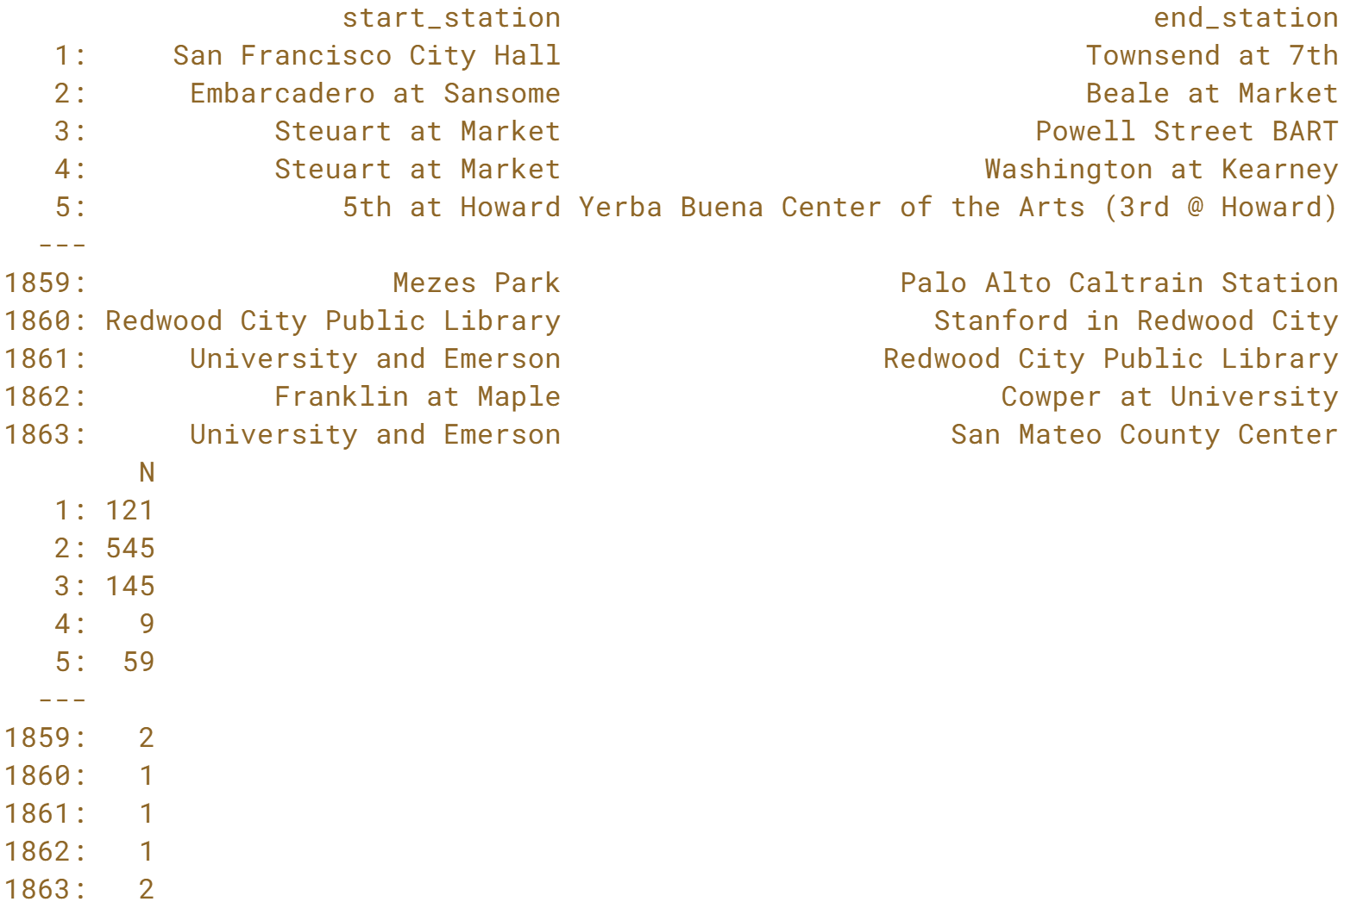

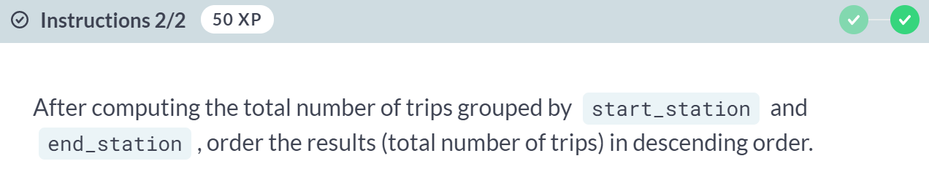

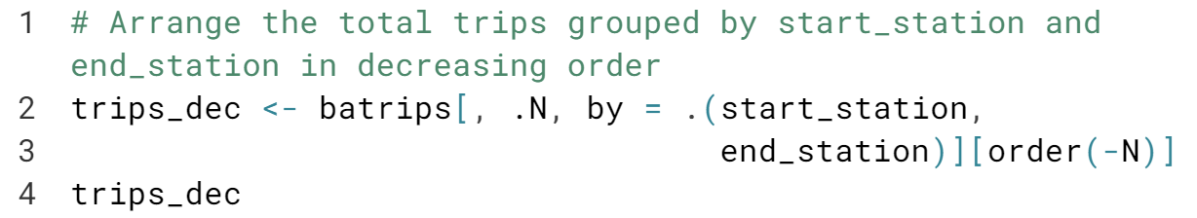

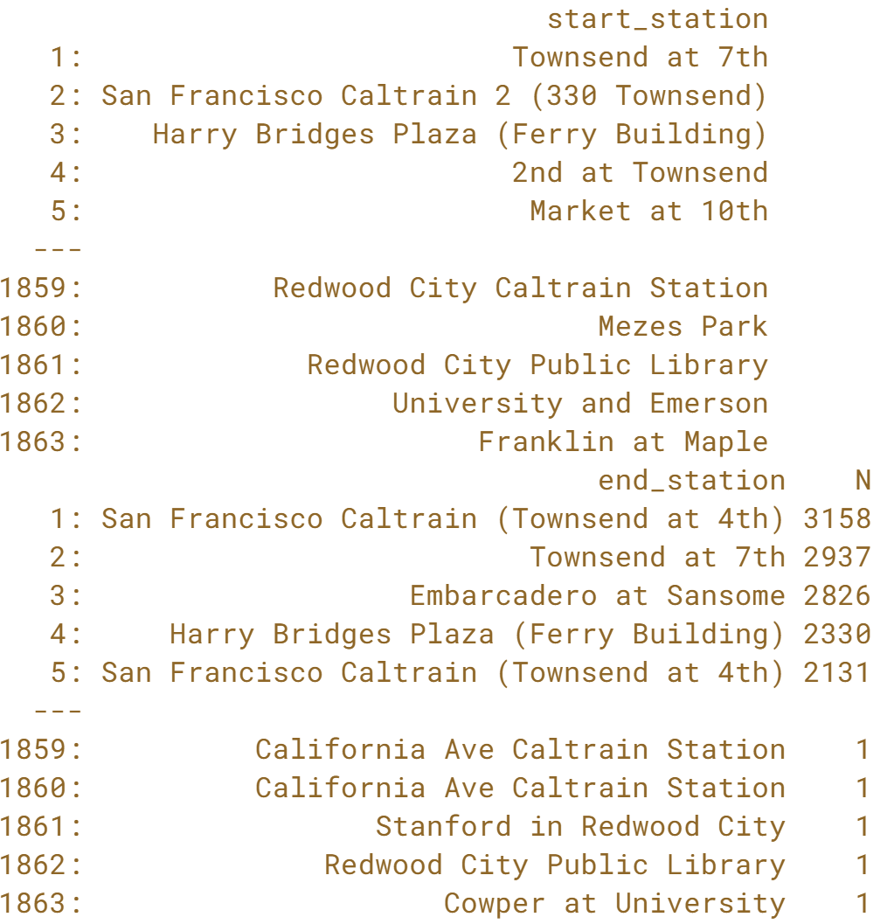

# What are the top 5 destinations?

When analyzing data, it is often useful to know the key top/popular stats such as the most popular cities or the most famous restaurants etc. In this exercise, you will find the five most popular destinations (i.e., the five most popular end_stations).

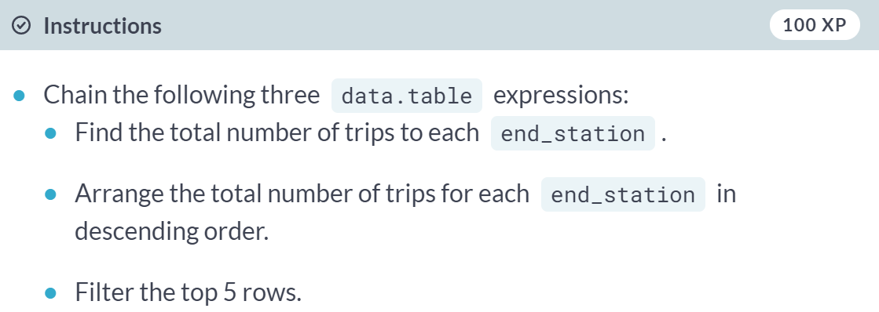

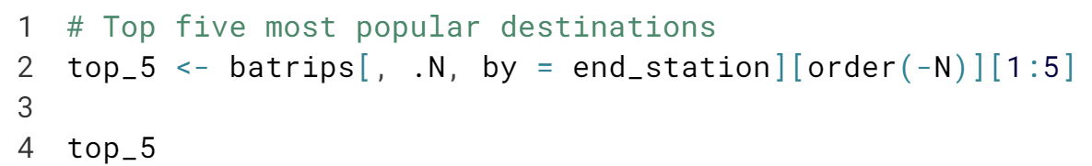

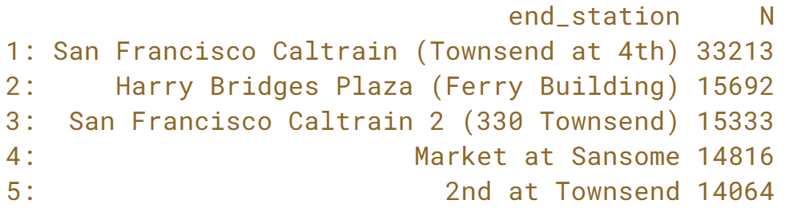

Brilliant! Data Scientists answer questions like these every day. Let's see if you can answer a slightly complicated one.

# What is the most popular destination from each start station?

In the last exercise, you created trips_dec, which consists of the total number of trips grouped by start_station and end_station in descending order. This gives you an opportunity to calculate the most popular end station for each start station. You can do this by simply extracting the first end_station for each start_station.

trips_dec is available in your workspace.

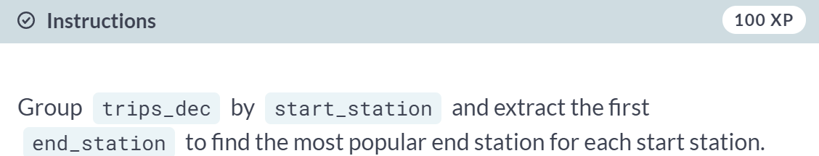  
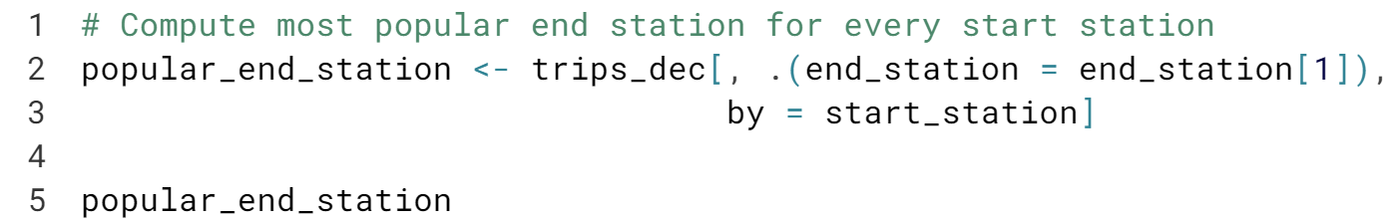

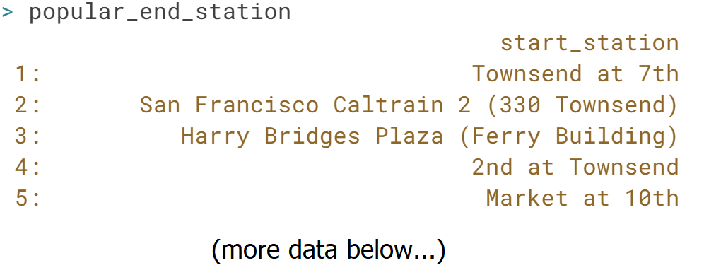

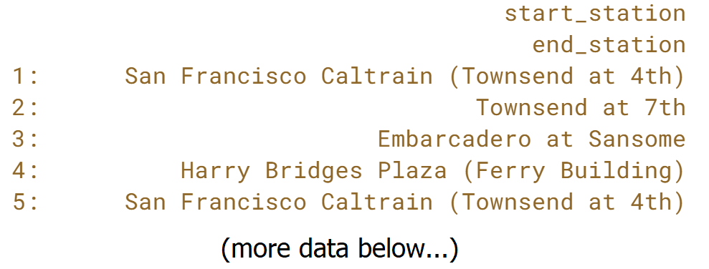

Nicely done! You are on your way to mastering data.tables. In the next exercise, we will combine the three important arguments of data.table, *i*, *j*, and *by* in one operation.

# Combining i, j, and by (I)

In this exercise, you will combine the i, j, and by arguments to find the first and last ride for each start station. Recall that data.table first filters the rows in i, and then groups the rows using by, and finally compute the expression in j.

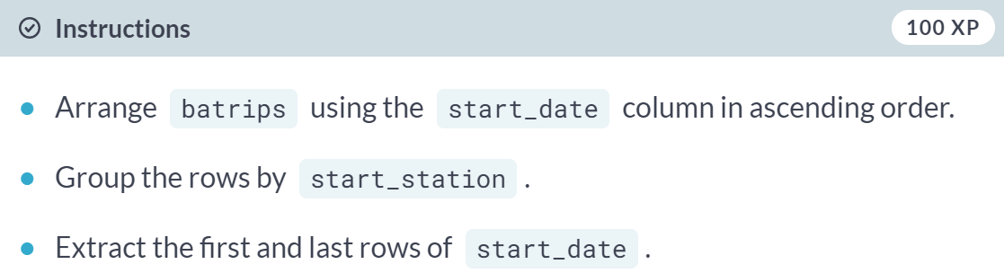

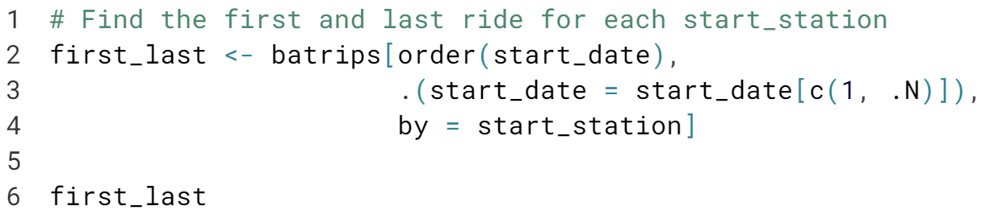

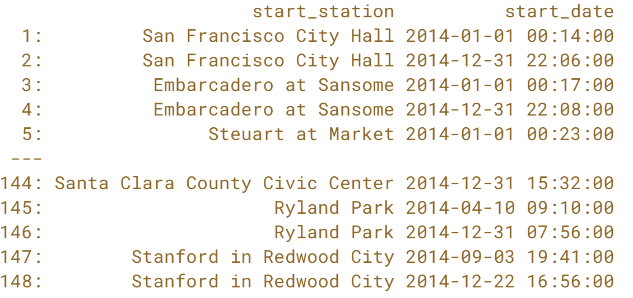  
Whoo! That was quite an involved task, wasn't it? We got it.



We will look at another special symbol, *.SD*, which stands for Subset of Data. It makes computations even easier and powerful as we will see in a moment.

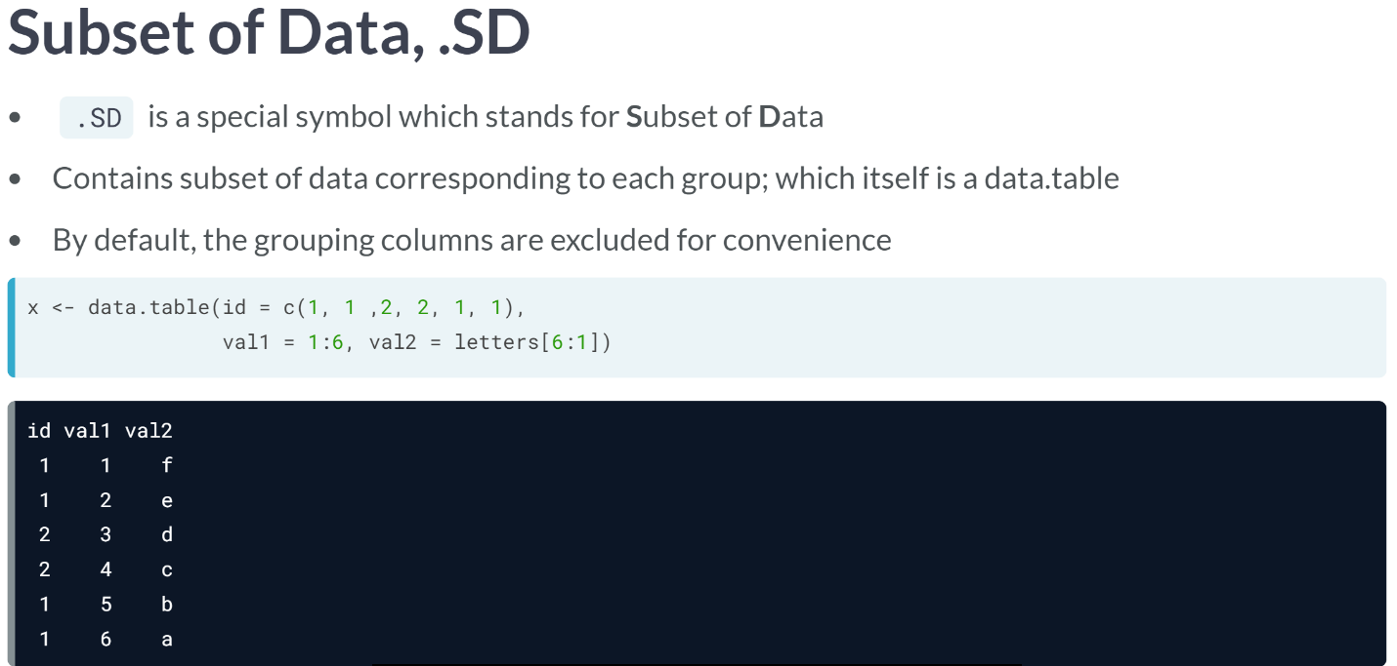  
***.SD*** is an extremely powerful symbol. Understanding it can help us do complex data wrangling in a straightforward manner. When grouping, it holds the intermediate data corresponding to each group while results for that group are being computed. It contains all the columns except the grouping column itself, by default. Let's see ***.SD*** in action using this data table.

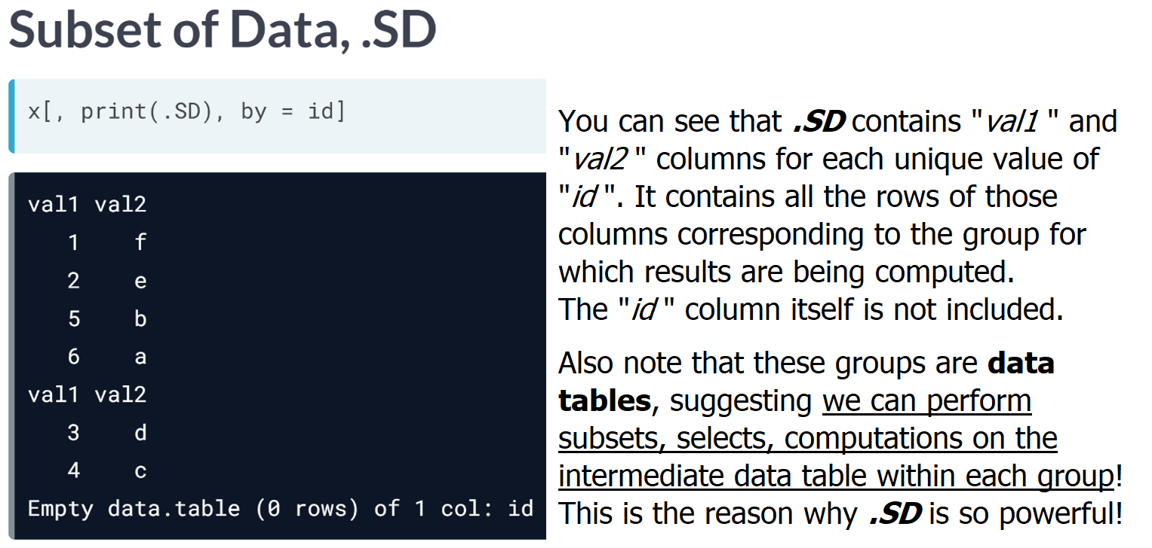

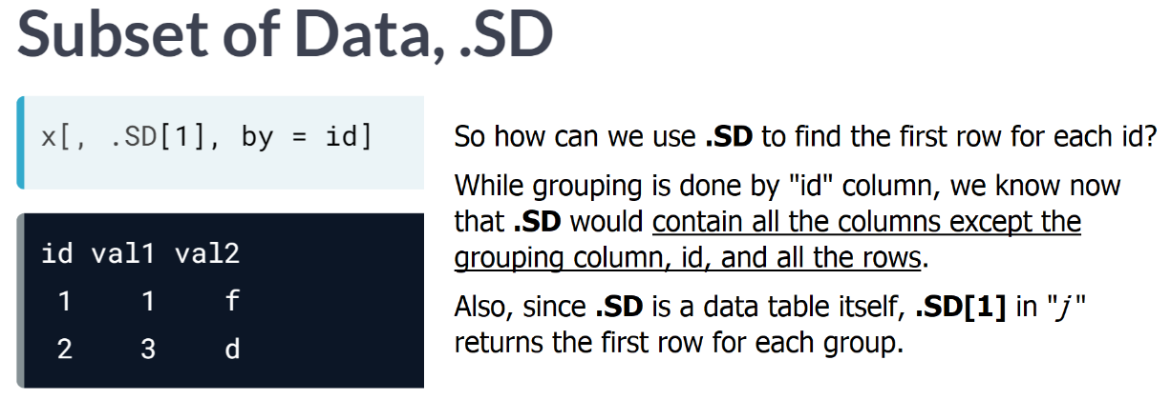  
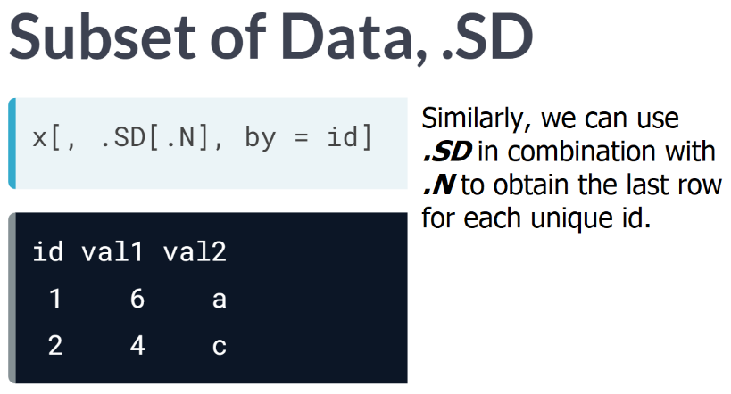  
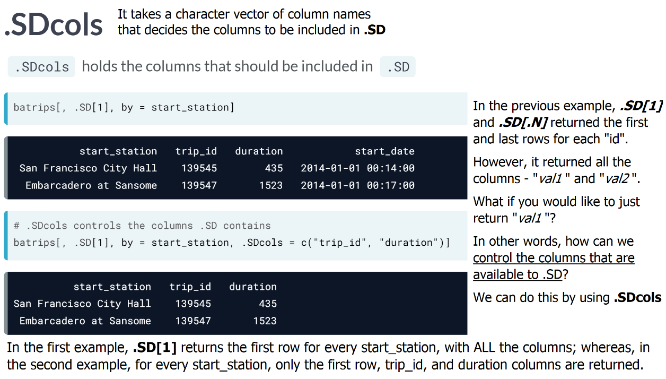  
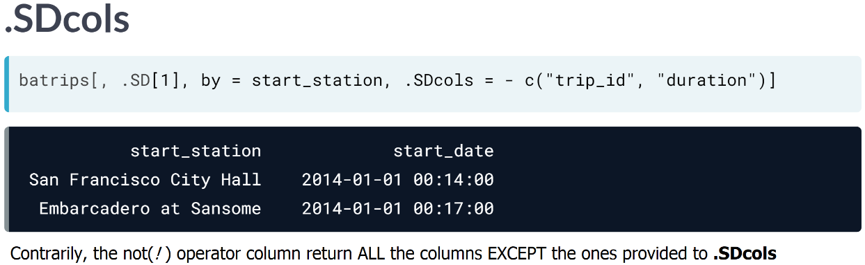

# Using .SD (I)

.SD together with .SDcols is an incredibly powerful feature that makes computing on multiple columns so much easier.

* .SD is a special symbol which stands for **S**ubset of **D**ata
* .SDcols holds the columns that should be included in .SD

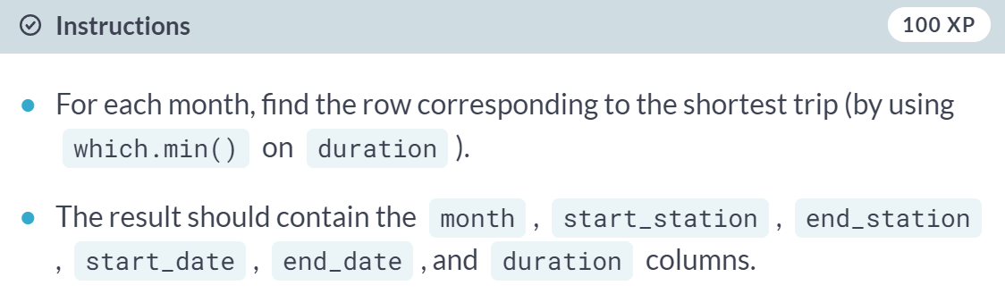

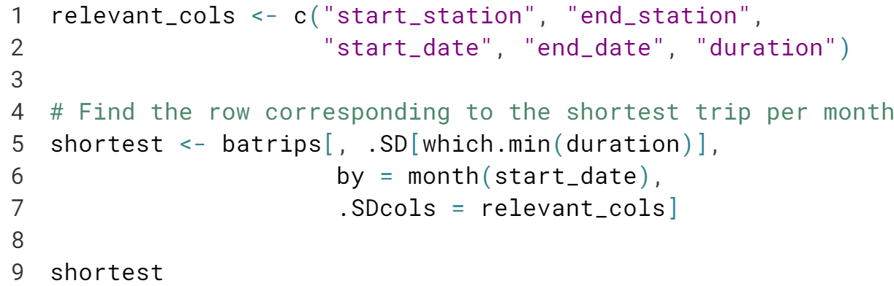  
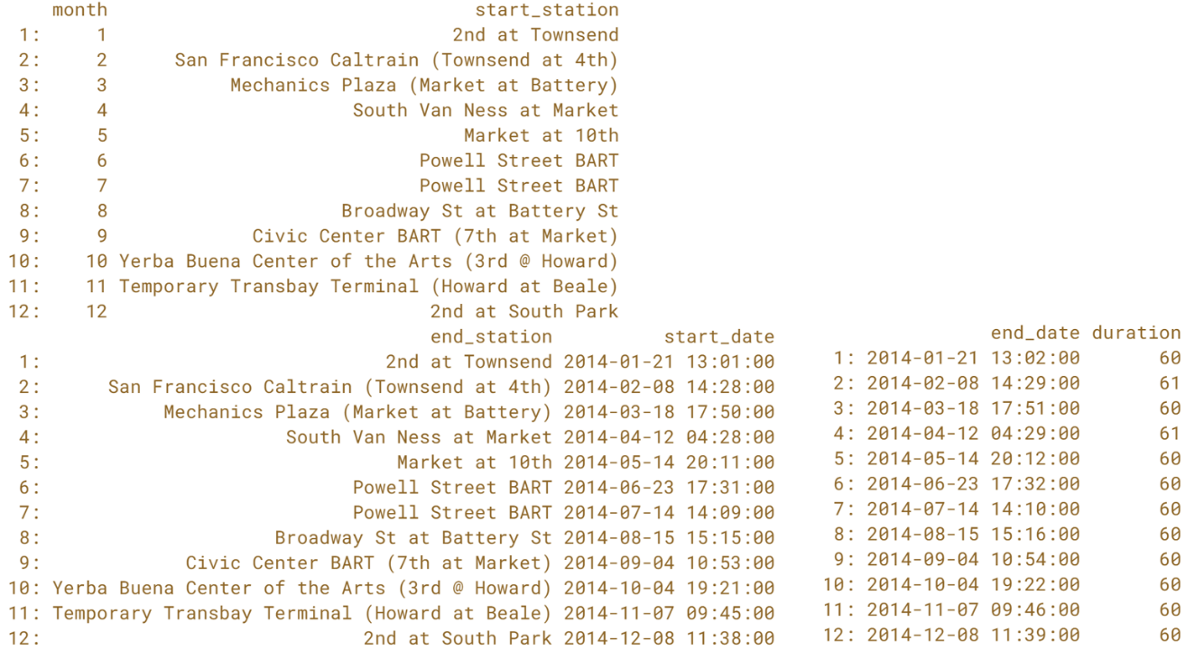  
You are terrific! .SD and .SDcols are especially useful when you are dealing with large data.tables. Do you really know how to use them? Let's find out.

# Using .SD (II)

You can also apply a single function to every column specified in .SDcols using lapply(). In this exercise, you will calculate the number of unique start stations and zip codes for each month using [**uniqueN()**](https://www.rdocumentation.org/packages/data.table/topics/duplicated). uniqueN() returns the number of unique elements in a column/vector/data.table.

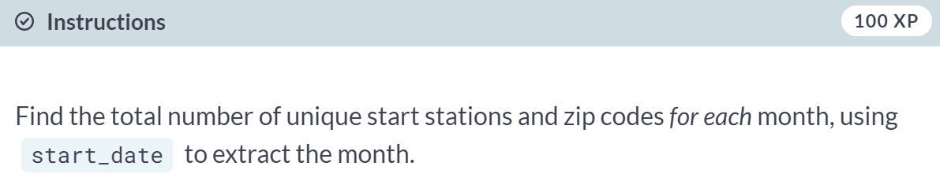

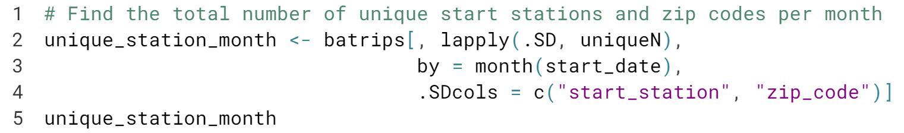

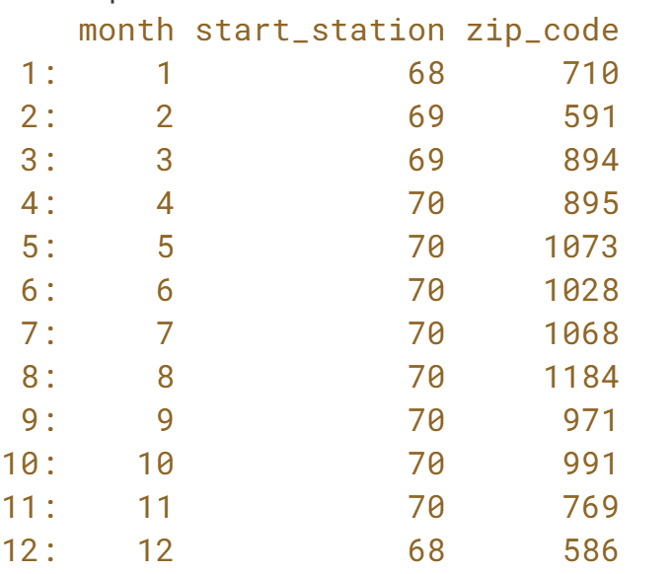

Looks like you know your way around **data.tables**! Well done! However, to truly master the basics of data.table, there is one more thing to you need to know: reference semantics. This will be the focus of the next chapter.

**Reference Semantics**You will learn about a unique feature of data.table in this chapter: modifying existing data.tables in place. Modifying data.tables in place makes your operations *incredibly fast* and is easy to learn.



One of the unique feature of data table is reference semantics, which allows us to add, update and delete columns of a data table in place.

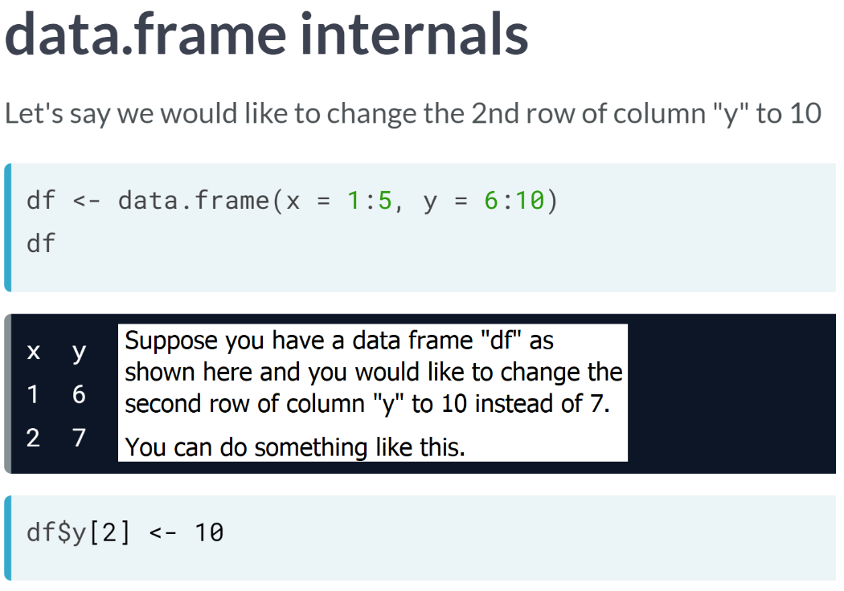  
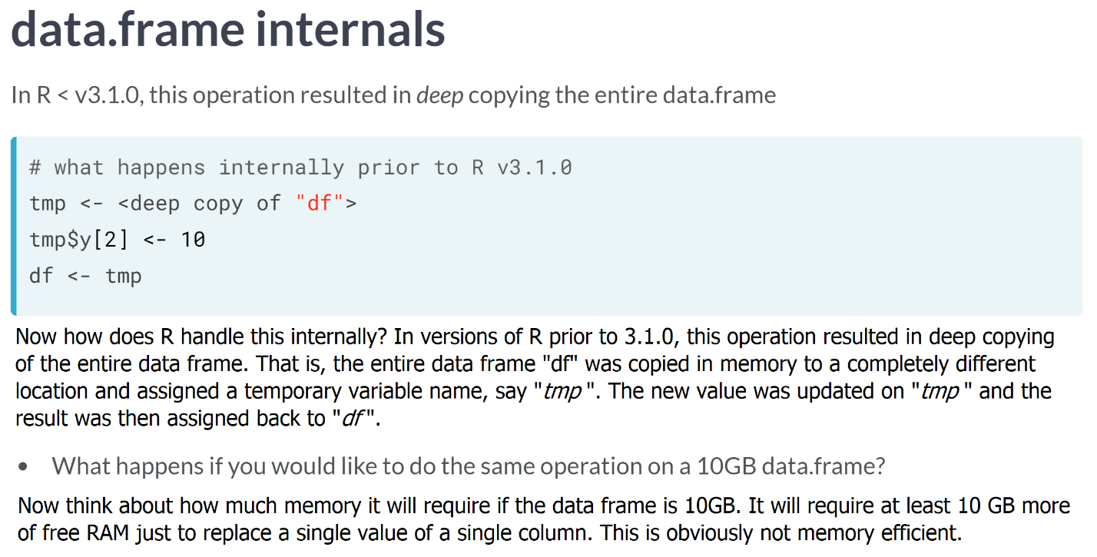

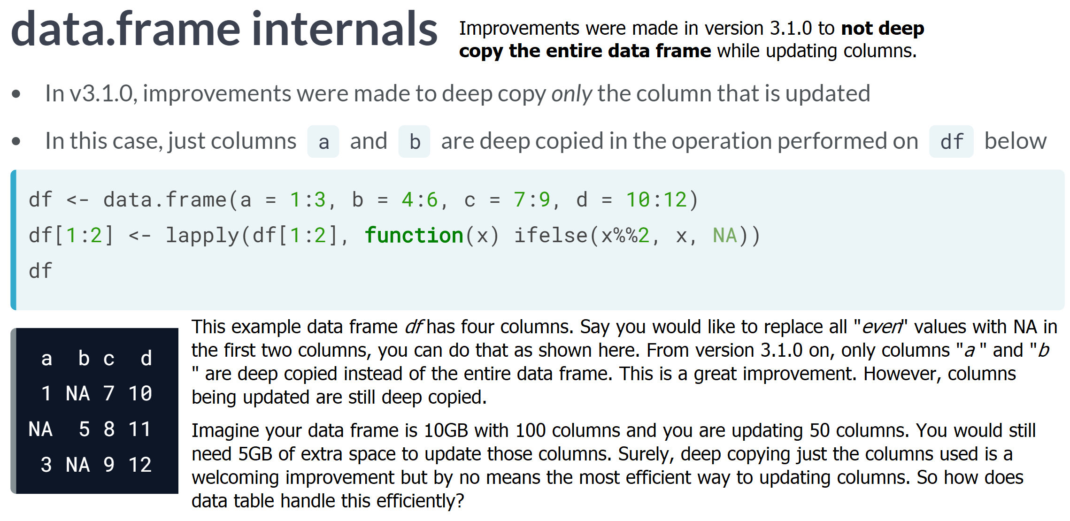

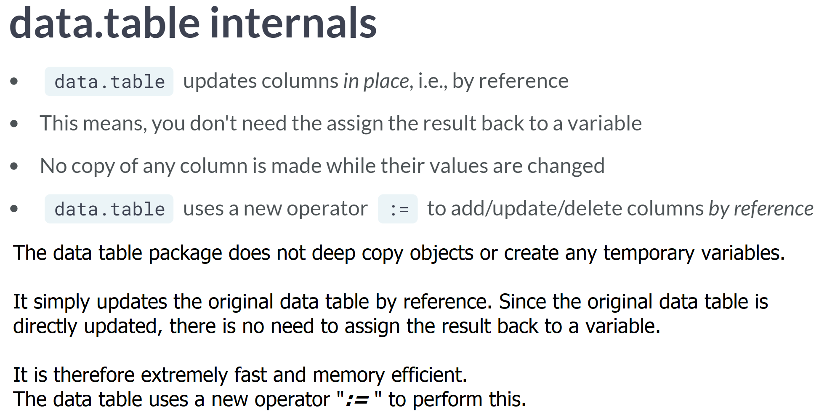

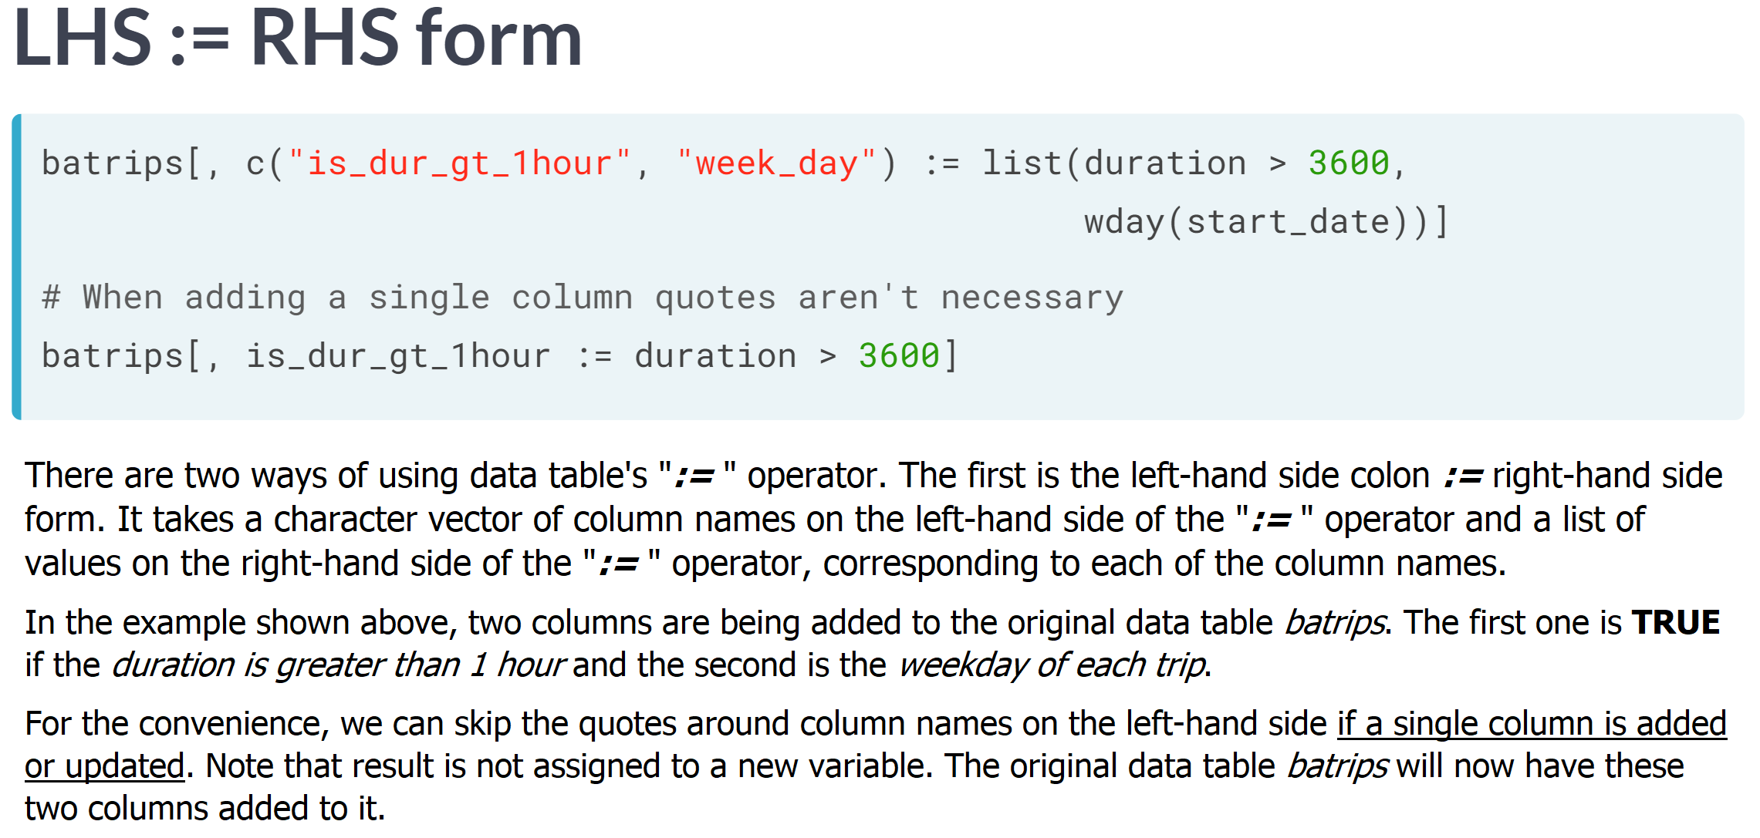

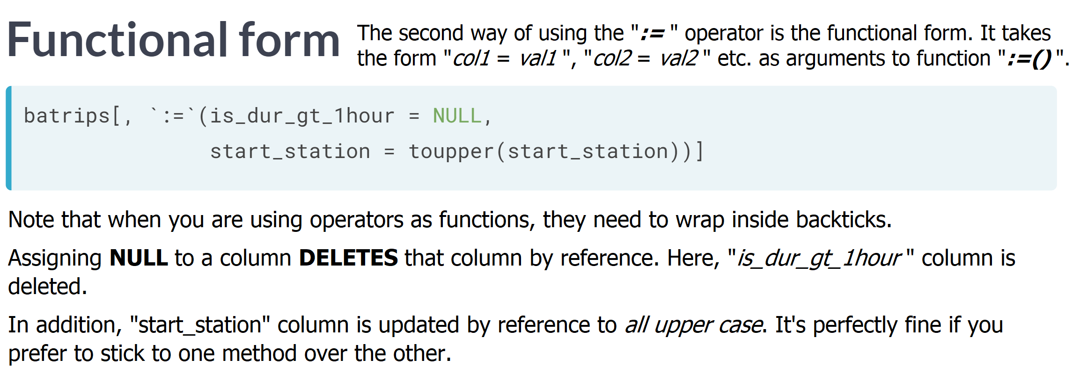

# Adding a new column

As mentioned in the video, data.table does not have to deep copy objects in order to modify them. It can modify objects by reference (inplace) to save memory and runtime using the := operator.

When you update a data.table by reference, you don't have to assign the result to a new object as the original data.table is modified directly.

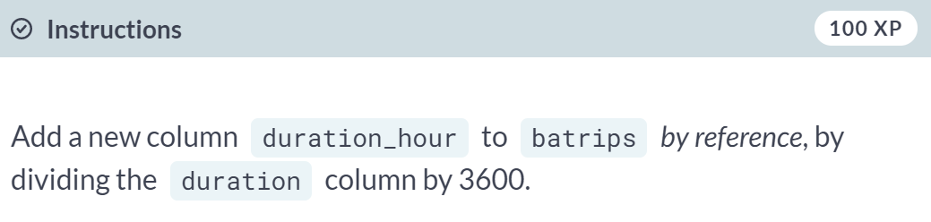  
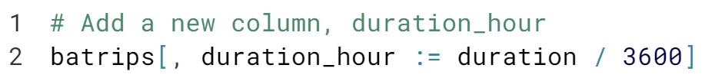

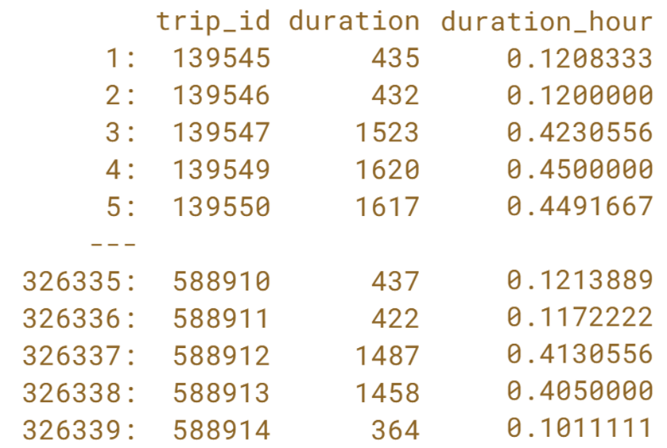  
Did you notice you didn't have to assign the result to any object? The new column was simply added to your existing *data.table*.

# Updating an existing column (I)

Being able to efficiently update existing columns is particularly useful when cleaning data. In this exercise, you will work with a new data.table, untidy, which is almost identical to batrips, except we introduced a typo in the second row of the start_station column.

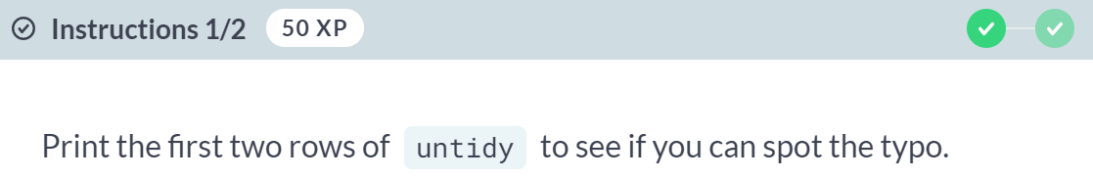  
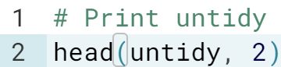  
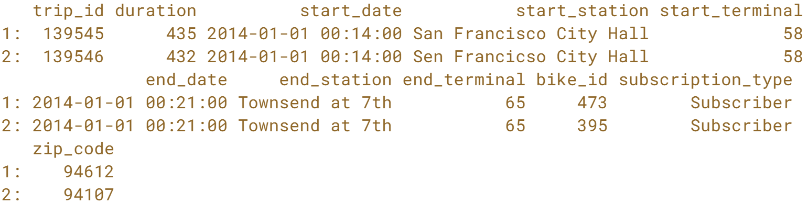

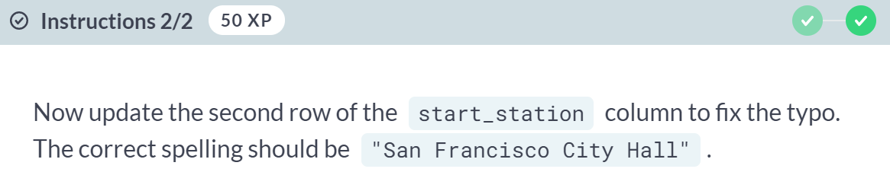

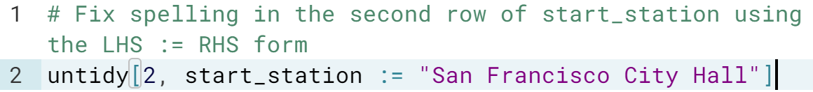  
  


Updating data.tables is incredibly useful when you are cleaning data. Instead of creating several objects and cluttering up your workspace, you can modify your original data.table directly. This is both cleaner and faster!

# Updating an existing column (II)

In the previous exercise, you updated only one value and you knew the exact location that had to be updated, i.e., the second row of the start_station column. However, in your day-to-day work, you often want to update several values and you won't know the locations in advance.

You can use the filtering expressions in i the same way you did in chapter 1 to update the columns by reference.

In this exercise, you will work with a new data.table, untidy, which is almost identical to batrips, except we randomly introduced some negative values in the duration column.

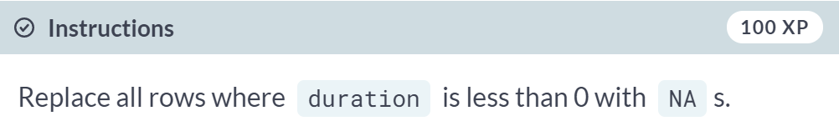  
  
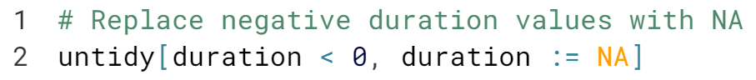  
  
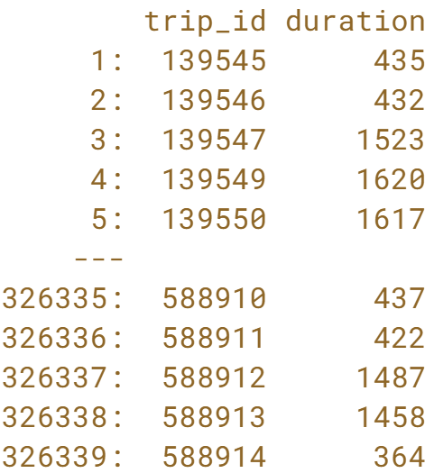  
  
You can also update *data.tables* when performing grouped aggregations. Do you know how? Check out the next lesson!



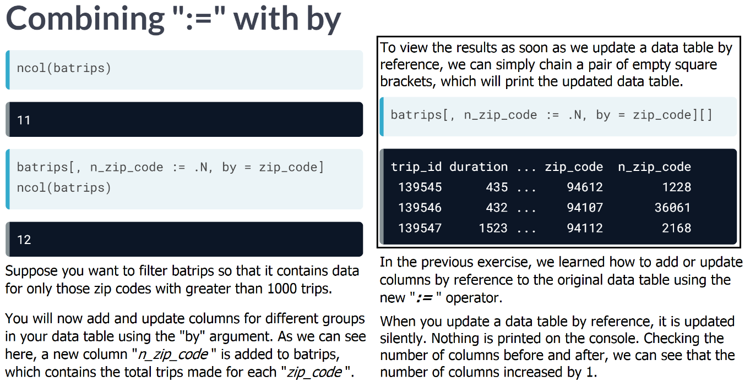

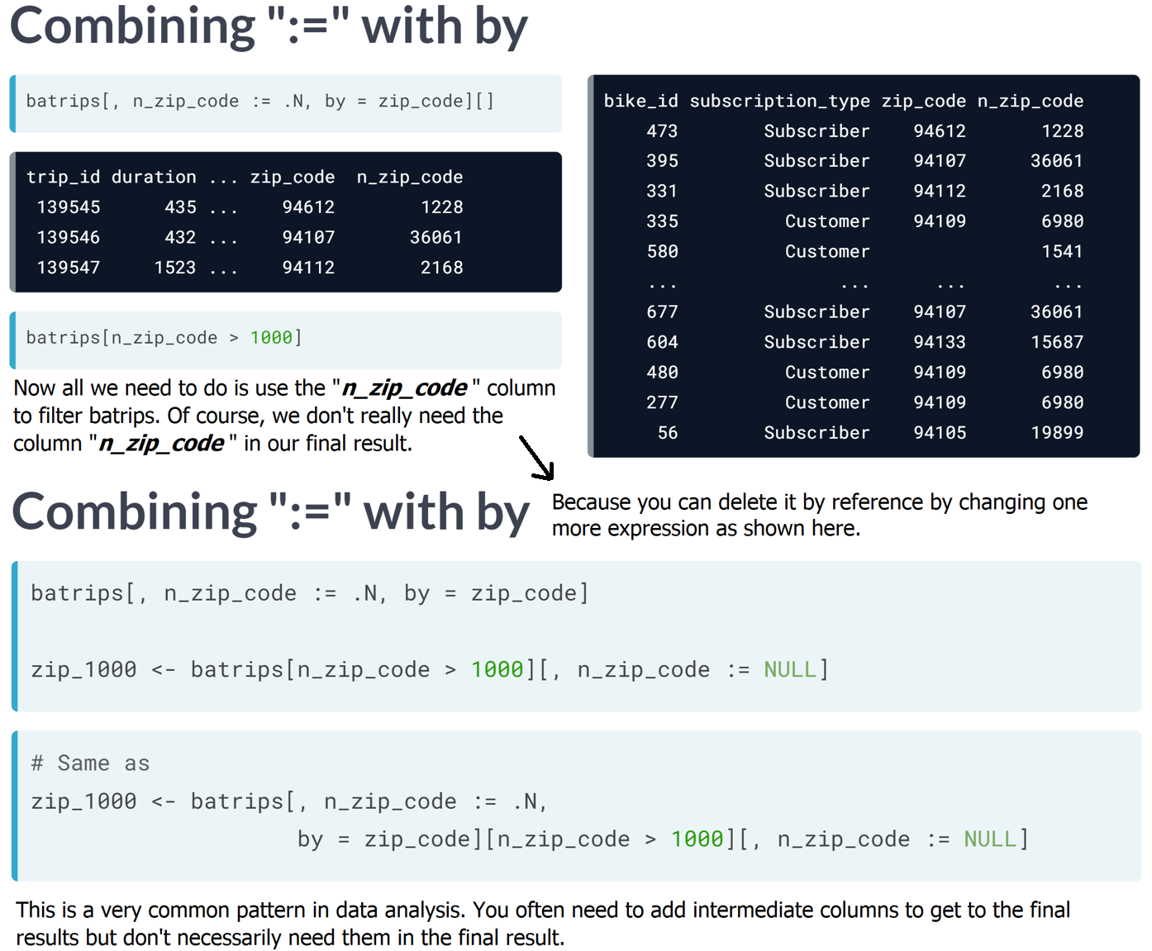

# Adding columns by group

Recall that you can perform computations by group using the by argument of the data.table. In this exercise, you will add new columns by group to the original data.table by reference.

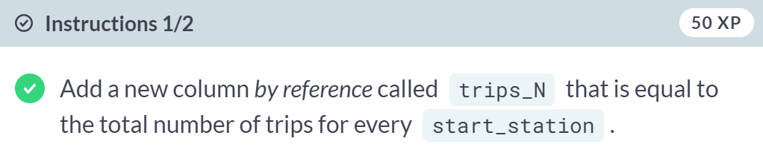  
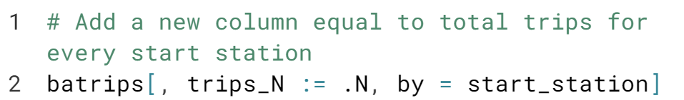

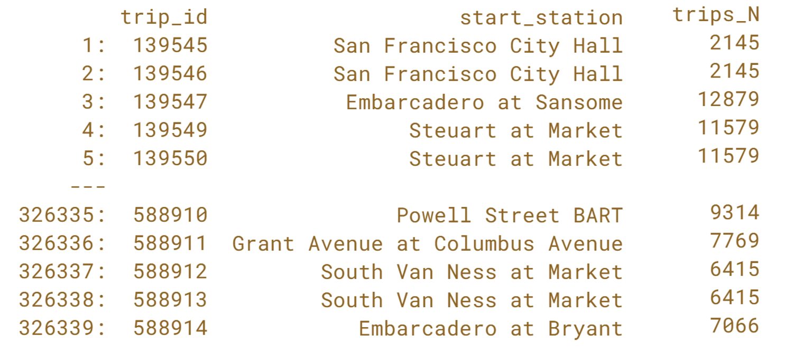

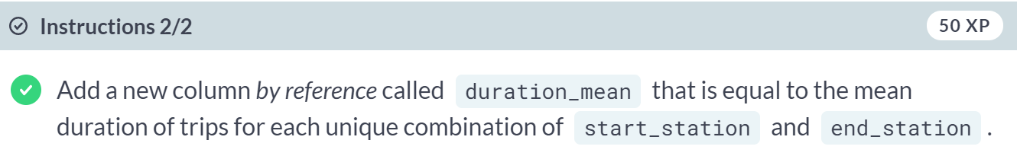

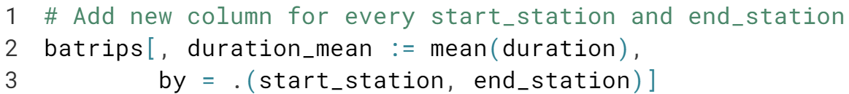

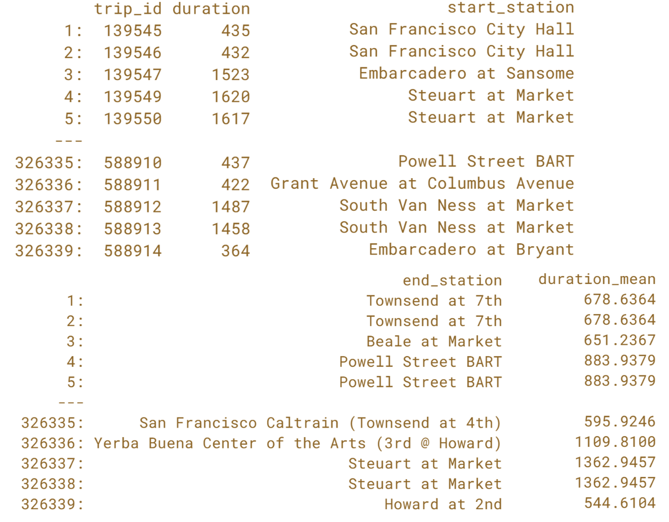

That's right! Adding new columns is not much different. All you need to do is specify the by argument.

# Updating columns by group

You often need to create new intermediate columns to get to the final result but don't necessarily need these intermediate columns in the final result. This is a very common pattern in data analysis.

In this exercise, you will work with a new data.table, batrips_new, which is almost identical to batrips, except we randomly introduced some missing values in the duration column.

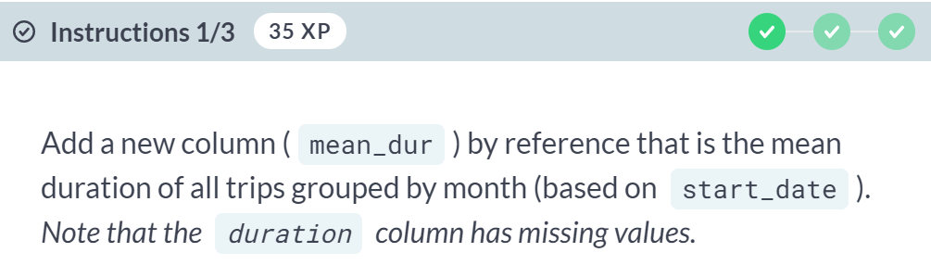  
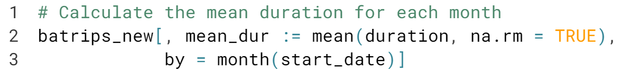  
  
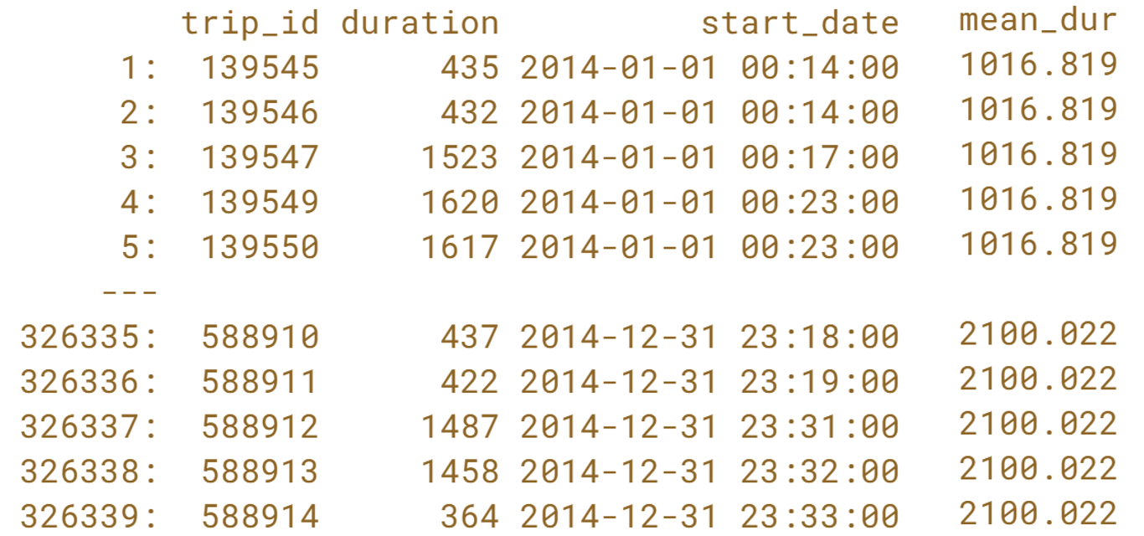

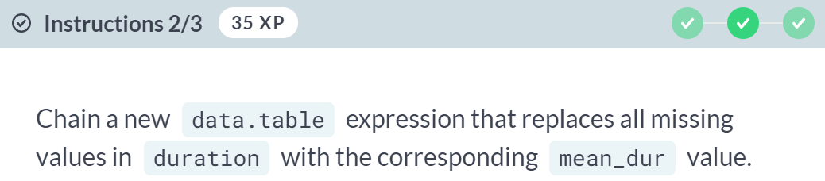

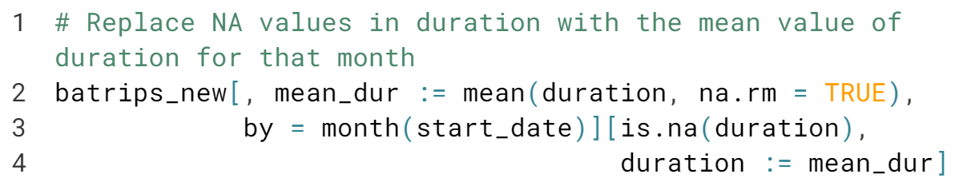

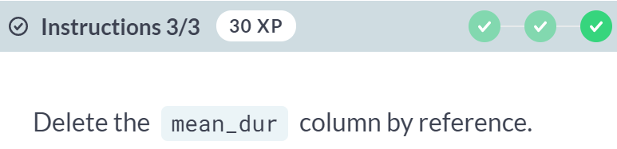

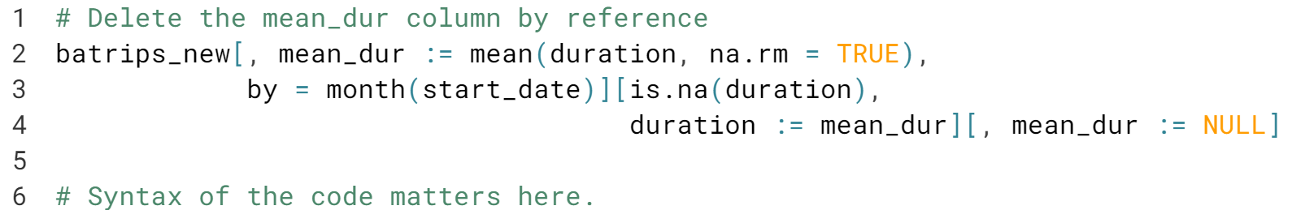

Nicely done! We are now ready for more advanced aggregations.



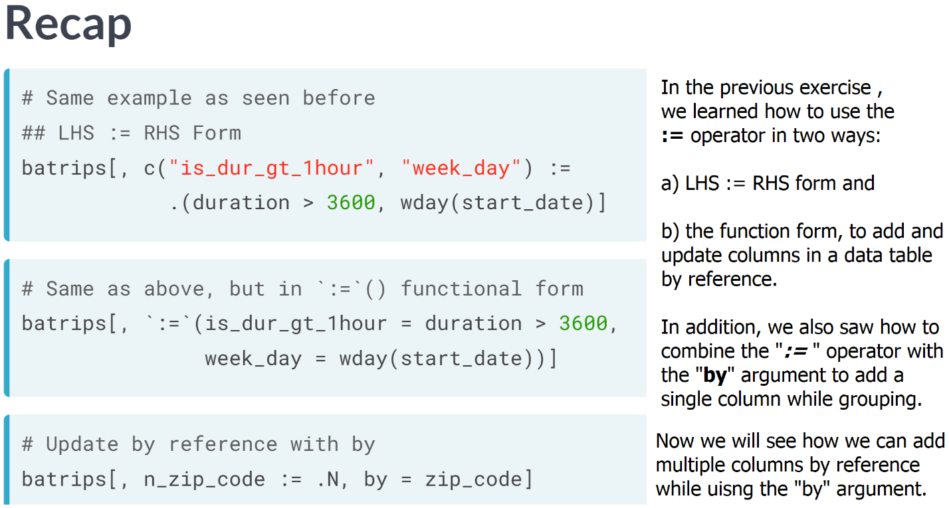

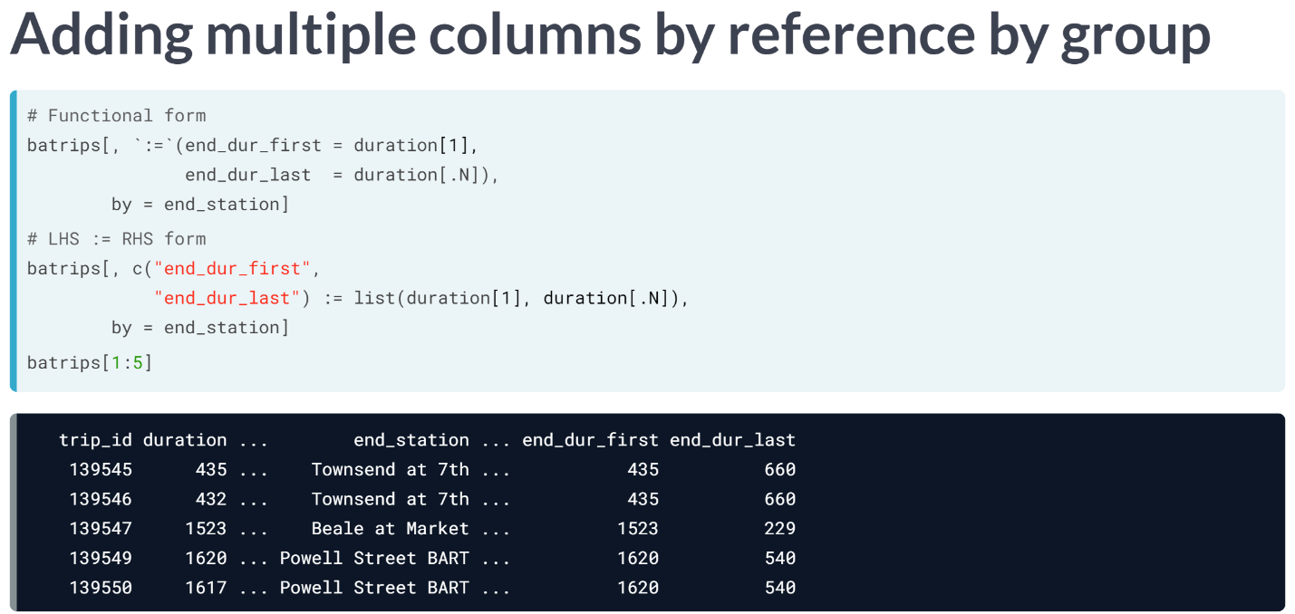You can provide all the columns to be added/updated along with their values in either of the two forms: LHS:=RHS or functional form and add the "by" argument to group by those columns.   
  
As you can see here, for each "***end_station***", the first and last duration values are assigned to the two new columns. Note that we would have identical first and last values of duration for all rows corresponding to the same end station.

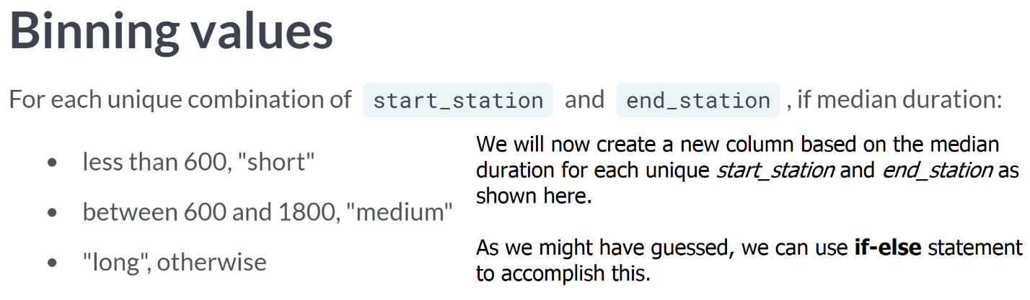

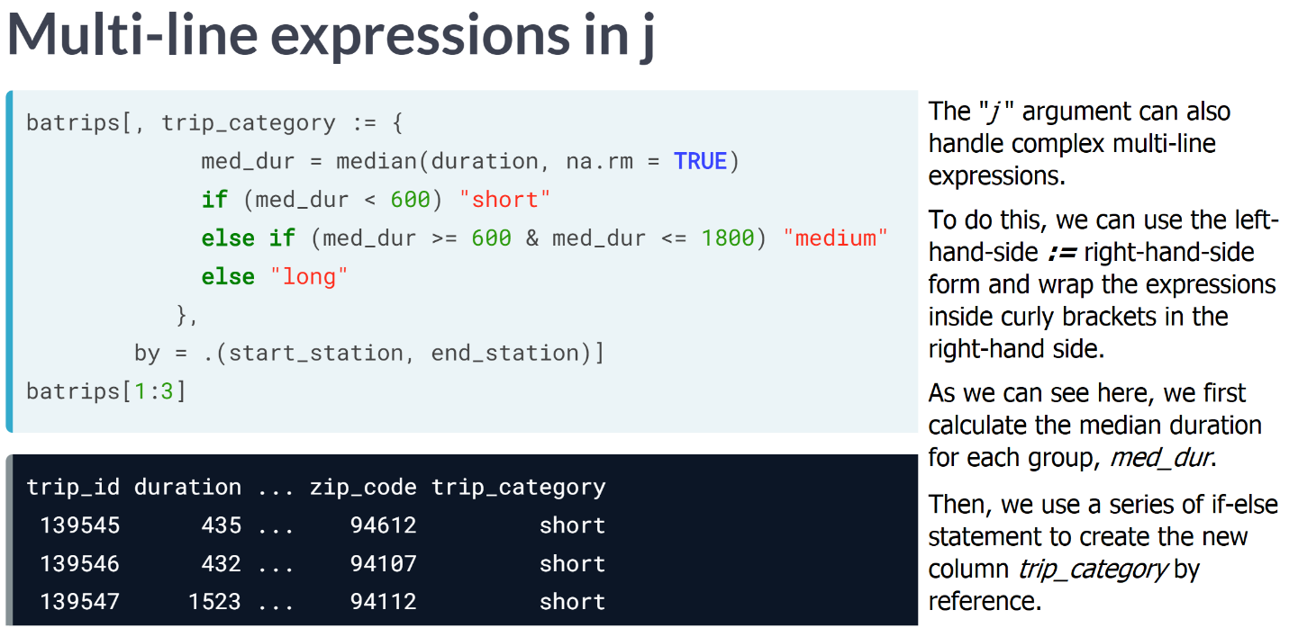  
  
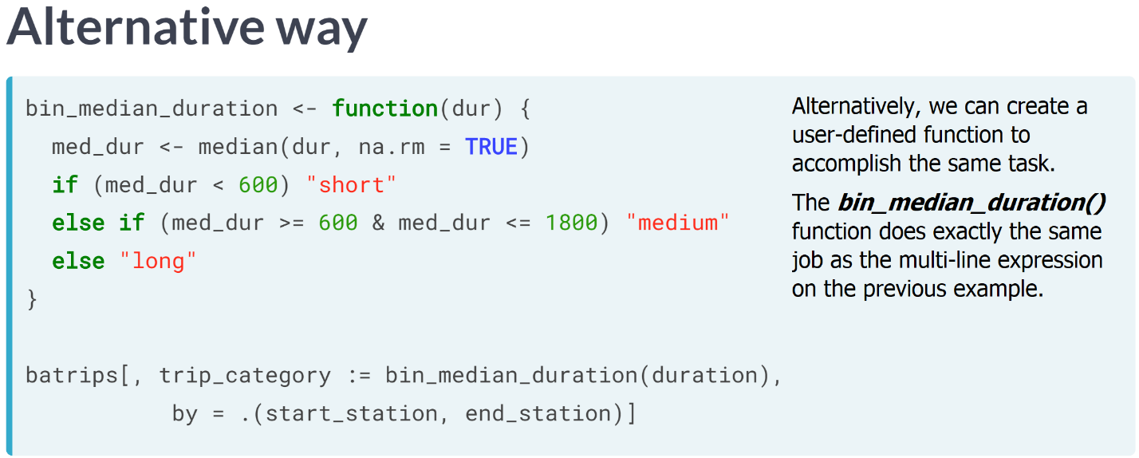

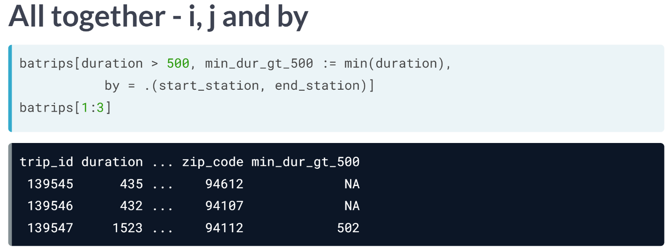

So far, we have used the "*j*" and "*by*" arguments to add/update columns by reference. Now let's combine all three - "*i* ", "*j*" and "*by*" altogether.

In the example shown here, data table first evaluates the expression in "*i* ", which returns all the rows where duration is >500.

Then on those rows, the "by" argument is applied by creating groups for each unique combination of "*start_station* " and "*end_station* ".

Finally, for each of those groups the expression in "*j* " is evaluated. We thereby obtain the smallest duration greater than 500 for each specified group.

If all values for a particular group are less than 500, there are no rows to group by, so the result would be NA, as shown in the first two rows of the output.

# Adding multiple columns (I)

More often than not, you may want to add/update multiple columns by reference. There are two ways to do this in data.table:

* LHS := RHS form
* Functional form

In this exercise, you will add columns using the **LHS := RHS** form. In the LHS, you specify column names as a character vector and in the RHS, you specify values/expressions to be added inside list() (or the alias, .()).

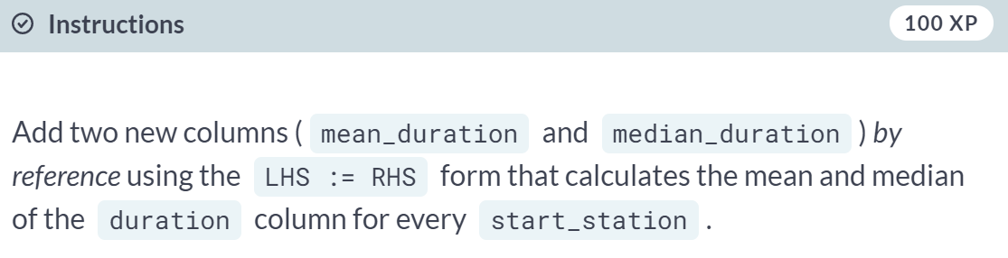  
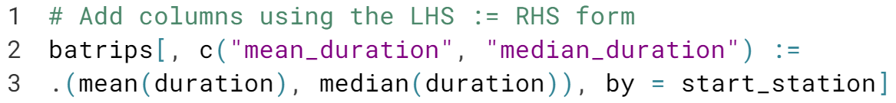

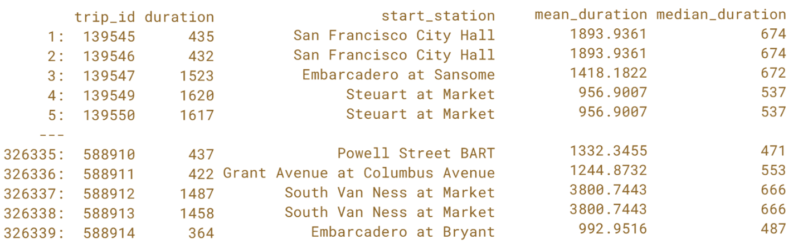  
Great job! In the next exercise, we will compute the same columns again, but this time using the functional form.

# Adding multiple columns (II)

In this exercise, you will add the same columns as in the previous exercise, using the **functional** form. In the functional form, you use the colon equal to operator (:=) as a function. Recall that when using operators as functions, they should be wrapped inside backticks, **`:=`()**. Inside the function call, you pass comma-separated col_name = expression values.

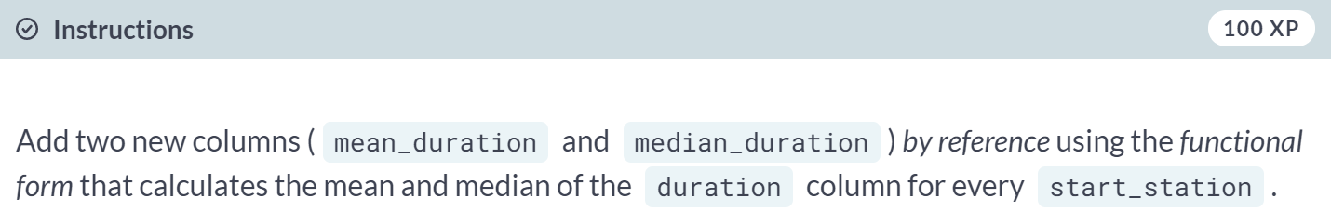

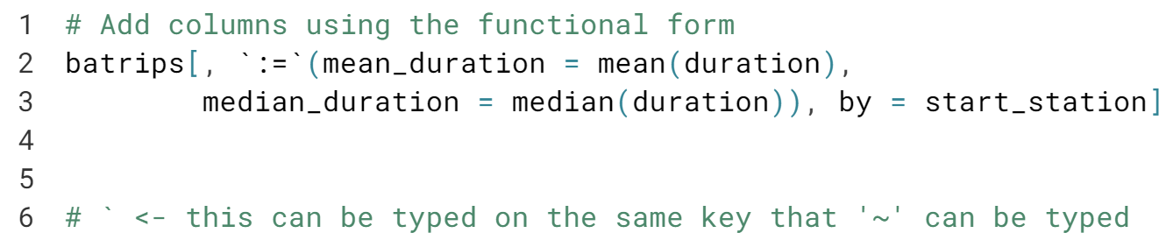

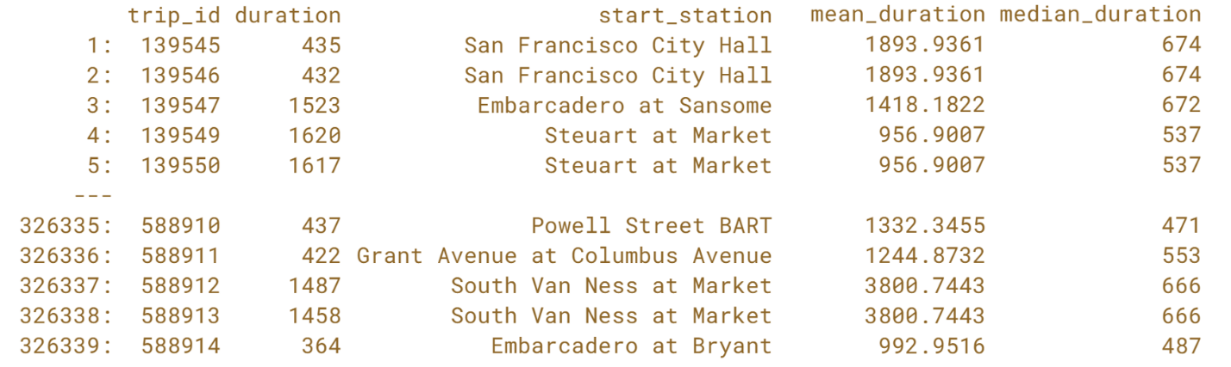  
Great! You can check that the results are same whether you use *LHS := RHS* or the *functional* form. Is there a preferred way? Nope, pick your favorite.

# Combining i, j, and by (II)

As you did in the last chapter, you will combine the i, j, and by arguments, but this time modify the existing data.table by reference in j.

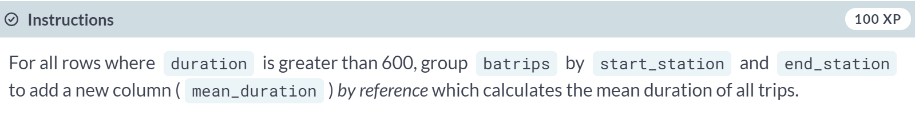

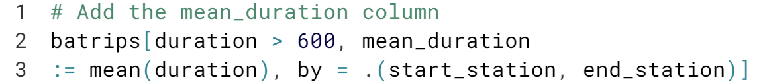

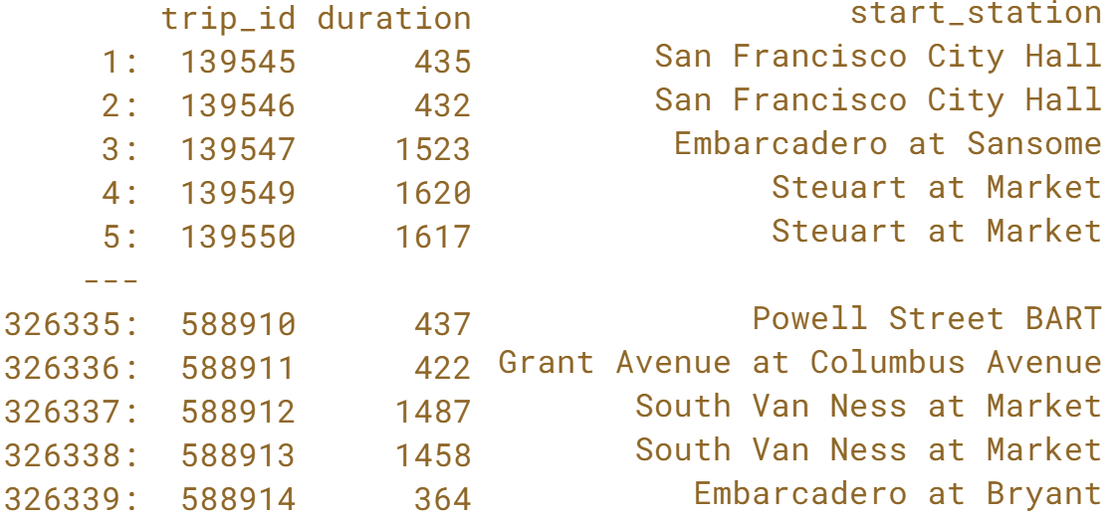  
  
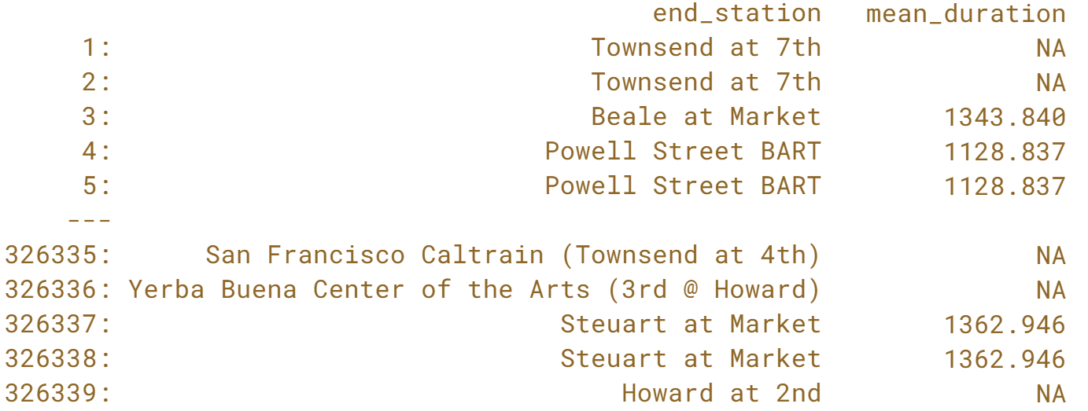  
Stunning! Congratulations on mastering the basics of *data.table*. In the next chapter, you will import and export flat files using data.table's amazing ***fread()*** and ***fwrite()*** functions!

**Importing and Exporting Data**Not only does the data.table package help you perform incredibly fast computations; it can also help you read and write data to disk with amazing speeds. This chapter focuses on data.table's *fread()* and *fwrite()* functions which let you import and export flat files *quickly* and *easily*!



We are already familiar with ***read.csv()*** and ***read.table()*** functions, which import flat files into R. In this chapter, we will use data table's high performance *fread()* to import flat files.

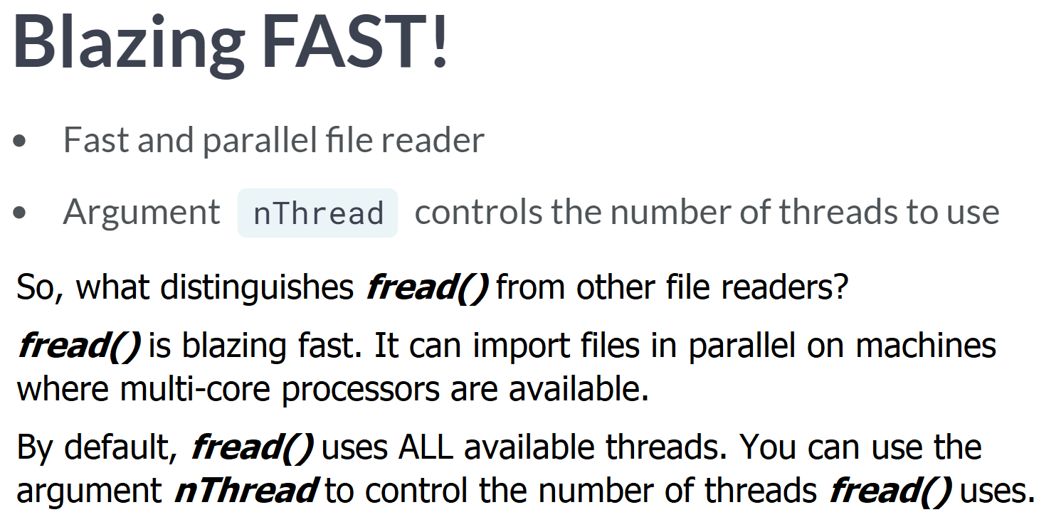  
  
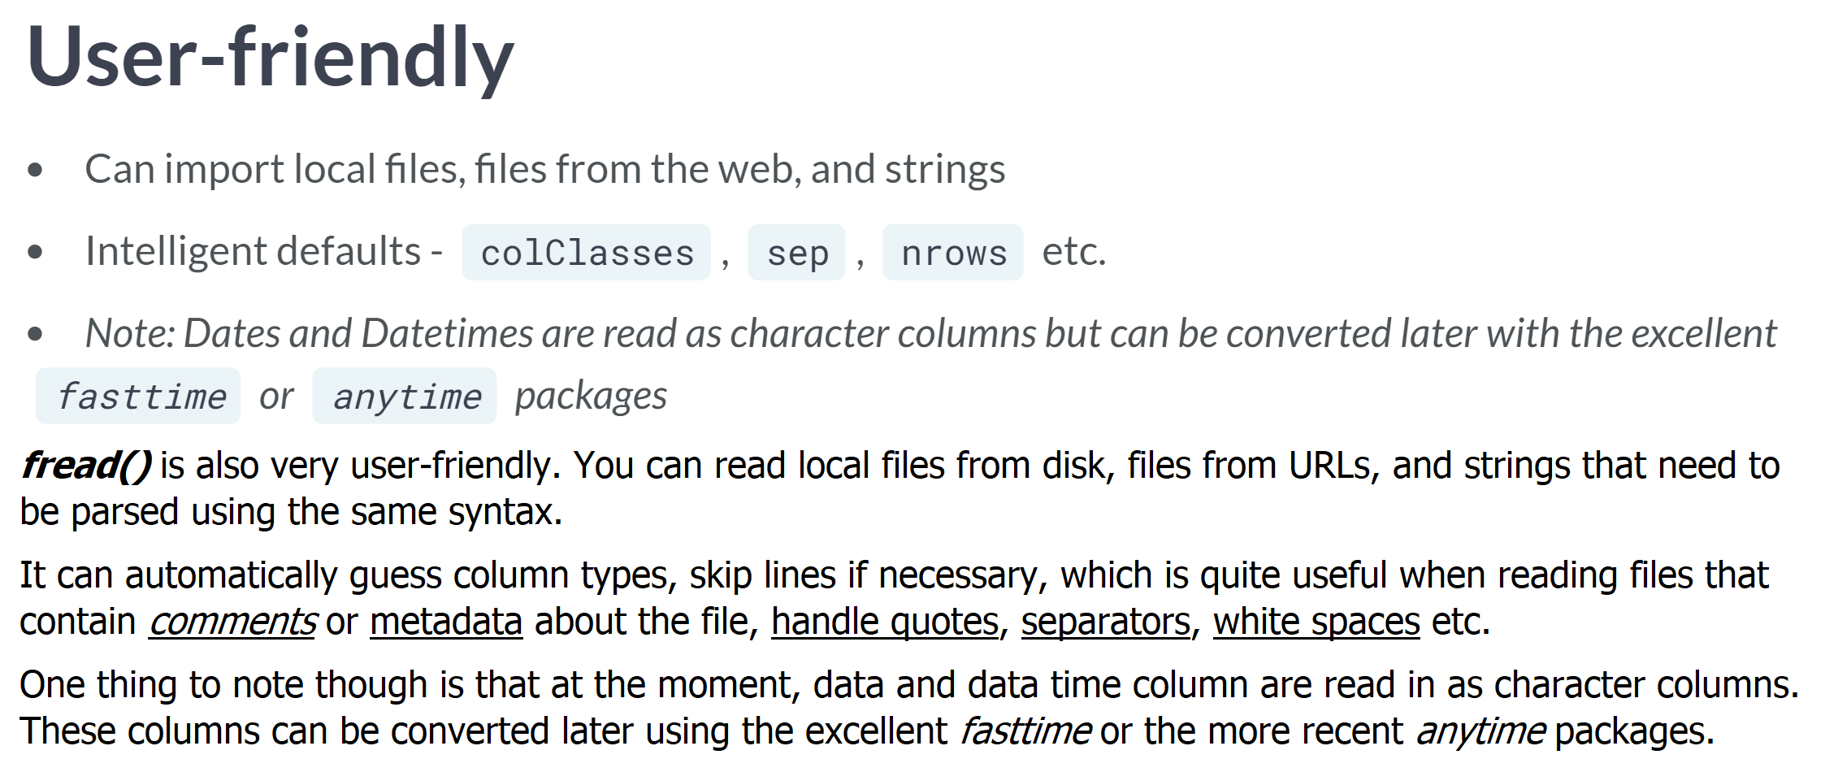

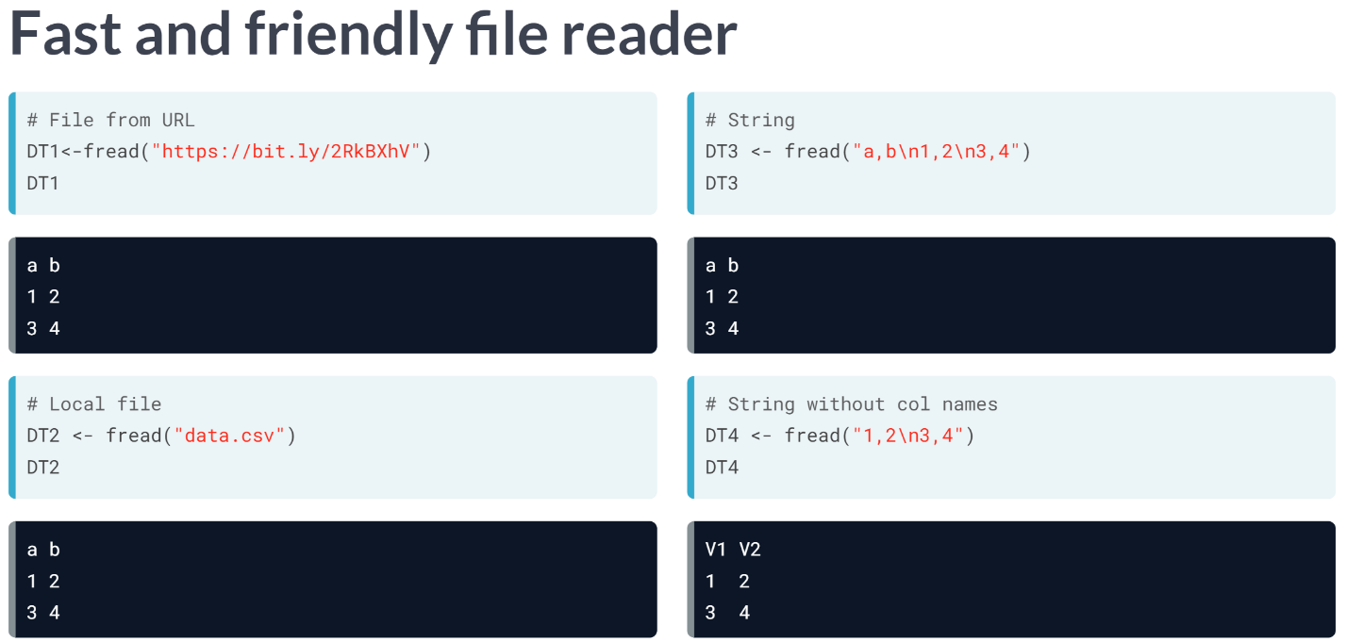

On this slide, we show how the same dataset in three different formats can be imported into R using ***fread()***.

As we can see, ***fread()*** automatically detects if it's a file name, URL, or string for us. Note how the header is automatically detected as well. If there's no header, ***fread()*** automatically names them "*V1* ", "*V2* " etc., similar to the *data.table()* function.

This example shows how we can import data using a filename, URL, or a string. That's it and everything else is taken care of automatically.

If we'd like to know what's going on under the hood, set the verbose argument to TRUE. In the rest of these coming exercises, we will use ***fread()*** to import data only through strings so we can see how the data looks like.

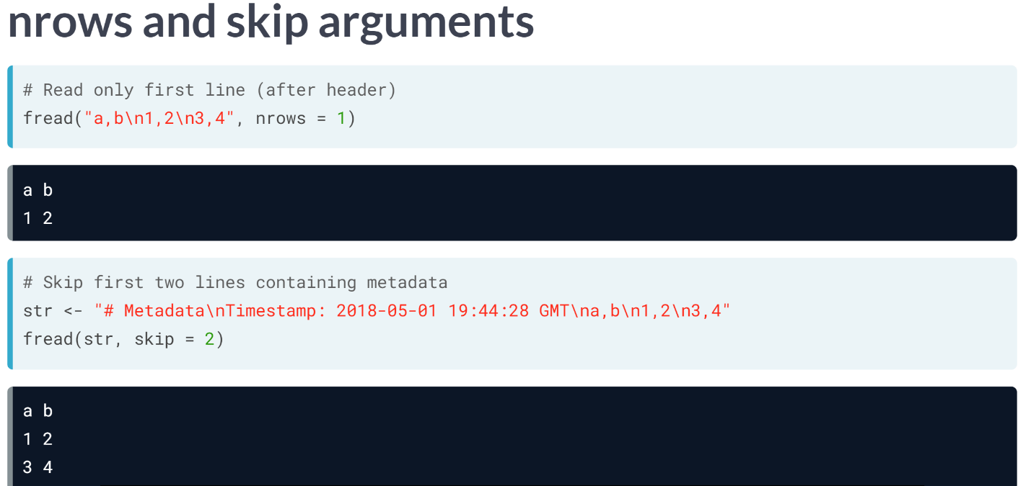  
Although ***fread()*** is clever enough to guess the column types and other details in most cases, there are times when we might appreciate a finer control when importing the data.

Let's see how these finer controls work. As we've learned, the argument *nrows* and *skip* allow us to control which rows or lines of a file are imported.

The ***nrows*** argument specifies the total number of rows to read, excluding the *header* row. It takes an integer as input. This is particularly useful when we want to have a quick look at the file by reading, let say, just the first 100 rows instead of millions of rows.

The ***skip*** argument also takes an integer as input and skips that many numbers of lines before attempting to parse the file. This is particularly useful in handling irregular files, for example, files with comments, or metadata at the beginning of a file. Even though ***fread()*** tried to handle this automatically, it might be required to manually specify the *skip* argument in some special cases.

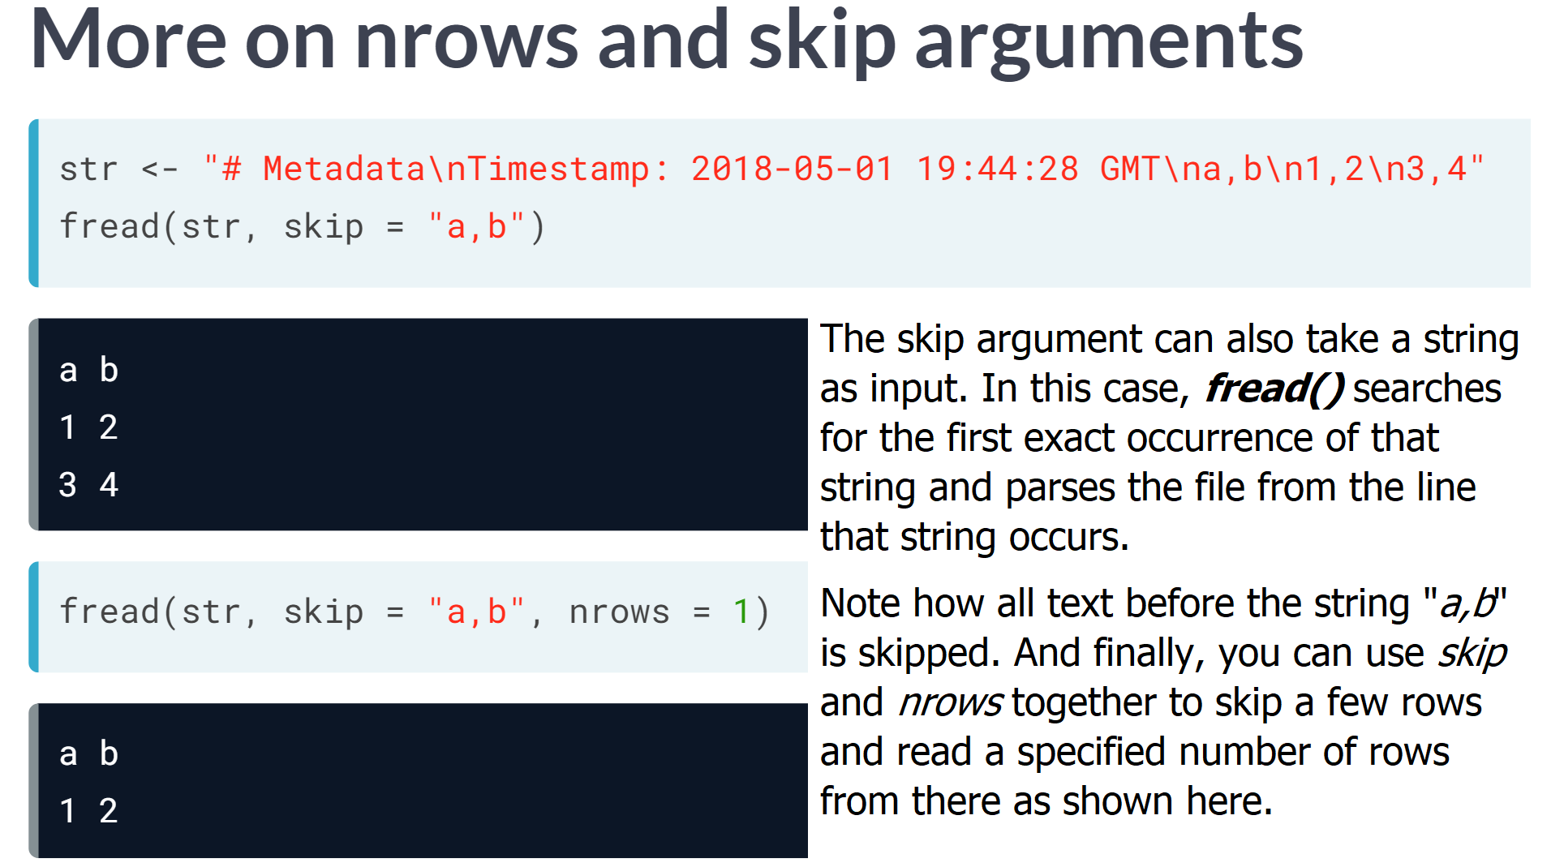

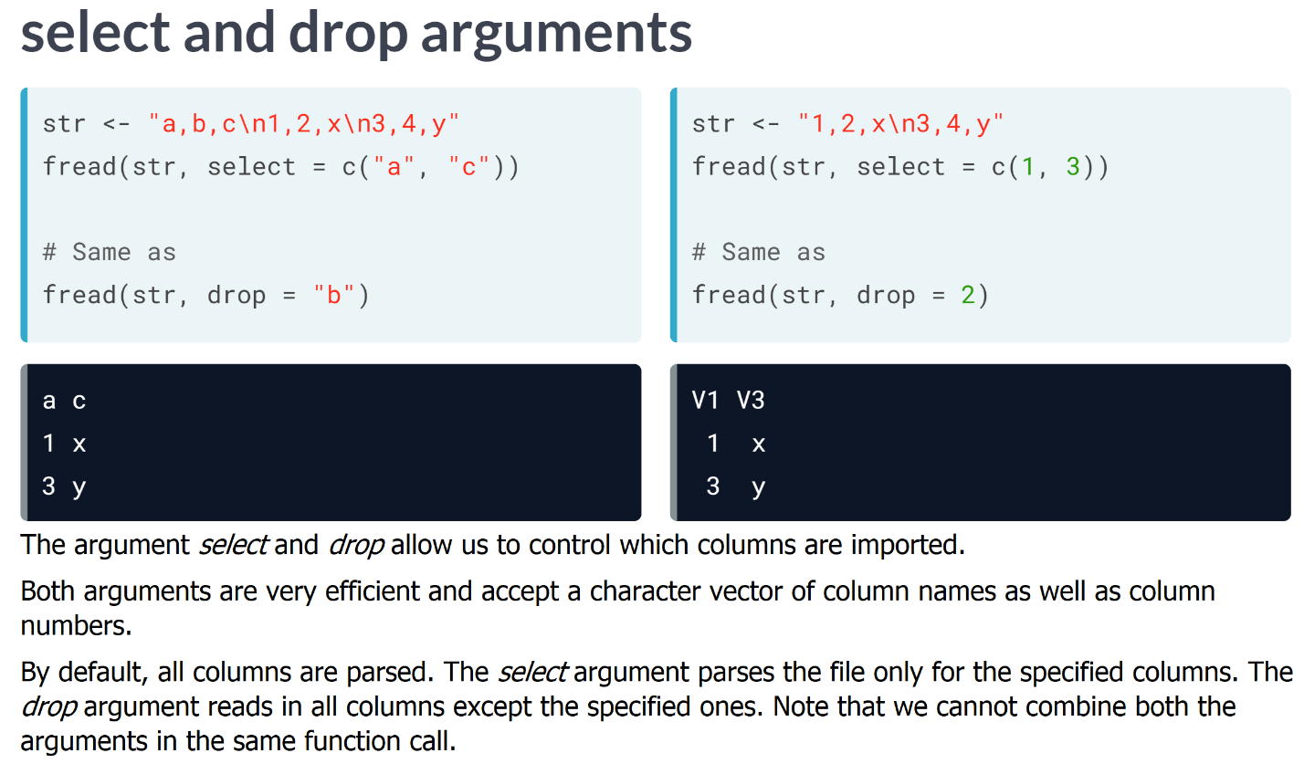

# Fast reading from disk

In addition to having intelligent defaults, fread() is super-fast! In this exercise, you will use the [**system.time()**](https://www.rdocumentation.org/packages/base/topics/system.time) function from base R to compare the time it takes to read the batrips.csv file using read.csv() and fread().

All you need to do is pass an expression to system.time(). For example, if you want to calculate how long it takes to import a file called sample.csv, you can use:

system.time(read.csv("sample.csv"))

user system elapsed

3.495 0.040 3.547

Generally, you want to consider user time when measuring execution time. So in this case, it took 3.495 seconds to import the file sample.csv.

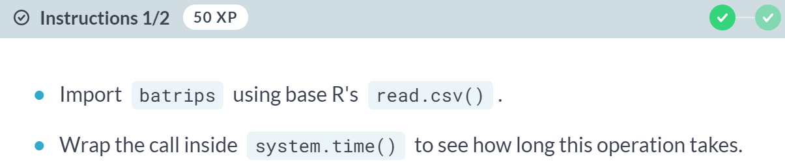

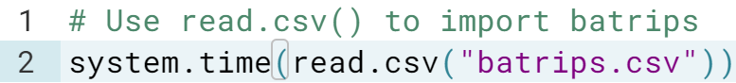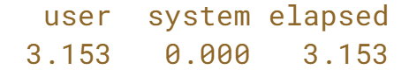

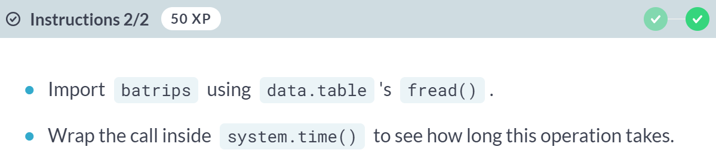  
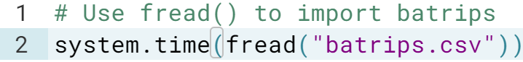 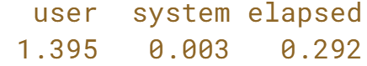  
  
That's right! data.table's *fread()* was able to import this file **~5x** faster compared to *read.csv()*.

# Importing a CSV file

In this exercise, you will import the file sample.csv using both [**read.csv()**](https://www.rdocumentation.org/packages/utils/topics/read.table) and [**fread()**](https://www.rdocumentation.org/packages/data.table/topics/fread) to compare these functions. Here are the contents of this file:

id,"name",val

29192,"Robert Whitaker", 200

49301 ,"Elisa Waters,190

The values in the file are separated by a comma. Note the unwanted spaces between entries, and the imbalanced quote in the second row.

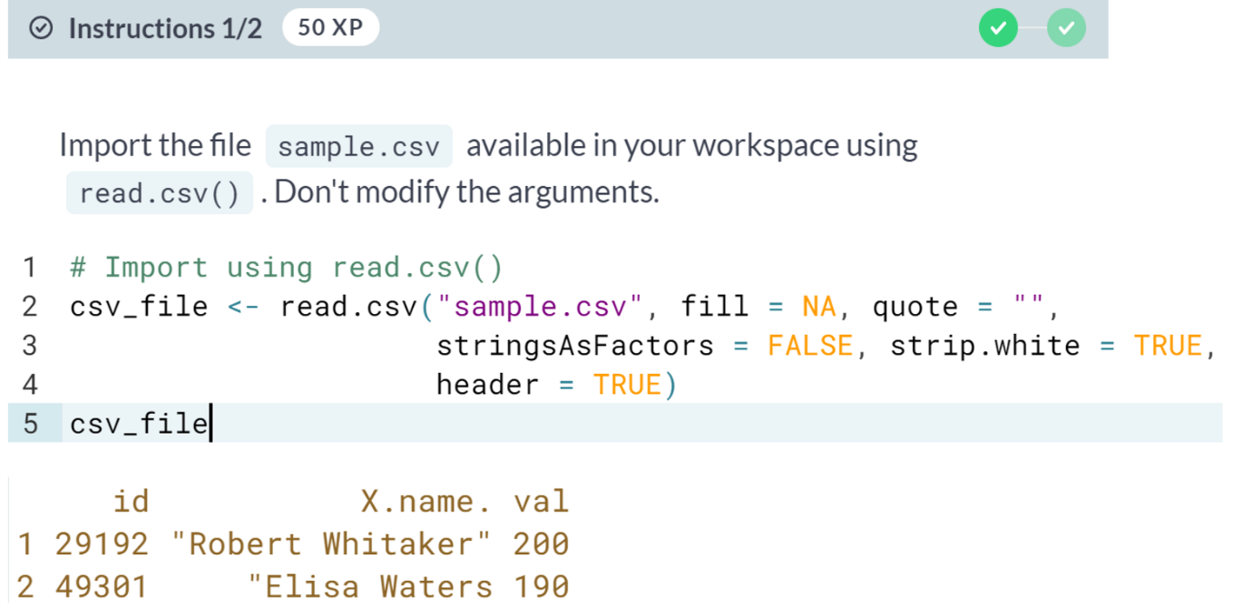  
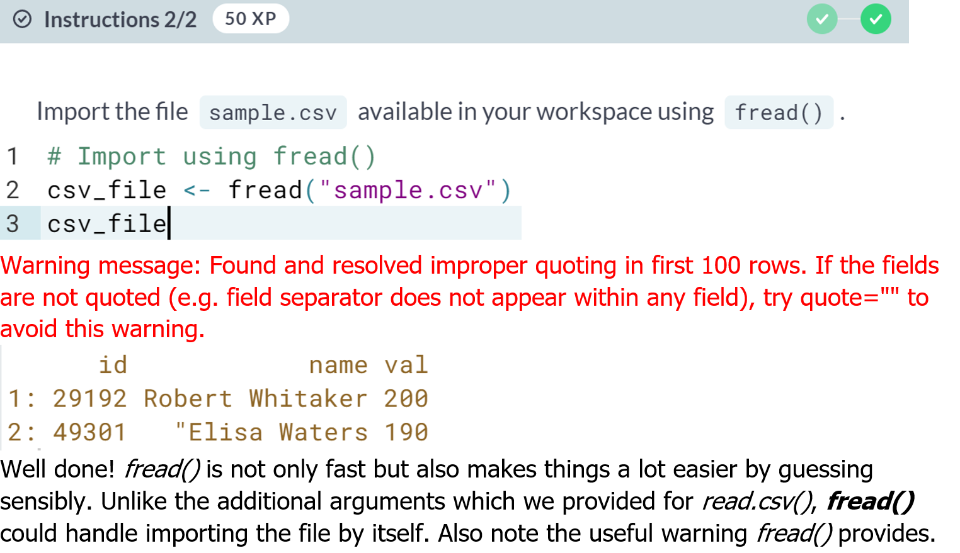

# Importing selected columns

It's time to practice importing only a few columns from a file as opposed to importing the entire file. You will be importing the following file:

id,name,val

29192,Robert Whitaker, 200

49301 ,Elisa Waters,190

34456 , Karla Schmidt,458

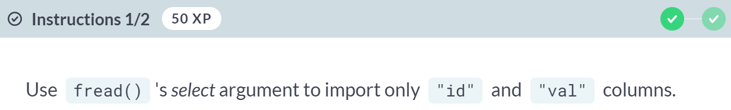

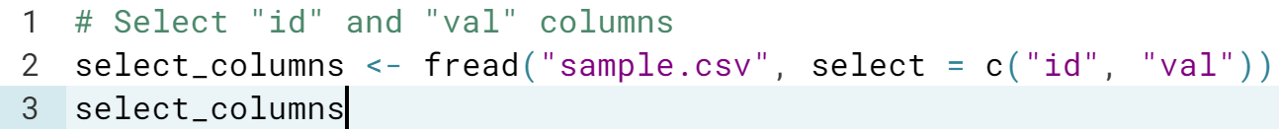

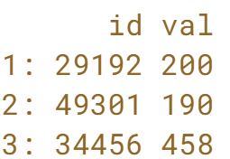

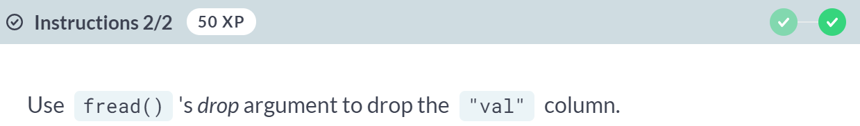  
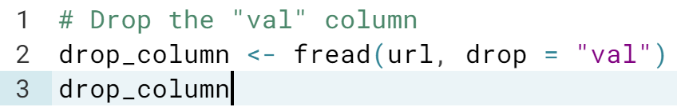  
  
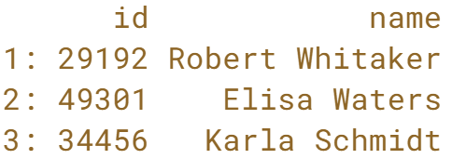  
Nice! So, we know how to import only the columns we want. Let us now practice importing only the rows we want.

# Importing selected rows

It's time to practice importing only a few rows from a file as opposed to importing the entire file. You will be importing the following file:

id,"name",val

29192,"Robert Whitaker", 200

49301 ,"Elisa Waters,190

34456 , Karla Schmidt,458

END-OF-DATA

METADATA

attr;value

date;"2018-01-01"

data;"cash payment"

Unfortunately, files like these do exist in real life.

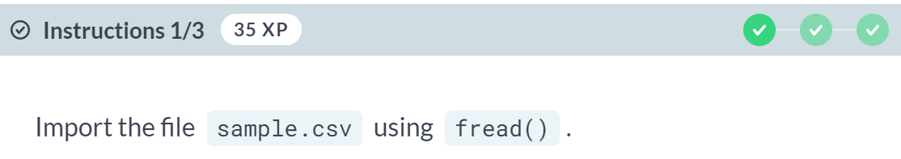

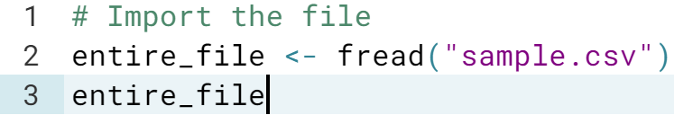

Warning message: Found and resolved improper quoting in first 100 rows. If the fields are not quoted (e.g. field separator does not appear within any field), try quote="" to avoid this warning.

Warning message: Stopped early on line 5. Expected 3 fields but found 0. Consider fill=TRUE and comment.char=. First discarded non-empty line: <<END-OF-DATA>>

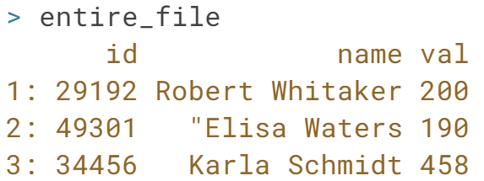

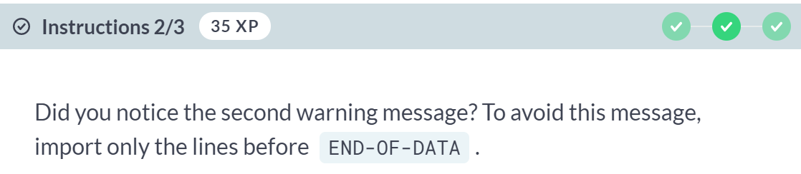

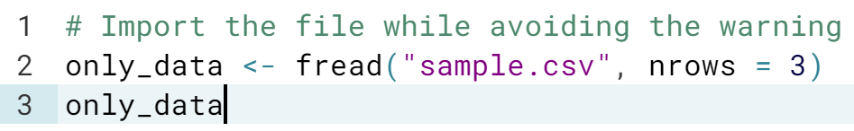

Warning message: Found and resolved improper quoting in first 3 rows. If the fields are not quoted (e.g. field separator does not appear within any field), try quote="" to avoid this warning.

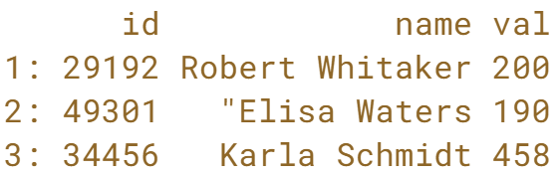

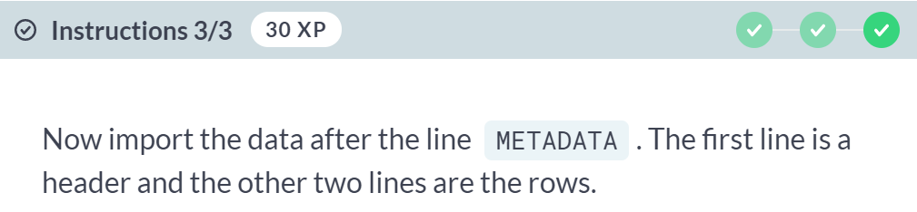  
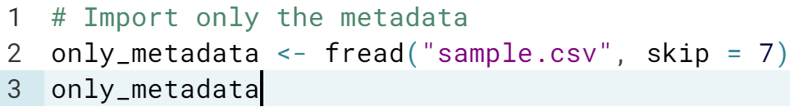

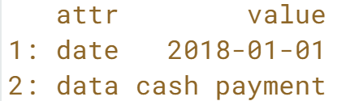  
Behold! You are not done witnessing the magic of *fread()*.



In this lesson, we will look at some of the more advanced features of data table's *fread().*

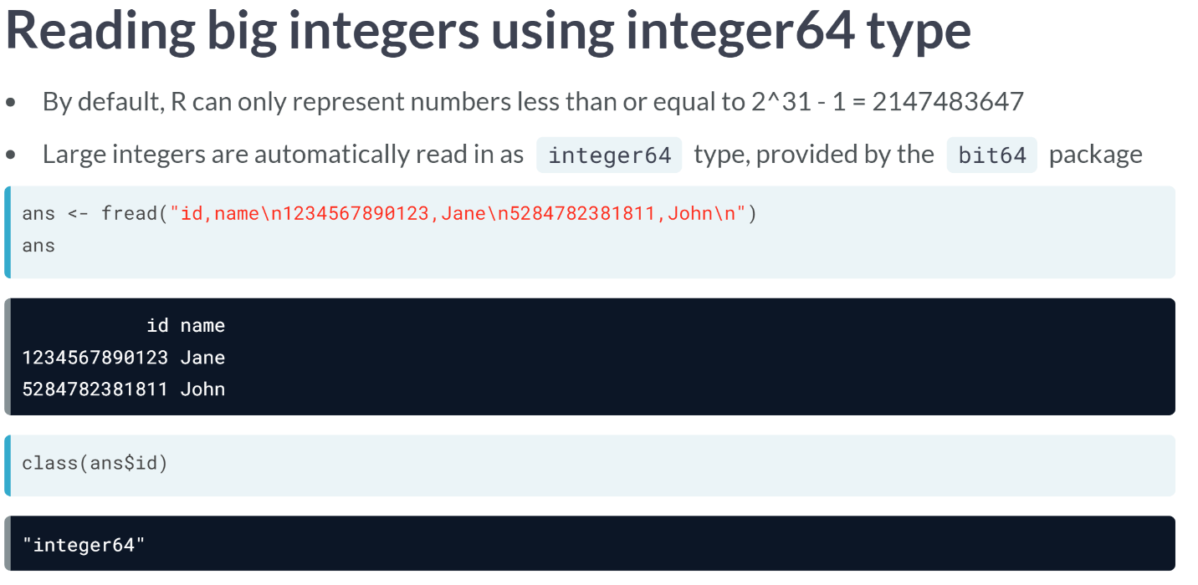  
R can only represent numbers less than or equal to $2^{31}-1=2,147,483,637$ as type "integers". The ***read.csv()*** automatically coerces numbers larger than this to numeric type. This might not be appropriate in some cases.

The data table therefore sets the type of such columns with large integer values to "*integer64* " type by default using the *bit64* package. It is however possible to override the default with numeric or character types if required using the *colClasses* argument.  
  
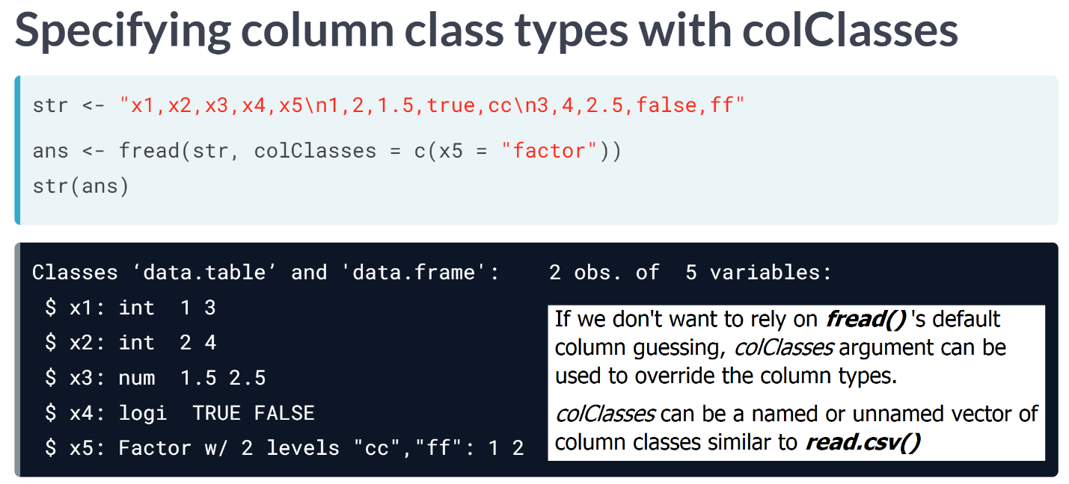

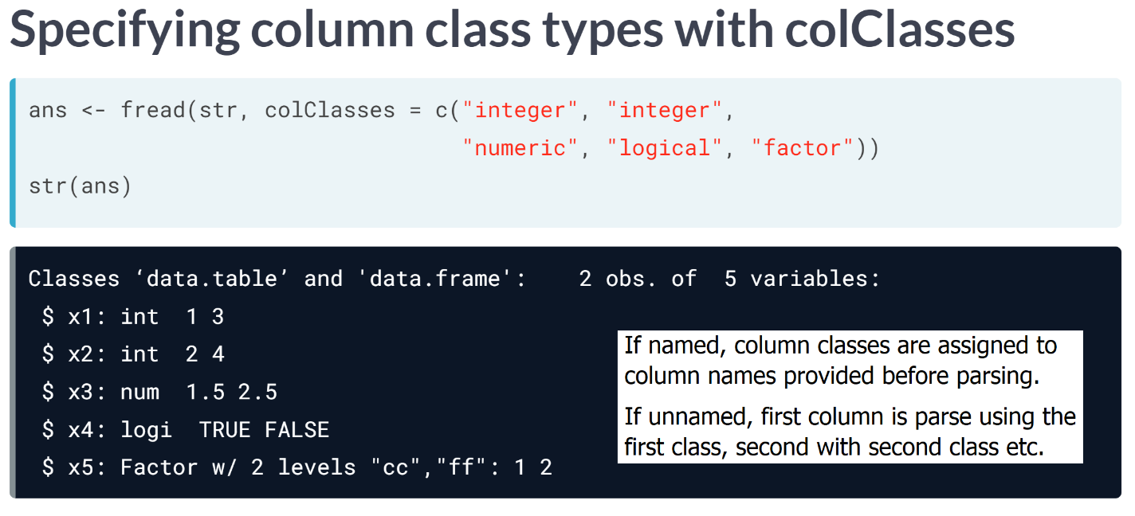

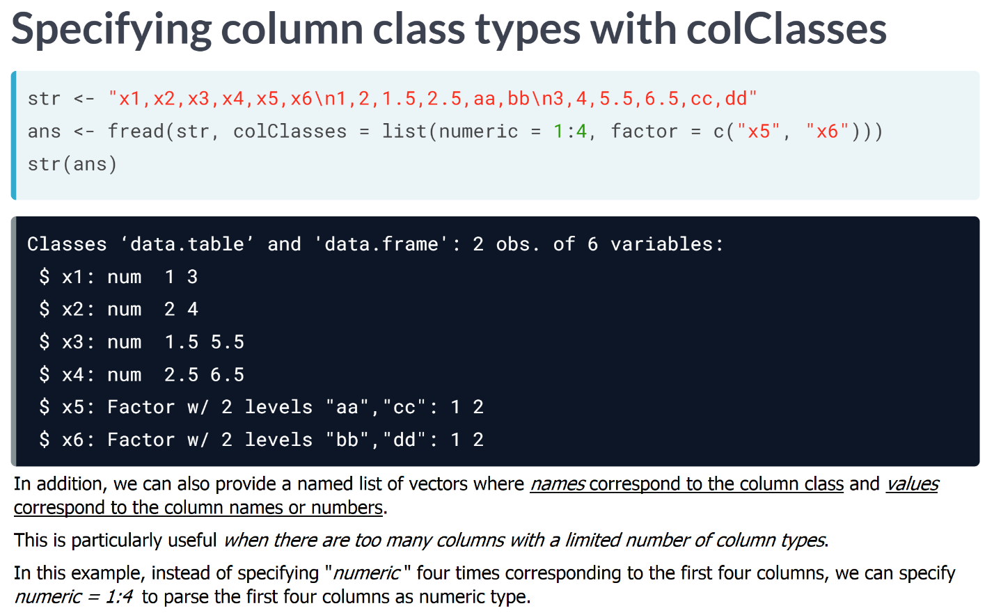

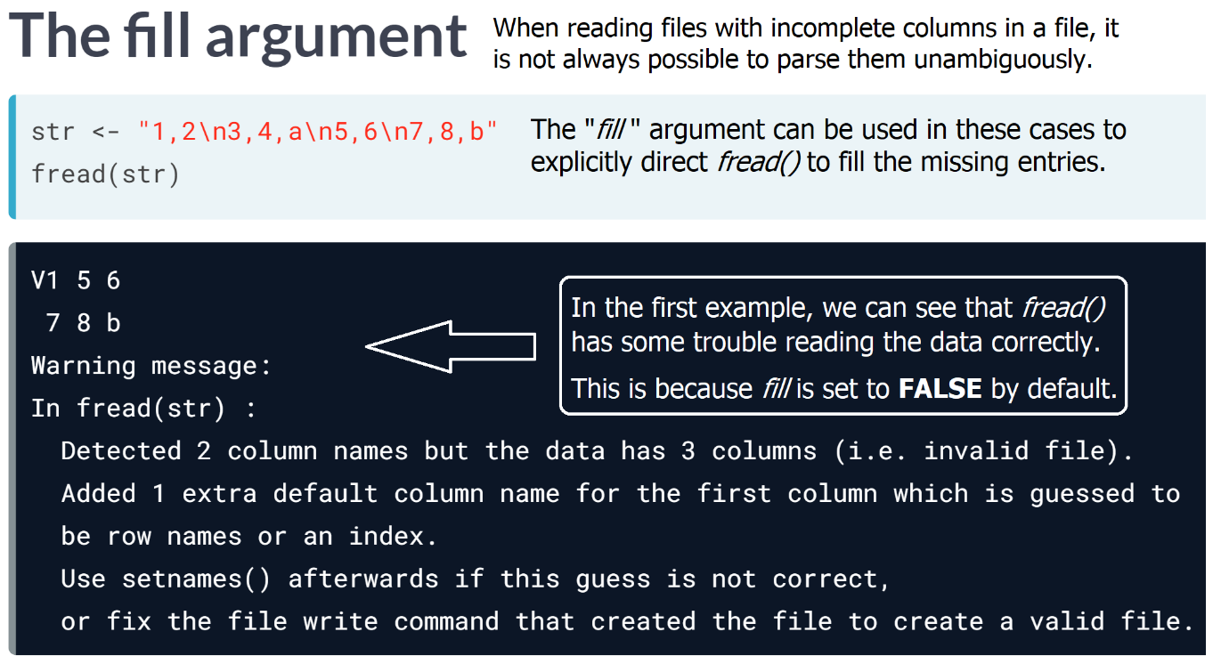  
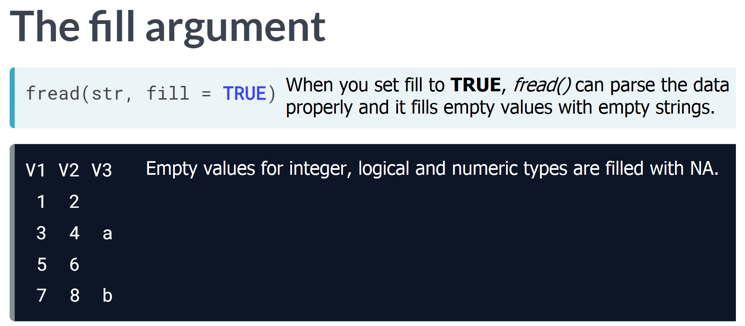  
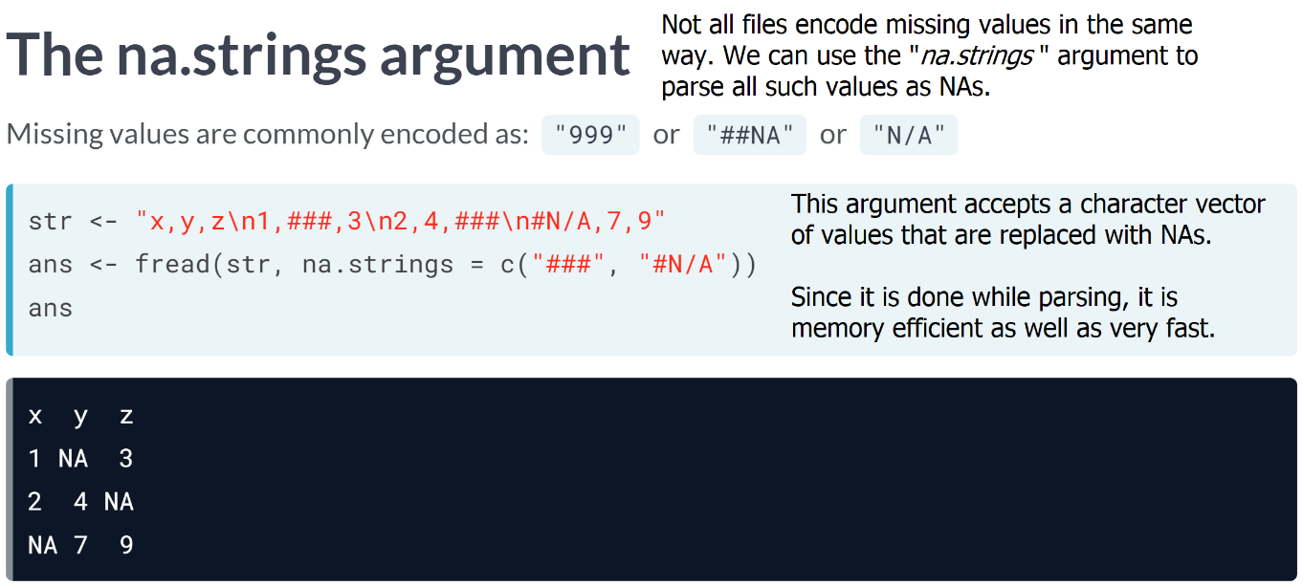

# Reading large integers

When importing massive datasets, it may be desirable to import numbers without decimals as integers since integers take up less space. Base R functions (such as read.csv(), read.table(), etc.) do this by default when the numbers are less than 2^31 - 1 (or 2147483647). However, columns with numbers greater than this are imported as numeric type by default.

If the bit64 package is installed, fread() can import these columns with huge numbers as the integer64 type which is implemented in bit64 package, by default.

You will be importing the following file:

id,name,val

9002019291929192,Robert Whitaker, 200

9200129401349301 ,Elisa Waters,190

9200149429834456 , Karla Schmidt,458

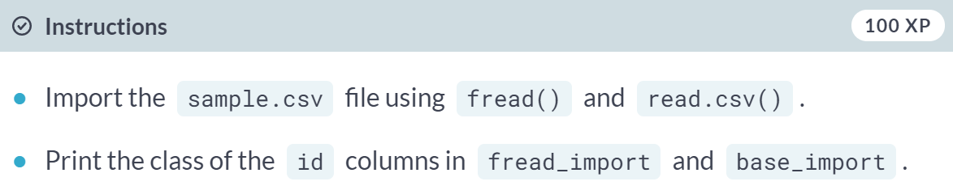  
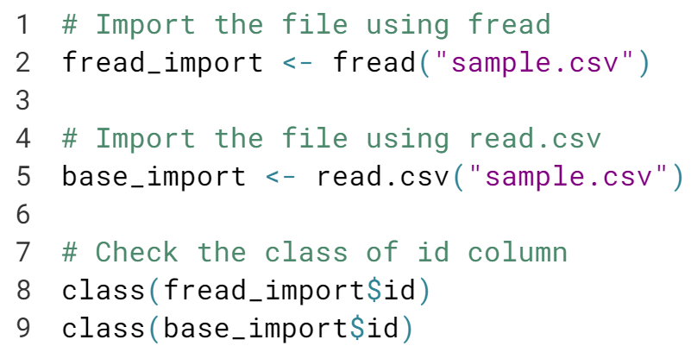

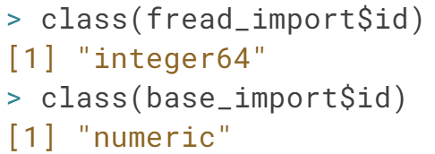  
Well done! Whenever possible, you should import your data as integers, especially when your data is big. Doing so results in saving memory in your RAM.

# Specifying column classes

The colClasses argument of fread() allows you to explicitly specify the class of the columns. You can specify the class of the columns as a character vector (as is done in base R functions such as read.csv()):

colClasses = c("integer", rep("factor", 3), "character")

However, this format requires you to specify the classes of all columns. This can be problematic if the file contains several columns and you only want to explicitly specify classes for some columns and leave the rest as default. You can use a more convenient list format for this purpose:

colClasses = list(factor = 2:4)

Here, the columns two through four are imported as factors and the rest are imported using fread()'s defaults.

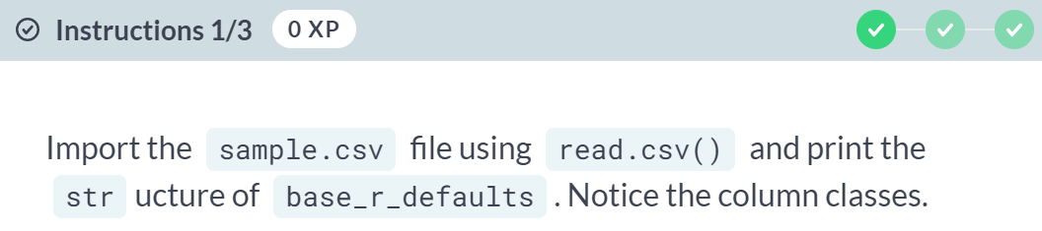  
  
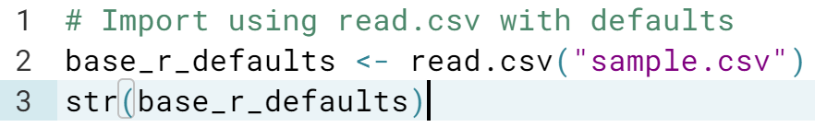  
  
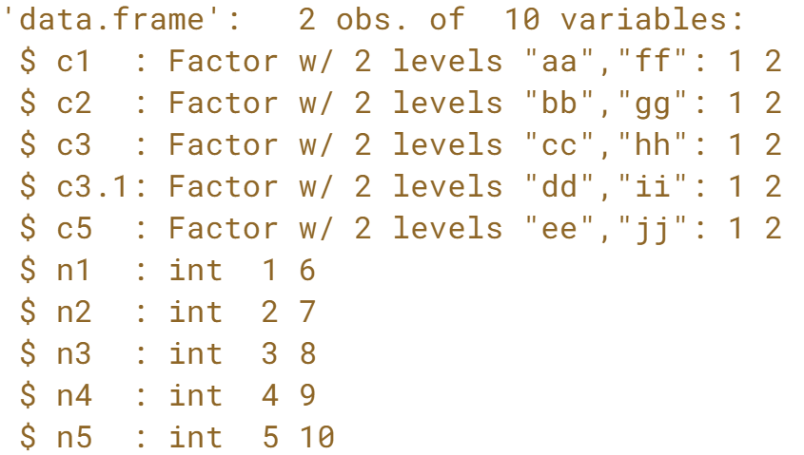

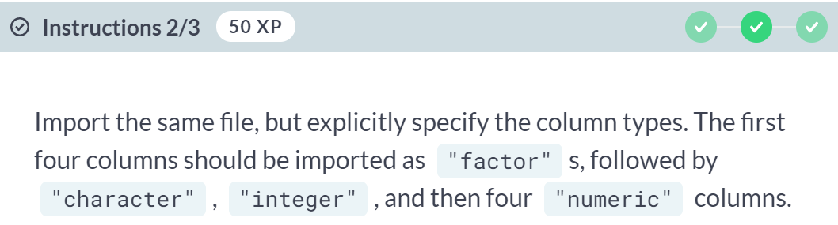

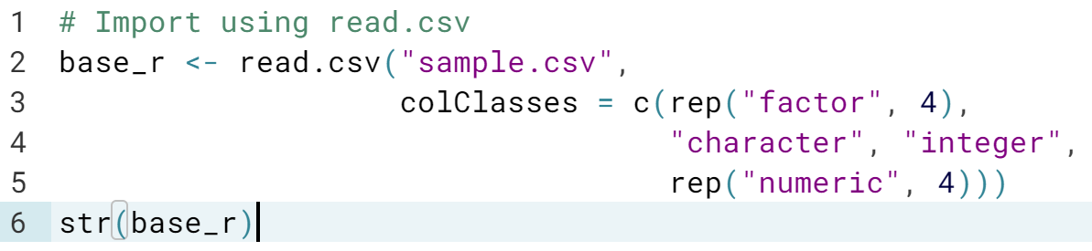  
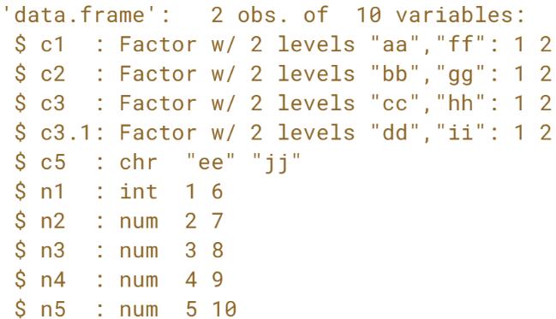  
  
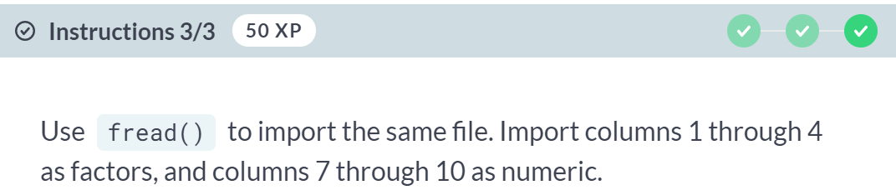  
  
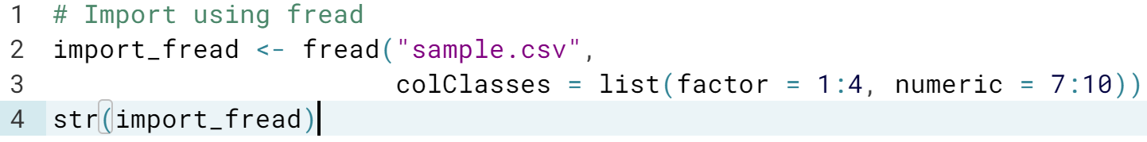  
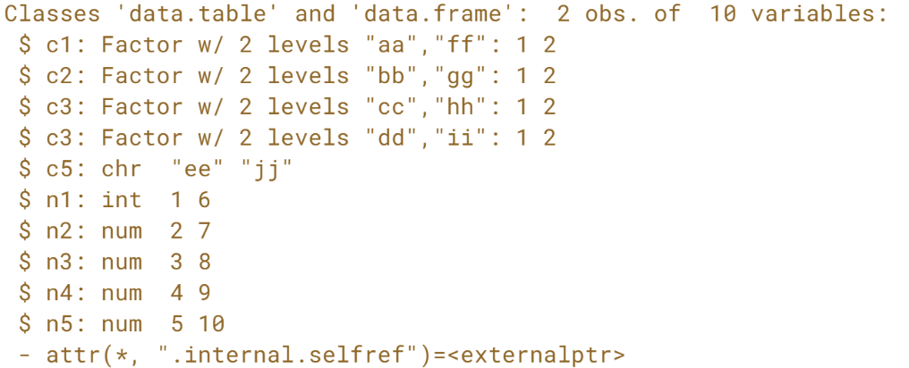

# Dealing with empty and incomplete lines

When reading irregular files, i.e., files with varying/missing fields in rows, fread() tries to parse them intelligently. However, it may not be always possible to guess if the irregular lines should be skipped or imported by filling missing fields. For such cases, you can use the fill argument of fread().

You will be importing the following file:

id,name,val

9002019291929192,Robert Whitaker,

9200129401349301 ,Elisa Waters,190

9200149429834456 , Karla Schmidt

Notice that the first and last lines are incomplete.

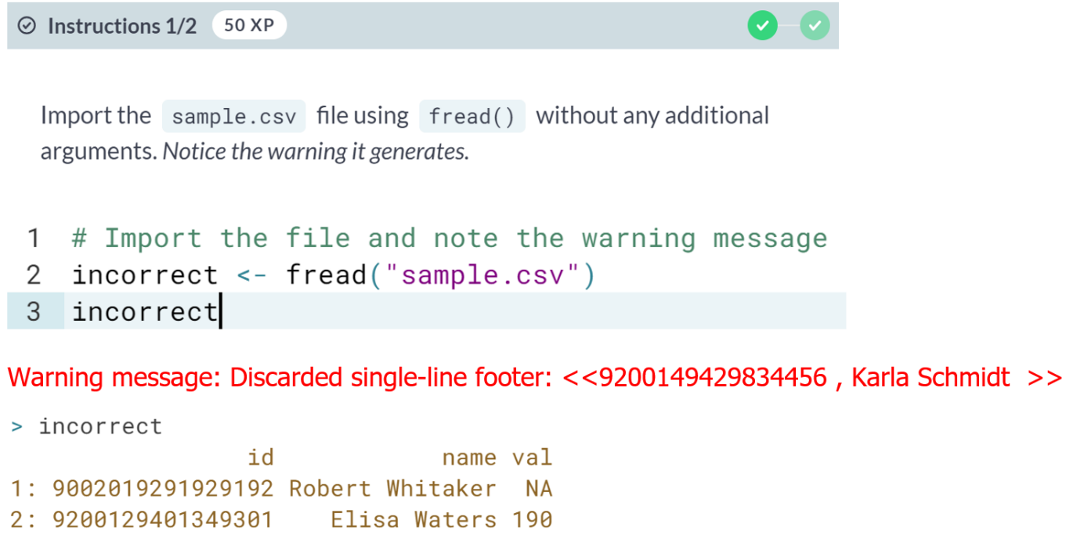  
  
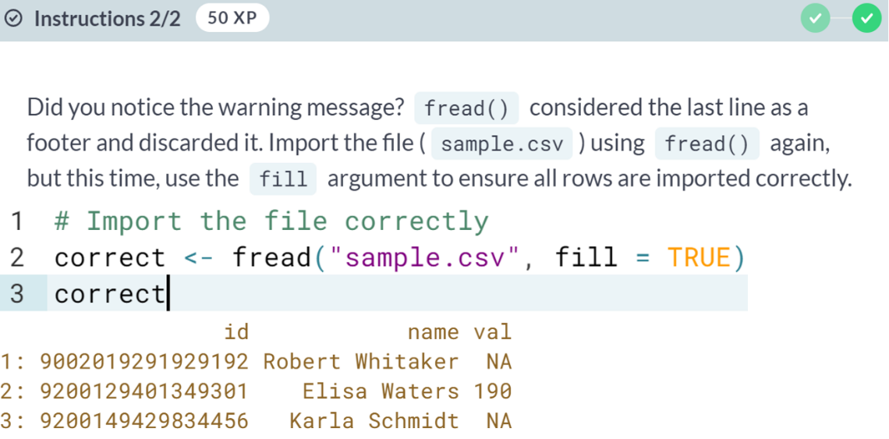

# Dealing with missing values

Missing values are often encoded differently. In some files, -9999 mean missing values and in others, they may be encoded as #$##. You can use the na.strings argument to tell fread() which values should be treated as missing values.

You will be importing the following file:

id,name,val1,val2

9002019291929192,Robert Whitaker,,44

9200129401349301 ,Elisa Waters,289,##

9200149429834456 , Karla Schmidt,458,29

The missing values are encoded as *"##"*. Note that *fread()* handles an empty field *,,* by default as *NA*.

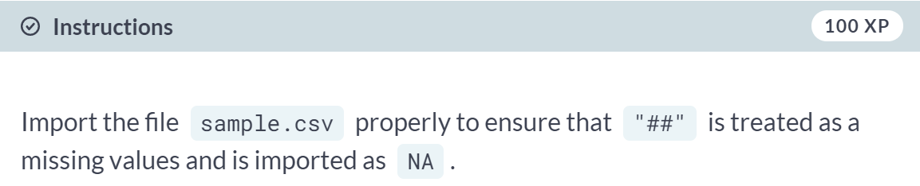  
  
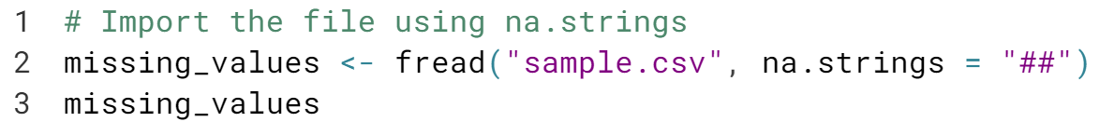  
  
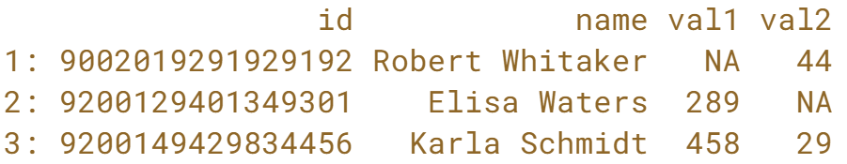  
  
Good job! Handling missing values is one of the most important steps in ensuring your data is well prepared.



***fwrite()*** is a data table's high-performance parallel file writer.

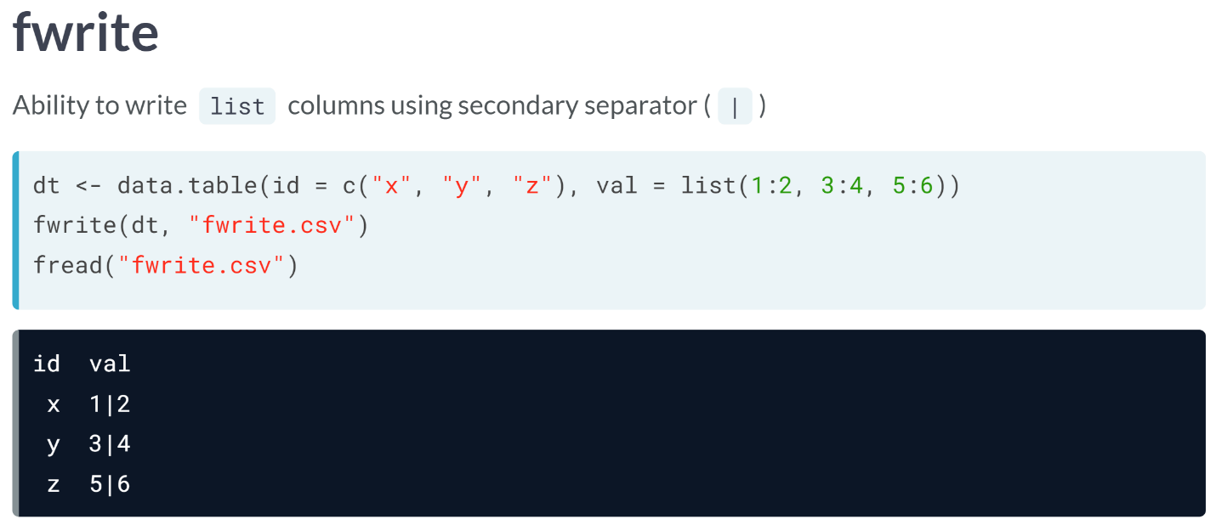Similar to *fread()*, ***fwrite()*** is a fast and parallel file writer. By default, it uses all available threads to write to file. We can control the number of threads to use using the "*nThread*" argument.

***fwrite()*** provides intelligent defaults so that in most cases, only the data and file name arguments are required. It also has the ability to write columns of type "*list* " by flattening the list column with a secondary separator, which is the symbol for the OR operator ("**|**") by default.

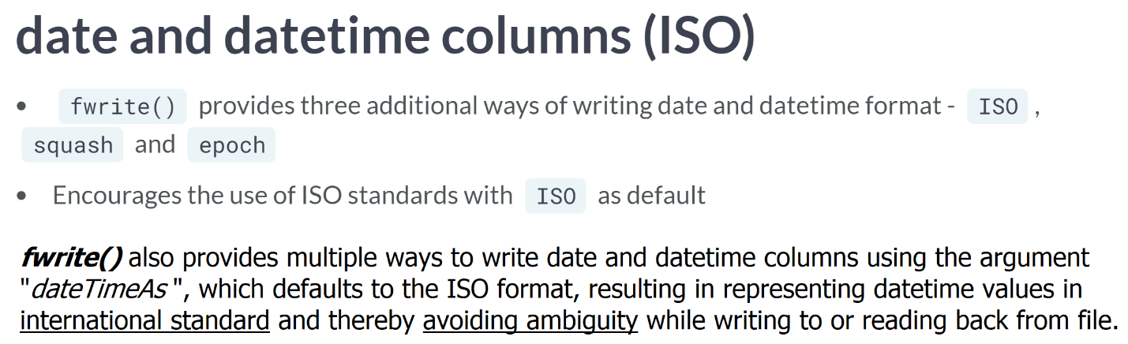

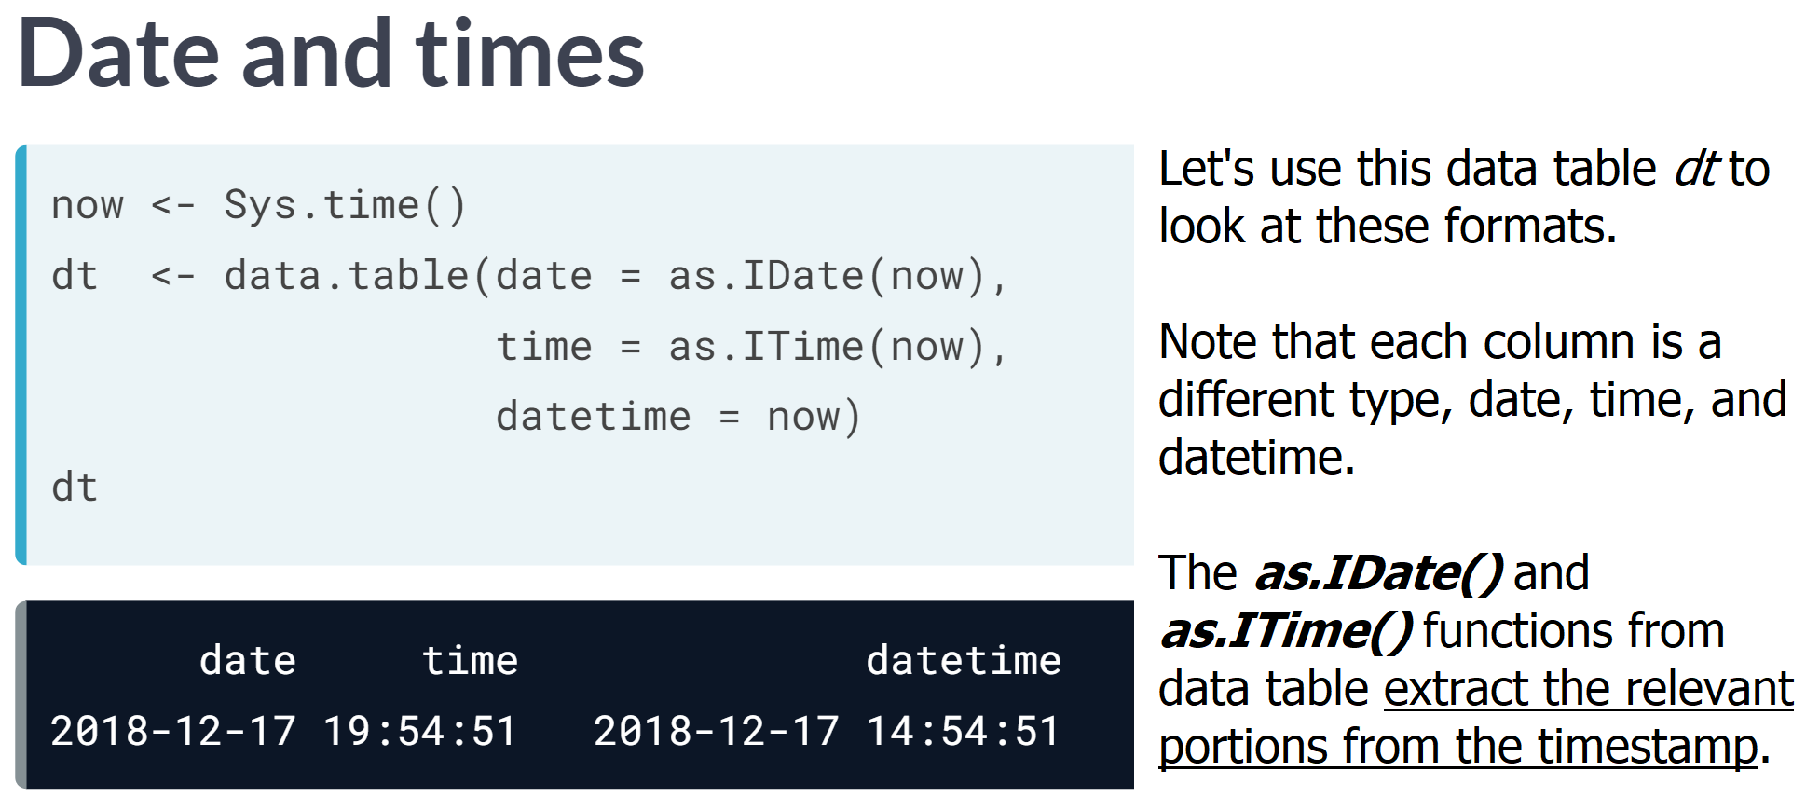

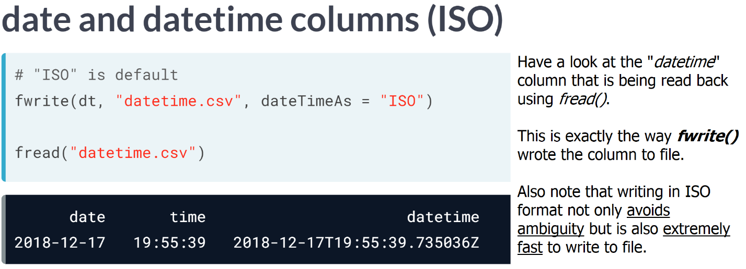  
  
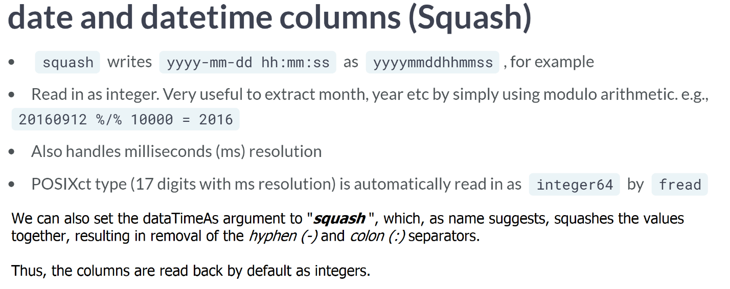

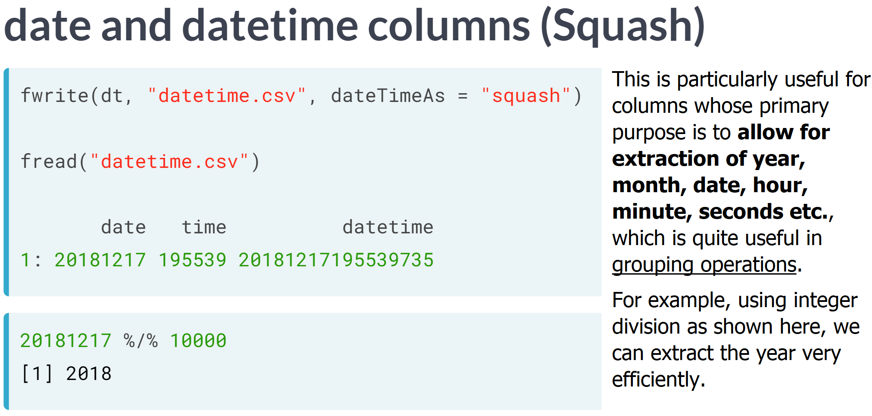

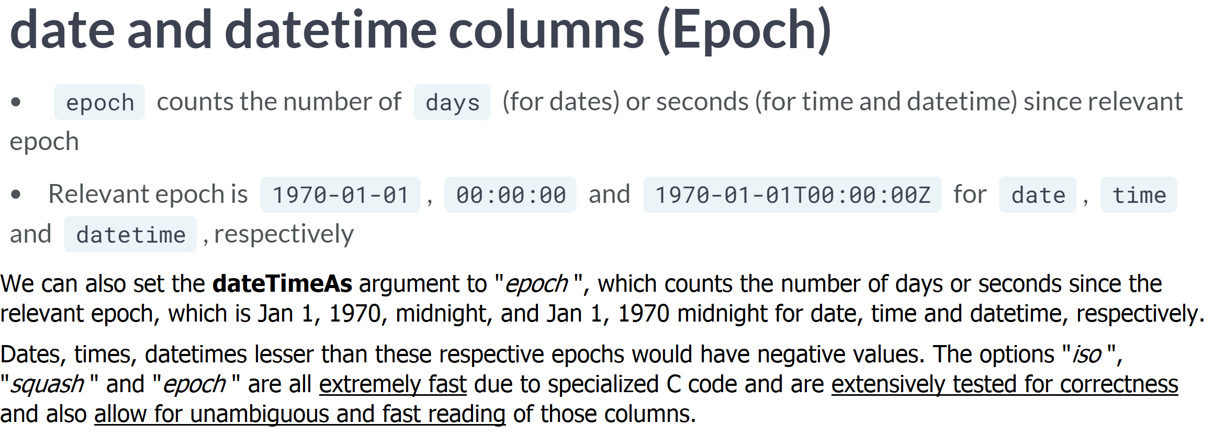  
  
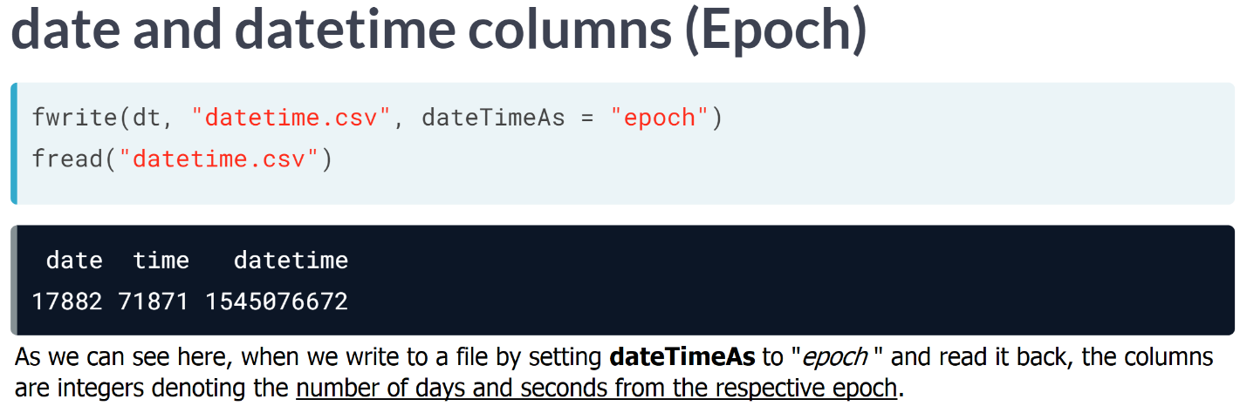

# Writing files to disk

fwrite() is a parallel file writer, and like fread(), it also has intelligent defaults.

For example, print dt in your console and notice that the column name has the first and last names separated with a , and the column val is of type list. fwrite() can automatically quote name column and add a secondary separator (the symbol for OR operator, |) for the list column.

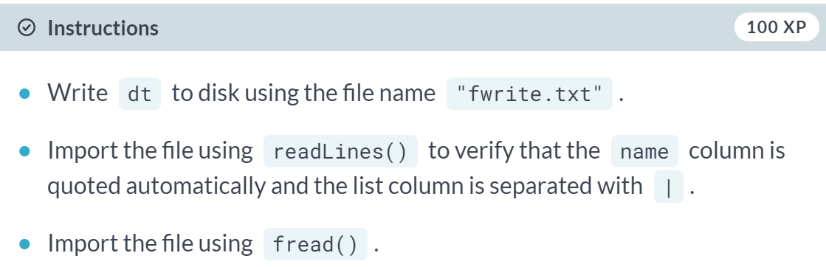

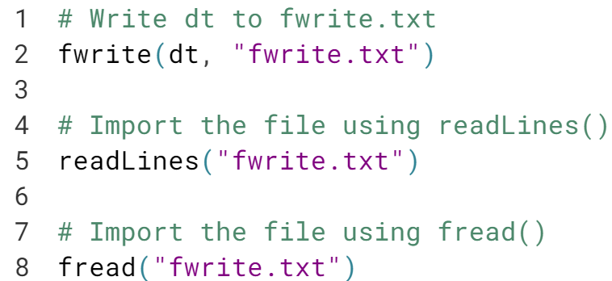

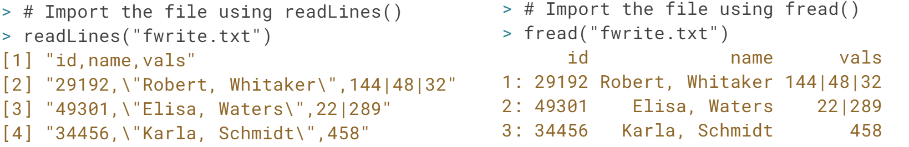  
Good! Being able to write list columns to file and reading them back properly is a very handy feature of ***fwrite()***.

# Writing date and time columns

fwrite() provides several fast and consistent ways of writing date and datetime columns to files using the dateTimeAs argument.

In order for you to clearly understand how this works, you will be working batrips_dates, which consists of two columns and five rows:

start_date end_date

1: 2014-01-01 00:14:00 2014-01-01 00:21:00

2: 2014-01-01 00:14:00 2014-01-01 00:21:00

3: 2014-01-01 00:17:00 2014-01-01 00:42:00

4: 2014-01-01 00:23:00 2014-01-01 00:50:00

5: 2014-01-01 00:23:00 2014-01-01 00:50:00

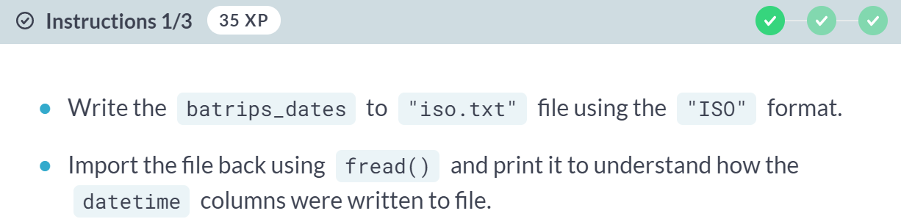

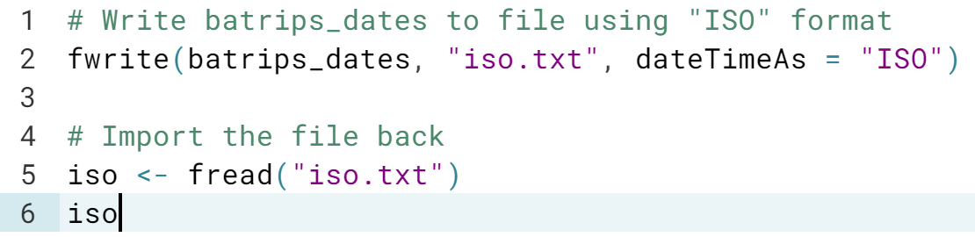  
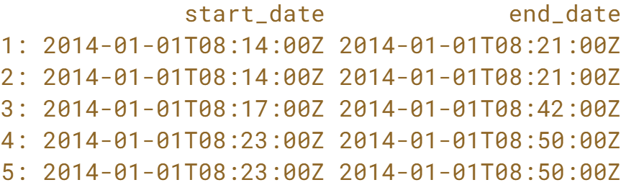

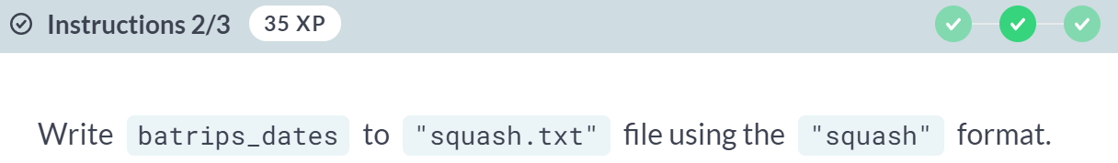  
  
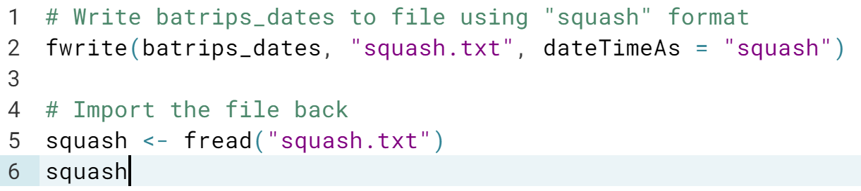  
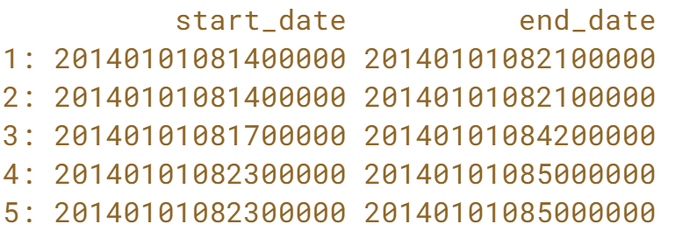

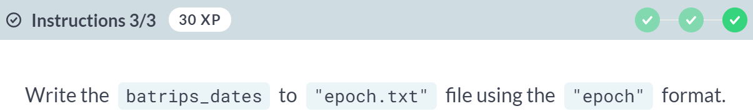

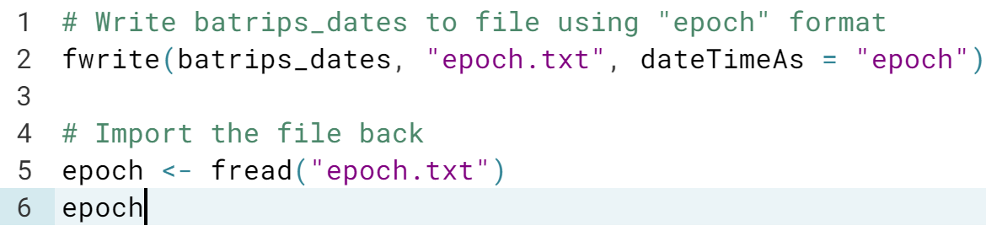  
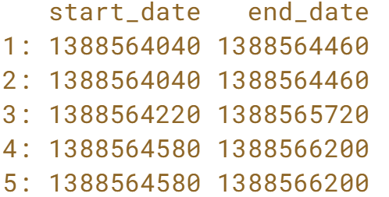  
You are superb! *Dates* and *Datetimes* are very common in Data Science and require proper handling.

# Fast writing to disk

As mentioned in the video, fwrite() writes data to disk is very fast! Also, just like fread() reads data in parallel, fwrite() also writes to file in parallel. The number of threads to write data to disk can be controlled using nThread argument.

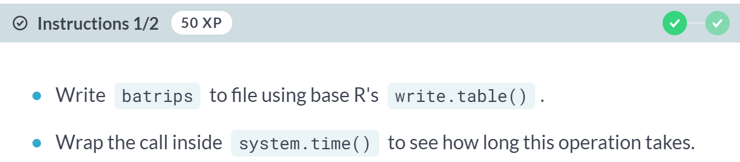

 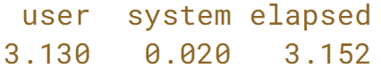

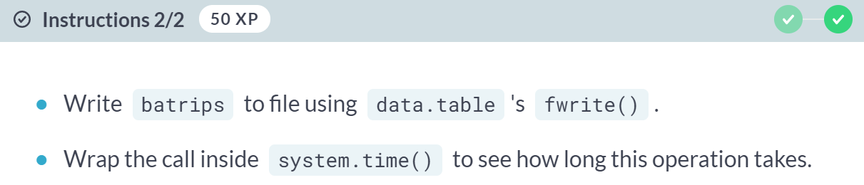

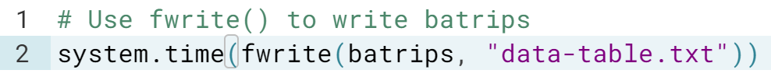  
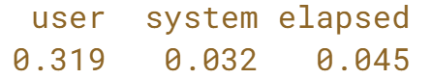

Sensational! Congratulations on completing this introductory course on data.table!